Xinzhen Wang

CIS750 – Video Mining
Prof. Latecki

Assignment 2

Introduction:
The object of this assignment is to detect motion in a video file. A video consists of a sequence of frames. A cut in a video is defined as a frame that is statistically significant difference to its adjacent frames. We explored two difference measures: the pixel-based image difference and histogram-based image difference. Further, an analysis and comparison of the results is supplied.
Histogram-based measure:
H(f)(i) is the histogram value at bin i of frame f . The following formula computes the histogram- based dissimilarity between any two consecutive frames in one video.
Pixel-based measure:
F(i,j) is the image intensity value at pixel (i,j). This formula computes the pixel-based dissimilarity between any two consecutive frames in one video.
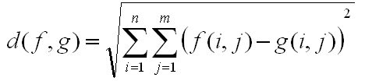
For real color image, the value of d(f, g) is calculated separately for R,G,B values.

Adaptive thresholding:
$$\begin{aligned}\text{spd}(a,b)=\sqrt{\text{wh}}\frac{\overline{d(a,b)}}{s_{d}(a,b)} \\ \overline{d(a,b)}=\frac{1}{\text{wh}}\sum_{x=1}^{w}{\sum_{y=1}^{h}{d(a,b,x,y)}} \\ s_{d}^{2}(a,b)=\frac{1}{\text{wh}−1}\sum_{x=1}^{w}{\sum_{y=1}^{h}{(d(a,b,x,y)}}−\overline{d(a,b)})^{2} \\ d(a,b,x,y)=c(a,x,y)−c(b,x,y)\end{aligned}$$
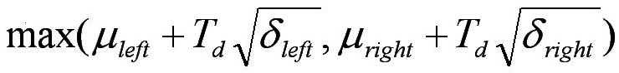
The above statistical refinement computes the adaptive threshold points where motion occurs.

Some results:
hall_monitor.avi
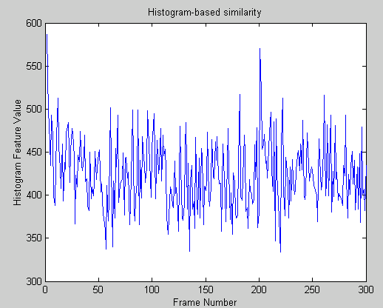
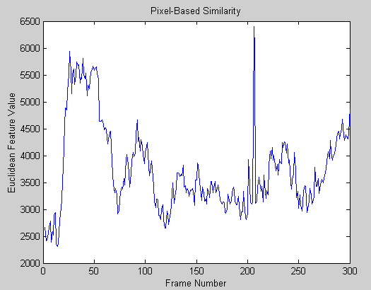
security1.avi
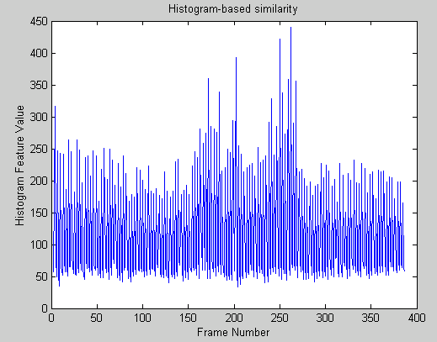
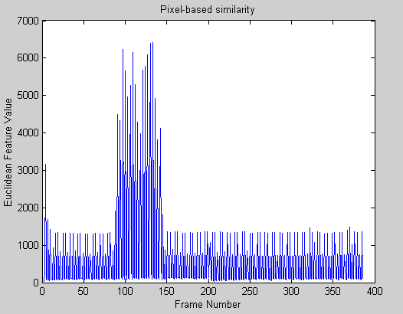

security7.avi
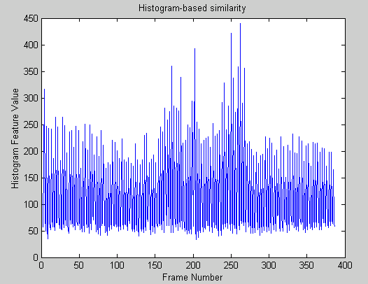
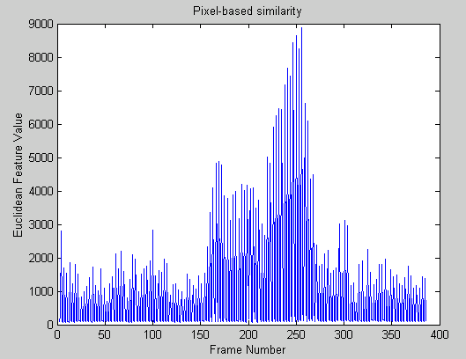

Conclusion:
We observe that the results are dependant on the characteristic of frames in the video file. The histogram approach performs better if frames have same objects but different motion (exp: security7.avi). The pixel approach performs better if the frames have different objects of similar color distribution. Also, the pixel method induces noise into the calculation of the discontinuity function that produces false positives.

