Pixel based and histogram based motion detector

Figure 1 is pixel based motion detection on the movie ‘fox.avi’, we can see that the curve is gracefully continues. The program detected that at frames of 37,38,39, there are big changes.

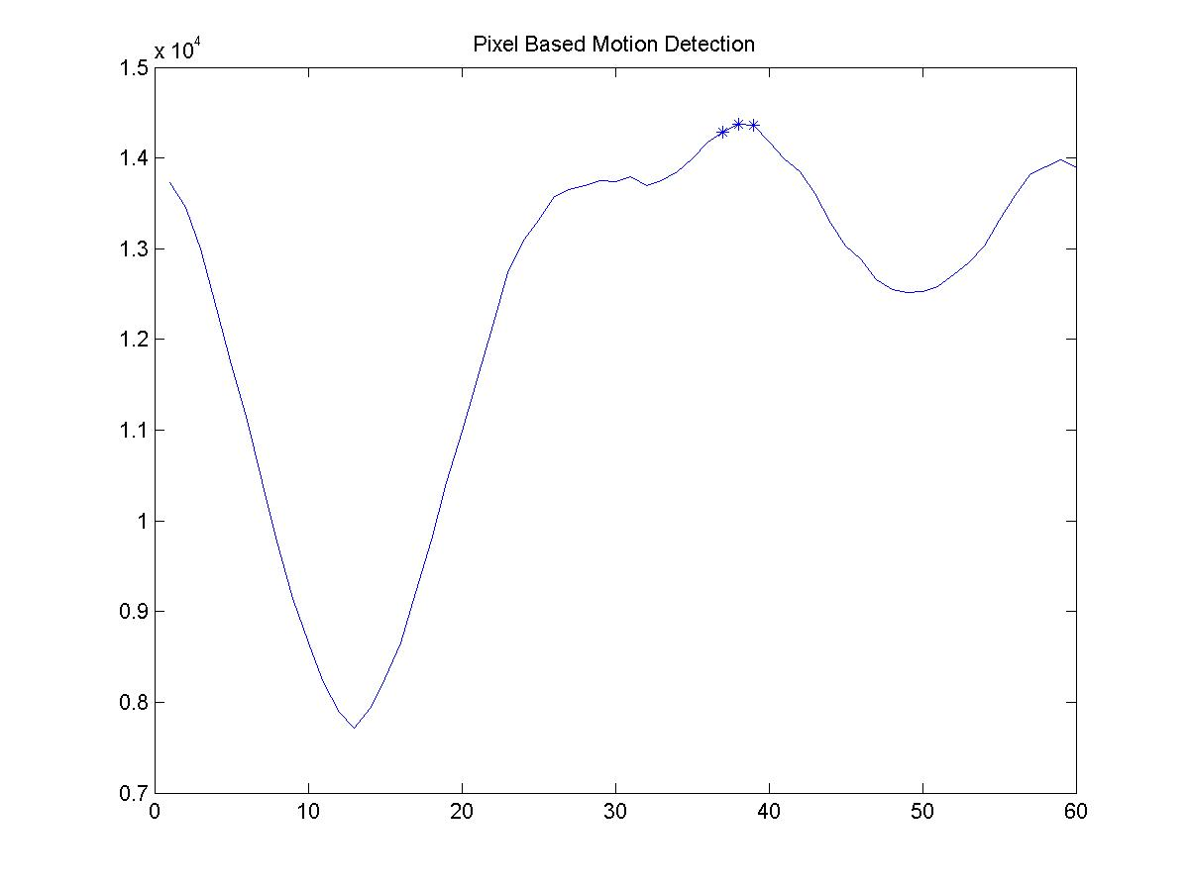
Figure 1


11 12 13 14 15

At frame 13, the right side “green” shrinks, while the left side “green” part increases. The lowest pixel-based difference appears at frame number 13.


36 37 38 39 40
At frame 38, the right side “green” disappears, while the left side “dark” part increases. The highest pixel-based difference appears at frame number 38.

Figure 2 is histogram based motion detection on the movie ‘fox.avi’, we can see that the curve is almost sawed everywhere. The program detected that at frames of 8,12,16,20,21,22,32,44,45,48,50 and 52 there are big changes.

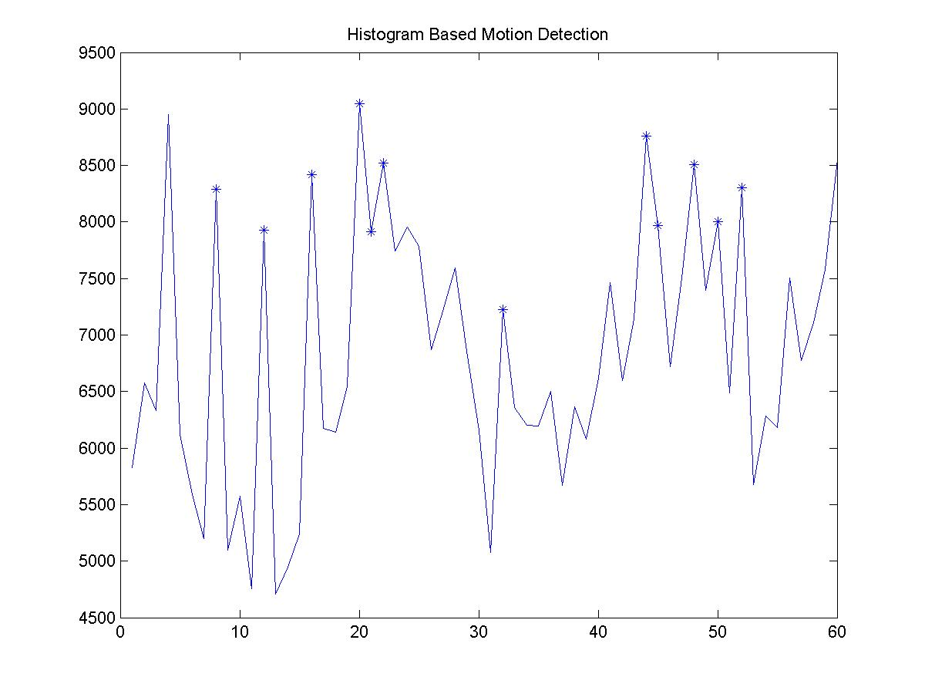
Figure 2

The histogram based motion detection is sawed. And shot detection could clearly detect the peaks for the graph.


18 19 20 21 22

The differences of the “green” parts for 20 and 19, and the differences for 22 and 21 are relatively bigger than the difference for the other continuous frames. And thus they are detected as appearance of big changes.

As we can see, the histogram-based method is better than the pixel-based method for shot detection.

