CIS750 – Assignment 1
Instructor Dr Latecki
Submitted by Vivek Parameswaran

Comparison of Pixel based and Histogram based Image Difference

Introdution:

The objective is to compare the difference in the results when we use these two different methods.
In the histogram methods we take the images and then compare the histogram vector produced by the different images. In the pixel methods we compare the two images pixel by pixel.

Experimental setup:

In the histogram method we first take the “.avi” movies convert it to number of ‘.jpg’ images. These images are stored in a specific directory. These images and taken two at a time and then compare the histogram vector. We pass the two images to function which computes the histogram vector and it is stored in a specific vector. Now we have to find the dissimilarity between the two frames the dissimilarity function between two frames are defined as follows. We first calculate a time series of discontinuity feature values f(n) for each frame. Then we use function dsim(x, y) to measure the dissimilarity between frame x and y. The discontinuity feature value for frame n is f(n) = dsim(n-1,n).The formulae used to get the histogram vector is

Where H(f) and H(g) are the histograms of the two images f and g.

We use the some threshold techniques to pick the cut positions from f(n). We are using the threshold function to do that. The same procedure is followed in the pixel based technique but instead of storing the histograms we compare the pixels in the two frames and store them. The formulae used for pixel comparison is

The formulae used for thresholding is
$\text{max}(μ_{\text{left}}+T_{d}\sqrt{δ_{\text{left}}},μ_{\text{right}}+T_{d}\sqrt{δ_{\text{right}}})$

The following are the main type of image classifications:

Hard cuts: A cut is an instantaneous transition from one scene to the next.
Fades: A fade is a gradual transition between a scene and a constant image (fade-out) or between a constant image and a scene (fade-in).
Dissolves: A dissolve is a gradual transition from one scene to another, in which the first scene fades out and the second scene fades in.
Wipe: another common scene break is a wipe, in which a line moves across the screen, with the new scene appearing behind the line.

Results:
The file used for the experiment is called ‘centroid7.avi’.
The results obtained for the two different types of comparisons are listed below:

The graph obtained for the pixel based comparison:

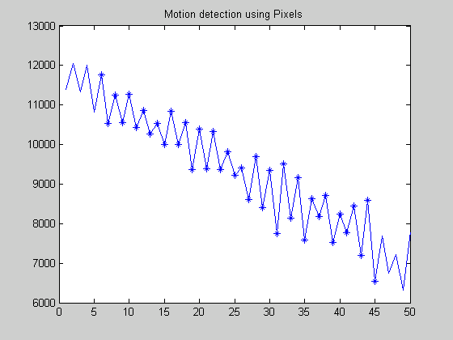

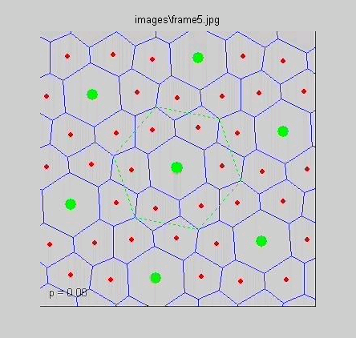

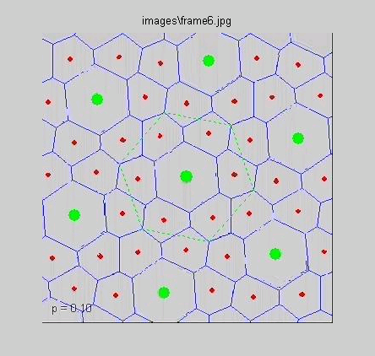

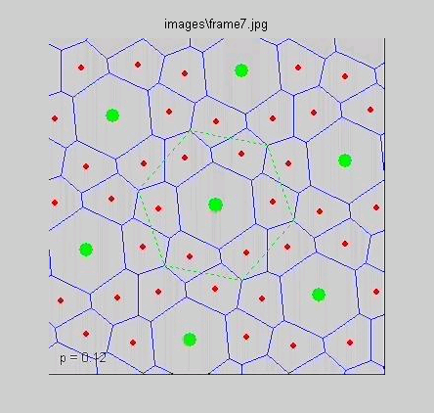

The following is the graph obtained for histogram comparison.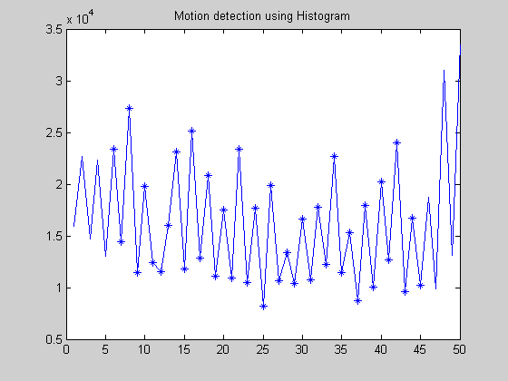

The same frame numbers where obtained for the first main dissimilarity for both the methods so they are posted twice.

Conclusion:

In the images that I am using it has different images with the same objects with different motions.
Since in this video it has the different object with the same color the pixel method has done well compared to the histogram method. The pixel method graph looks different from the histogram method due to the noise induced. We cannot directly assume one method is better than the other it really depends on the data we use.

