Motion detector using pixel based difference and histogram based difference

Introduction:
This assignment was to design an application that analyses a video file and report the change in motion. A useful application would be to alert guards of an intruder in a secured area. We restrict our analysis to stored video files not real time video streams. This report describes the algorithm of an application that detects motion.
Method:
To apply an algorithm to a video file, one has to investigate which video formats that are available for analysis. As we used Matlab programming language mainly for this assignment we restrict ourselves to AVI video files.
Idea is to take a video file as input and in order to compare two consecutive video frames, they had to be extracted in some kind of image format, such as jpeg, bmp etc. and calculate a time series of discontinuity feature values f(n). Suppose we use function d(x,y) to measure the dissimilarity between frame “x” and “y” , the discontinuity feature value for frame n is f(n) = d(n-1,n).
The discontinuity feature value “d” can be calculated by using two different approaches. One is to find pixel based differences between frames “n-1” and “n” the other is to find histogram based differences between frames “n-1” and “n”.
Pixel based:
If “f” and “g” be two gray value image functions the discontinuity feature value using pixel differences can be calculated using the formula:
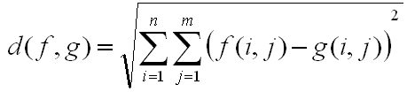
If the input image is a color image the value of “d” calculated separately for the “R”, “G” and “B” values.

Histogram based:
If “f” and “g” be two gray value image functions the discontinuity feature value using histogram differences can be calculated using the formula
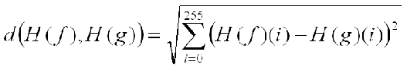
If the input image is a color image the value of “d” calculated separately for the “R”, “G” and “B” values.
The next step is to find the threshold points (cut – off points) where motion occurs. The method used here is based on Adaptive thresholding.
Adaptive Thresholding:
The idea is to use a sliding window. The window slide on the array which contains the discontinuity feature values. While sliding it compares the value of the middle frame with that of the left and right feature values. The size of the window is 2w+1.
Based on the condition below the cut-off point is detected:
The middle frame of the window is detected as the cut-off if:
- Its feature value is the maximum in the window
- Its feature value is greater than
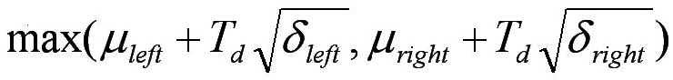

Results:
The program is called on the matlab command line by typing:
>>motion_detect('test1.avi',1,5);
where the first parameter is the video file name, second parameter is the option. Option is “1” for computing histogram based discontinuity feature value and option is “0” for computing pixel based discontinuity feature value. The last parameter is the size of the sliding window size, here it’s set to “5” (value of “w”).
The below figures shows the discontinuity feature values between frames for the video file “test1.avi” using the above two approaches and the “*” points shows the cut-off points where the motion has been detected.
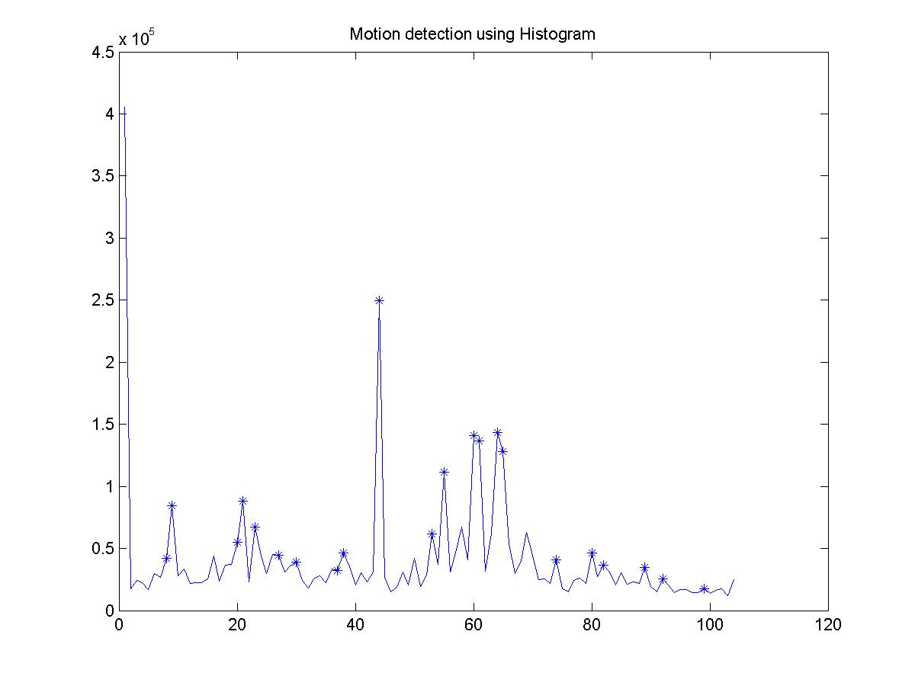

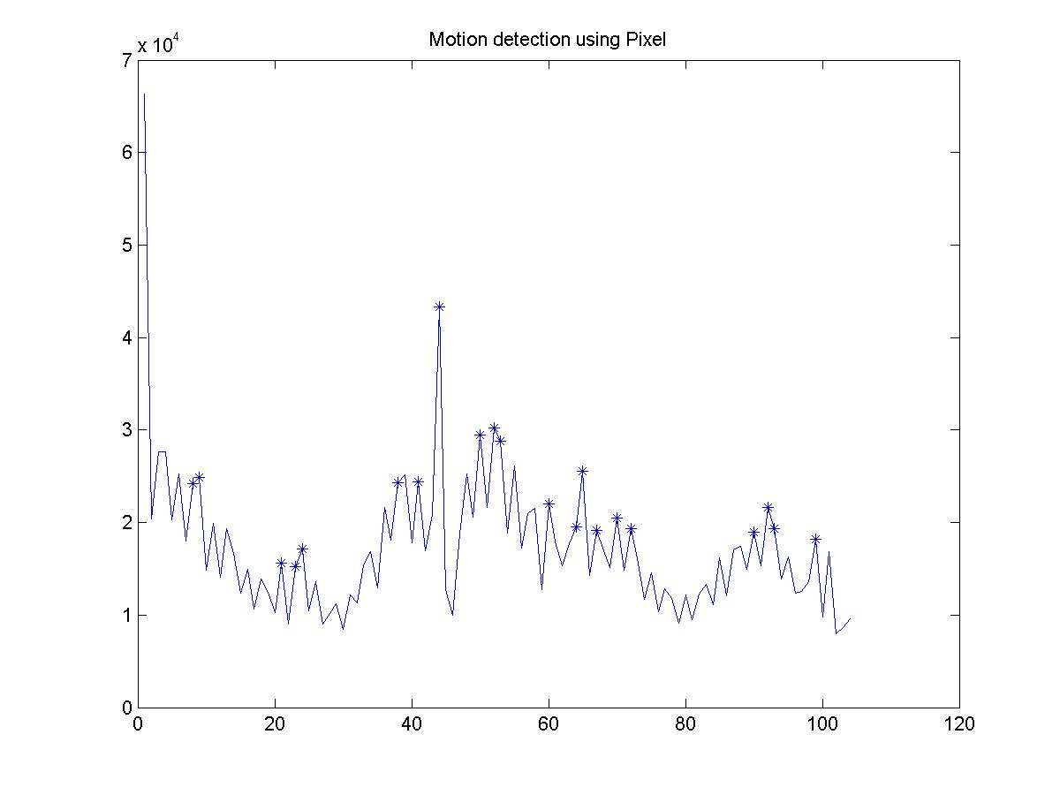

We compare the cut – off points found by the two methods in a table below:
Total number of frames: 105
Histogram | 8 | 9 | 20 | 21 | 23 | 27 | 30 | 37 | 38 | 44 | 53 | 55 | 60 | 61 | 64 | 65
Pixel | 8 | 9 | 21 | 23 | 24 | 38 | 41 | 44 | 50 | 52 | 53 | 60 | 64 | 65 | 67 | 70
For comparison purposes the frame numbers that are common to both histogram and pixel are shown in bold letters. From the above table we can see that the cut detected by these two methods are pretty much stable.
The below figures just shows the middle, left and right frames where the cut has been detected (frame no. 44) by both methods.
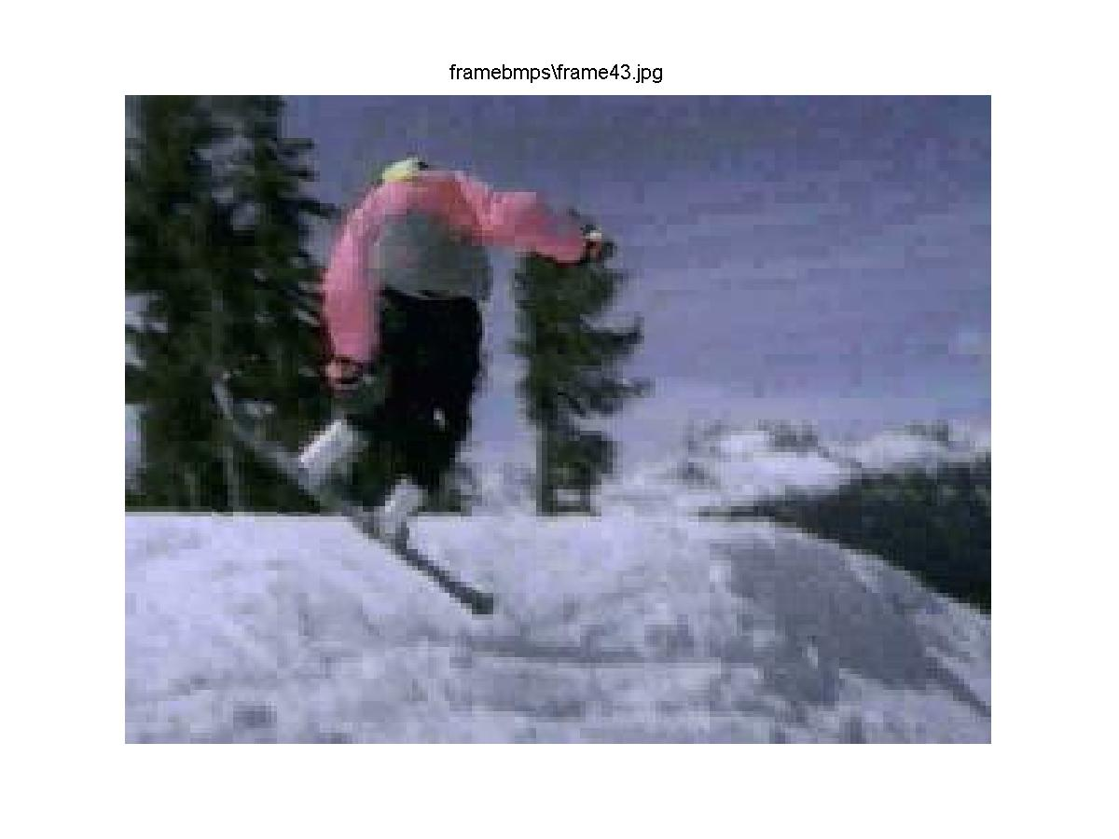
Frame No. 43
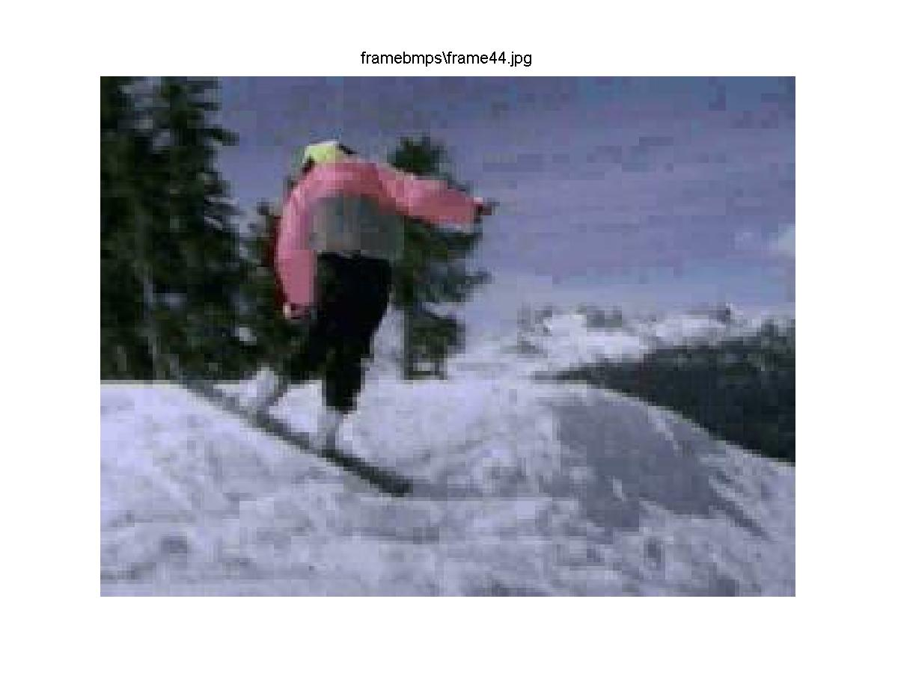
Frame No. 44
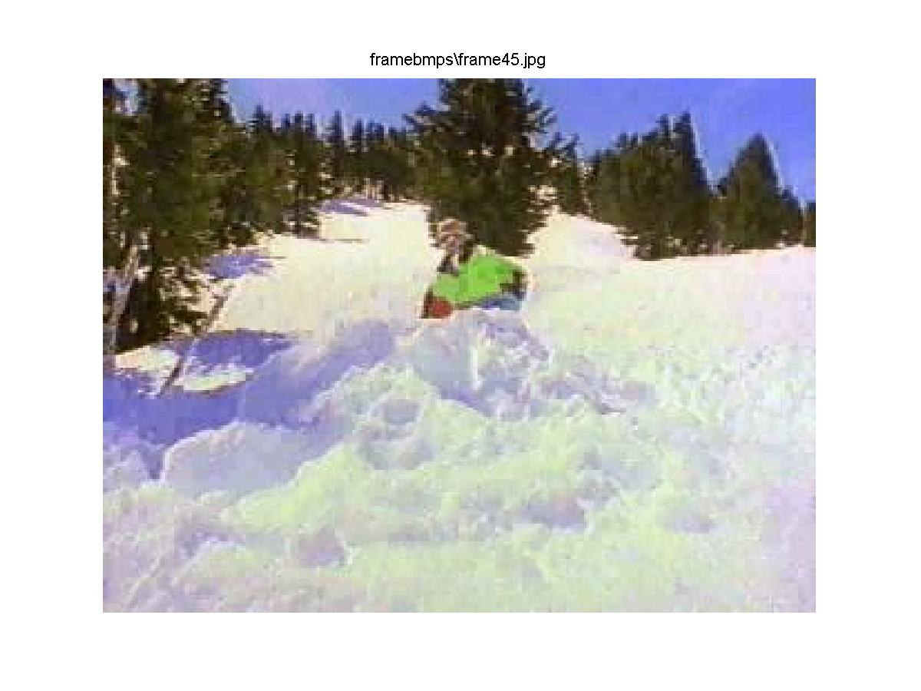
Frame No. 45

Conclusion:
From the above results we can see that the outputs from both the methods are pretty much stable but the results are dependant on the type of frames in the video file. If the frames have same objects but different motion then histogram method will do a good job. Or if the frames have different objects of same color pixel method will do a good job. Another disadvantage in the pixel method is that it induces noise into the calculation of the discontinuity function which might give us false alarms which is evident from the graph shown above. Another disadvantage is pixel method takes more time to compute the values than the histogram method.

