Roland Miezianko

CIS750 – Video Mining
Prof. Latecki

Homework 2

Software Operation

An uncompressed AVI file is first read and its individual frames are stored as bitmapped files. A function will then read each frame in sequence and compute the difference in histograms. Another function will compute the pixel-based difference in two consecutive images. Output from both these functions is an array of frame numbers and the dissimilarity values between any given frame and its predecessor. This output is then fed to a frame selection function that reads the dissimilarity value and compares it to some threshold. Output consists of dissimilarity graph and of frame selection graph.

Histogram-based image similarity measurement

H(f)(i) is the histogram value at bin i. This formula is used to compute the histogram-based dissimilarity between any two consecutive frames.

Pixel-based image similarity measurement

F(i,j) in the image intensity value at location (i,j). This formula is used to compute the pixel-based dissimilarity between any two consecutive frames.
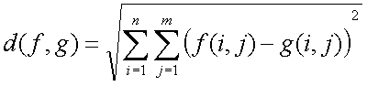

Software Pseudo-code

Read AVI file and store each frame as a bitmap.
Histogram-based image dissimilarity
Read each frame bitmap
Convert to gray-scale bitmap
Compute histogram for this frame
Apply above formula to compute difference in histograms
Store the difference in the output array
Pixel-based image dissimilarity
Read each frame bitmap
Convert to gray-scale bitmap
Apply above formula to compute difference in pixel values
Store the difference in the output array
Find frames - histogram-based dissimilarity
Accept output array from histogram-based image dissimilarity
Compute the threshold value: average between max and average
Find frames that are above the threshold value
Graph output
Find frames - pixel-based dissimilarity
Accept output array from pixel-based image dissimilarity
Compute the threshold value: average between max and average
Find frames that are above the threshold value
Graph output

Sample files used

Security1.avi
Security7.avi

Sample frames from security7.avi file. Frame 1 show a “typical” background and frame 243 shows a “foreign object” obstructing the background.

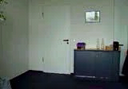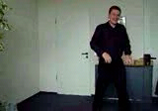
Frame 1 Frame 243

Analysis of Results

From the graph showing the histogram-based difference and pixel-based difference between frames, the pixel-based difference shows the motion detection frames as having larger values from the background noise. This is evident in the two test videos. The histogram-based dissimilarity measure pickup a significant amount of motion from the background noise and small camera movements. The pixel-based dissimilarity measure is less immune to the small camera movements and background noise. It shows a clean distinction between background noise and motion. The histogram-based dissimilarity measure picked up several background motion detection frames, which were just a small camera movements. It seems that for this set of videos, a pixel-based dissimilarity measurement in motion detection, performed better than histogram-based dissimilarity measurement motion detection. However, if the moving subject had its intensity color values close to the background, then the histogram-based intensity values would not change drastically to be detected. Pixel-based dissimilarity measurements also have their limitation when subject is moving slower than the frame rate of the video. Therefore, neither method is sufficient to perform motion detection by itself, however, it does provide a basic structure and verification of the generic motion detection schemas.

Matlab Code Files

Main.m main driver file, specify the input avi file
MotionDetection.m create frames, get histogram and pixel differences
GenerateFrames.m generate frames from and avi file, store as bitmaps
GetHistogramDiff.m compute the histogram-based image similarity
GetPixelDiff.m compute the pixel-based image similarity
GetMotionFrames.m get motion frames based on a threshold

File: security1.avi
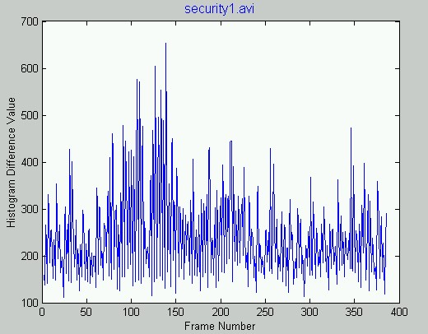
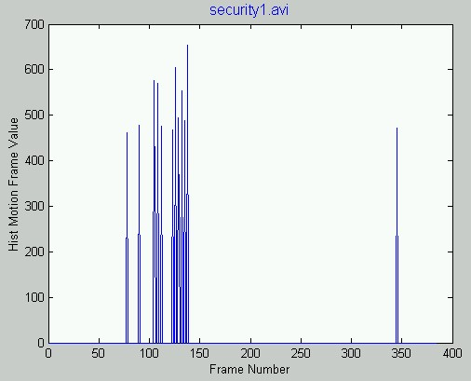

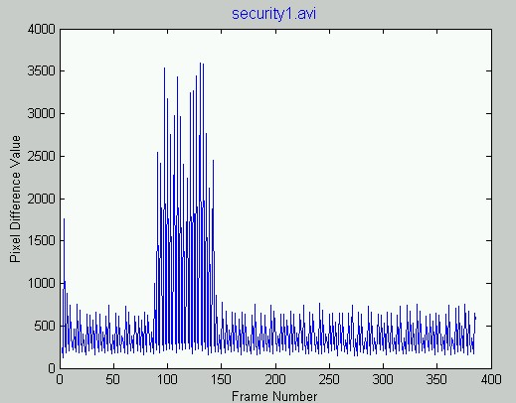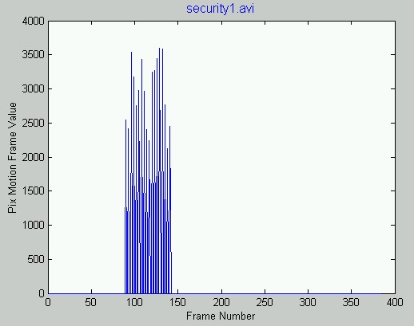
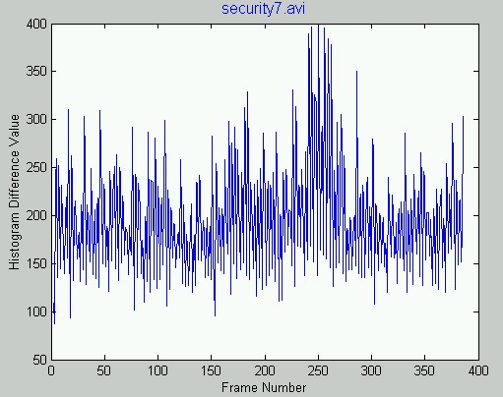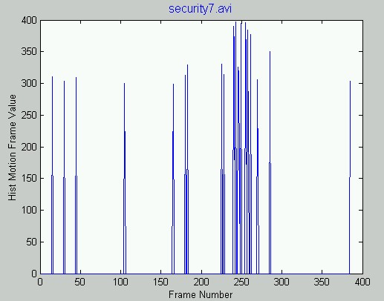

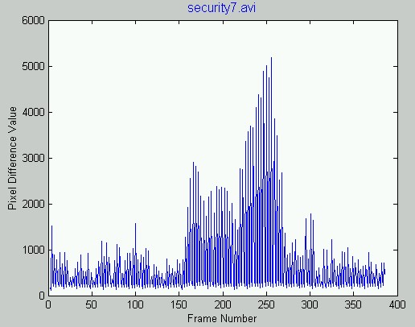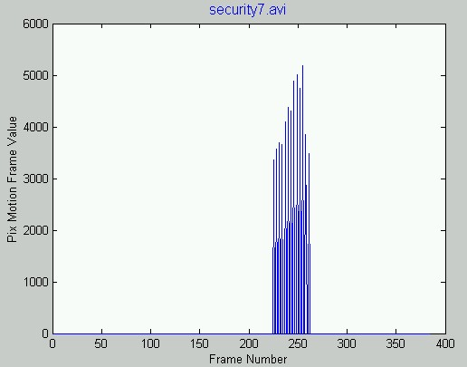

Matlab Code Files

Main.m main driver file, specify the input avi file
MotionDetection.m create frames, get histogram and pixel differences
GenerateFrames.m generate frames from and avi file, store as bitmaps
GetHistogramDiff.m compute the histogram-based image similarity
GetPixelDiff.m compute the pixel-based image similarity
GetMotionFrames.m get motion frames based on a threshold

Main.m

%%%%%%%%%%%%%%%%%%%%%%%%%%%%%%%%%%%%%%%%%%%%%%%%%%%%%
%
% Author: Roland Miezianko (rmiezian@astro.temple.edu)
% Date: Spring 2003
% Instructor: Dr.Longin Jan Latecki
% Course: CIS 750
% Project : Assignment 2
%
%%%%%%%%%%%%%%%%%%%%%%%%%%%%%%%%%%%%%%%%%%%%%%%%%%%%%%

% main driver program
clear all;
clc;
%MotionDetection('security1.avi');
%MotionDetection('security7.avi');
%MotionDetection('hall_monitor.avi');

MotionDetection.m

%%%%%%%%%%%%%%%%%%%%%%%%%%%%%%%%%%%%%%%%%%%%%%%%%%%%%%
%
% Author: Roland Miezianko (rmiezian@astro.temple.edu)
% Date: Spring 2003
% Instructor: Dr.Longin Jan Latecki
% Course: CIS 750
% Project : Assignment 2
%
%%%%%%%%%%%%%%%%%%%%%%%%%%%%%%%%%%%%%%%%%%%%%%%%%%%%%%

function []=MotionDetection(aviFileName)

% % assign a frame prefix
imageFileNamePrefix = 'frame_';
% % generate individual frames from the avi file in the current directory
% % and store the total number of frames generated
noOfFrameImages = GenerateFrames(aviFileName,imageFileNamePrefix);
% noOfFrameImages = 386; % store the value here, so we don't have to regenerate bmps
noOfFrameImages

% ***************************
% compute the histogram difference values
HistDiffVals = GetHistogramDiff(imageFileNamePrefix, noOfFrameImages);
%HistDiffVals
Threshold = max(HistDiffVals(:,2)) - (max(HistDiffVals(:,2)) - mean(HistDiffVals(:,2)))/2;
HistMotionFrames = GetMotionFrames( HistDiffVals, Threshold );
% plot the result
figure; plot(HistDiffVals(:,1),HistDiffVals(:,2));
xlabel('Frame Number'); ylabel('Histogram Difference Value'); title(aviFileName,'FontSize',12,'Color','b')
figure; plot(HistMotionFrames);
xlabel('Frame Number'); ylabel('Hist Motion Frame Value'); title(aviFileName,'FontSize',12,'Color','b')

% ***************************
% compute the pixel difference values
PixDiffVals = GetPixelDiff(imageFileNamePrefix, noOfFrameImages);
%PixDiffVals
Threshold = max(PixDiffVals(:,2)) - (max(PixDiffVals(:,2)) - mean(PixDiffVals(:,2)))/2;
PixMotionFrames = GetMotionFrames( PixDiffVals, Threshold );
% plot the result
figure; plot(PixDiffVals(:,1),PixDiffVals(:,2));
xlabel('Frame Number'); ylabel('Pixel Difference Value'); title(aviFileName,'FontSize',12,'Color','b')
figure; plot(PixMotionFrames);
xlabel('Frame Number'); ylabel('Pix Motion Frame Value'); title(aviFileName,'FontSize',12,'Color','b')

return;
GenerateFrames.m

%%%%%%%%%%%%%%%%%%%%%%%%%%%%%%%%%%%%%%%%%%%%%%%%%%%%%%
%
% Author: Roland Miezianko (rmiezian@astro.temple.edu)
% Date: Spring 2003
% Instructor: Dr.Longin Jan Latecki
% Course: CIS 750
% Project : Assignment 2
%
%%%%%%%%%%%%%%%%%%%%%%%%%%%%%%%%%%%%%%%%%%%%%%%%%%%%%%

function [noOfFrameImages] = GenerateFrames(aviFileName, imageFileNamePrefix)

% create movie object
movieObj = aviread(aviFileName);

% store file information (not used)
% fileinfo = aviinfo(aviFileName);

% store number of frames
noOfFrameImages = size(movieObj,2);

% generate gray level frames
for count = 1 : 1 : noOfFrameImages

% generate the filename
fileName = strcat( imageFileNamePrefix, num2str(count), '.bmp' );

% store the individual frame in a bmp file
imwrite( movieObj(count).cdata, fileName, 'bmp' );

% disp(r) % show the frame we are working with...
end

return;
GetHistogramDiff.m

%%%%%%%%%%%%%%%%%%%%%%%%%%%%%%%%%%%%%%%%%%%%%%%%%%%%%%
%
% Author: Roland Miezianko (rmiezian@astro.temple.edu)
% Date: Spring 2003
% Instructor: Dr.Longin Jan Latecki
% Course: CIS 750
% Project : Assignment 2
%
%%%%%%%%%%%%%%%%%%%%%%%%%%%%%%%%%%%%%%%%%%%%%%%%%%%%%%

% Compute the histogram based distance value for a set of bmp images
% Input params: bmp image prefix and total number of frames
% The bmp image filename will be constructed here Prefix_X

function [HistDiffVals] = GetHistogramDiff(imageFileNamePrefix, TotalNumFrames)

% init the output params
HistDiffVals = [];

% read first frame, convert to gray scale and compute the histogram
fileName = strcat( imageFileNamePrefix, num2str(1), '.bmp' );
im = imread(fileName);
imd = rgb2gray(im);
[n1, xnum1] = imhist(imd);

% process frames 2 to TotalNumFrames
for i = 2: TotalNumFrames

% generate filename based on the prefix and frame number
fileName = strcat( imageFileNamePrefix, num2str(i), '.bmp' );
% read the rgb file
im = imread(fileName);
% conver the rgb image to gray lavel image
imd = rgb2gray(im);
% compute the histogram of this frame
[n2, xnum2] = imhist(imd);

% compute the dissimilarity value between this and prevoius frames
var = (n2-n1).*(n2-n1);
var = sum(var);
d = sqrt(var);

% store the histogram based dissimilarity values
HistDiffVals = [HistDiffVals; i d];

% make this frame the prevoius frame before moving forward
n1 = n2;
end

return;

GetPixelDiff.m

%%%%%%%%%%%%%%%%%%%%%%%%%%%%%%%%%%%%%%%%%%%%%%%%%%%%%%
%
% Author: Roland Miezianko (rmiezian@astro.temple.edu)
% Date: Spring 2003
% Instructor: Dr.Longin Jan Latecki
% Course: CIS 750
% Project : Assignment 2
%
%%%%%%%%%%%%%%%%%%%%%%%%%%%%%%%%%%%%%%%%%%%%%%%%%%%%%%

% Compute the pixel based distance value for a set of bmp images
% Input params: bmp image prefix and total number of frames
% The bmp image filename will be constructed here Prefix_X

function [PixDiffVals] = GetPixelDiff(imageFileNamePrefix, TotalNumFrames)

% init the output params
PixDiffVals = [];

% read first frame, convert to gray scale
fileName = strcat( imageFileNamePrefix, num2str(1), '.bmp' );
im = imread(fileName);
imd1 = rgb2gray(im);
%[n1, xnum1] = imhist(imd);

% process frames 2 to TotalNumFrames
for i = 2 : TotalNumFrames

% generate filename based on the prefix and frame number
fileName = strcat( imageFileNamePrefix, num2str(i), '.bmp' );
% read the rgb file
im = imread(fileName);
% conver the rgb image to gray lavel image
imd2 = rgb2gray(im);
% compute the histogram of this frame
% [n2, xnum2] = imhist(imd);

% compute the dissimilarity value between this and prevoius frames
var = (double(imd2)-double(imd1)).*(double(imd2)-double(imd1));
var = sum(sum(var));
d = sqrt(var);

% store the histogram based dissimilarity values
PixDiffVals = [PixDiffVals; i d];

% make this frame the prevoius frame before moving forward
imd1 = imd2;
end

return;

GetMotionFrames.m

%%%%%%%%%%%%%%%%%%%%%%%%%%%%%%%%%%%%%%%%%%%%%%%%%%%%%%
%
% Author: Roland Miezianko (rmiezian@astro.temple.edu)
% Date: Spring 2003
% Instructor: Dr.Longin Jan Latecki
% Course: CIS 750
% Project : Assignment 2
%
%%%%%%%%%%%%%%%%%%%%%%%%%%%%%%%%%%%%%%%%%%%%%%%%%%%%%%

% accept difference vector
function [MotionFrames] = GetMotionFrames(DiffVector, Threshold)

MotionFrames = zeros(1,size(DiffVector,1));

for i = 1 : size(DiffVector,1)

if DiffVector(i,2) > Threshold
MotionFrames(i) = DiffVector(i,2);
end

end

return;

