Motion Detector: Pixel based and Histogram based

Brief program description: The algorithms have been explained for pixel based and histogram based motion detector.

Algorithm for pixel based motion detector:

- Extract frames from the given input .avi file using the ‘aviread’ function of Image Processing Toolbox of Matlab.
- For imageCount = 1 to (Number of images - 1)
  - Read 2 consecutive images using ‘imread’ function.
  - Convert the images into ‘indexed’ image using ‘rgb2ind’ function.
  - Store the Euclidean distance between the vectors of 2 consecutive indexed images into a vector of distances. The Euclidean distance is computed using ‘norm’ function.
- Plot the vector of distances.
- All distances above threshold (say values above 70% of max distance) indicate the frames where motion occurred.
- Delete the extracted frames from the movie.

Algorithm for histogram based motion detector:

- Extract frames from the given input .avi file using the ‘aviread’ function of Image Processing Toolbox of Matlab.
- For imageCount = 1 to (Number of images - 1)
  - Read 2 consecutive images using ‘imread’ function.
  - Obtain histogram of the two images using ‘imhist’ function.
  - Store the Euclidean distance between the histogram counts of the two consecutive images. The Euclidean distance is computed using ‘norm’ function.
- Plot the vector of distances.
- All distances above threshold (say values above 70% of max distance) indicate the frames where motion occurred.
- Local threshold can applied using the concept of window.
  - For frame number ‘i’, consider left window of say 10 frames and compute the mean value of all Euclidean distances between the histogram counts of the consecutive frames in this window.
  - For frame number ‘i’, consider right window of say 10 frames and compute the mean value of all Euclidean distances between the histogram counts of the consecutive frames in this window.
  - If the value of the distance (from the vector of distances obtained in step 2.c above) of the frame ‘i’ under analysis is greater than the distance values in steps ‘a’ and ‘b’ above, then the frame ‘i’ is the one where specific motion has occurred.
  - Plot the distance values of all the detected frames where motion has occurred.
- Delete the extracted frames from the movie.

Experiments have been performed on following movies:

- Security1.avi (Dr.Latecki enters the camera view and then exits)
- Mov3.avi (Rustam waving his hand)
- Hall_Monitor.avi (A person moving away from the camera view while another coming towards the camera view)

Security1.avi

Pixel based
pixelBasedMotionDetector(‘security1.avi’)

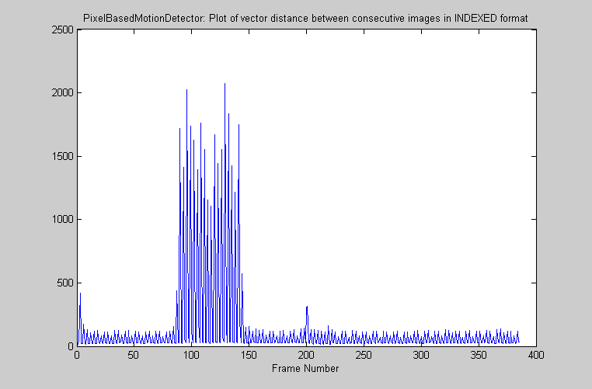

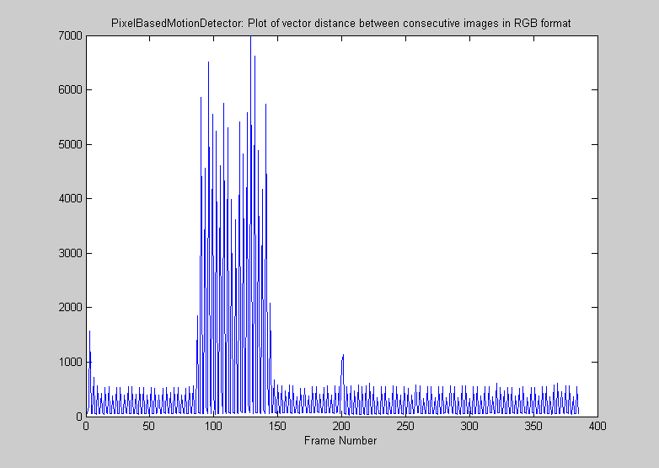

Note: For all values above threshold, say 75% above max value of the euclidean distance, it is seen that there was motion from from 80 till 144 which is true, since in the actual video of security1.avi, there is an entry of person at approx frame 80 and exit at approx frame 144.

Histogram based
[vectorOfShotFrames] = histogramBasedMotionDetector(‘security1.avi’,10)

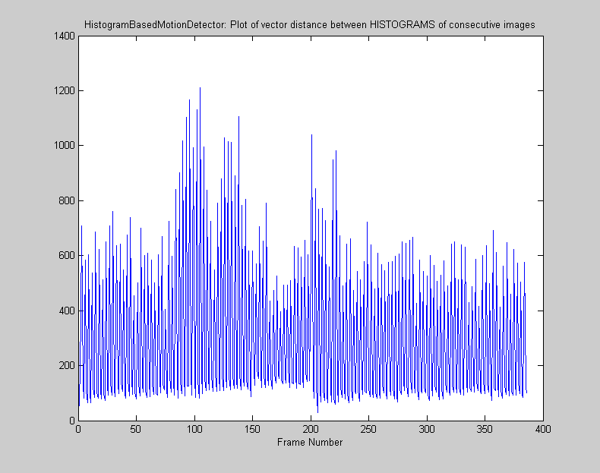

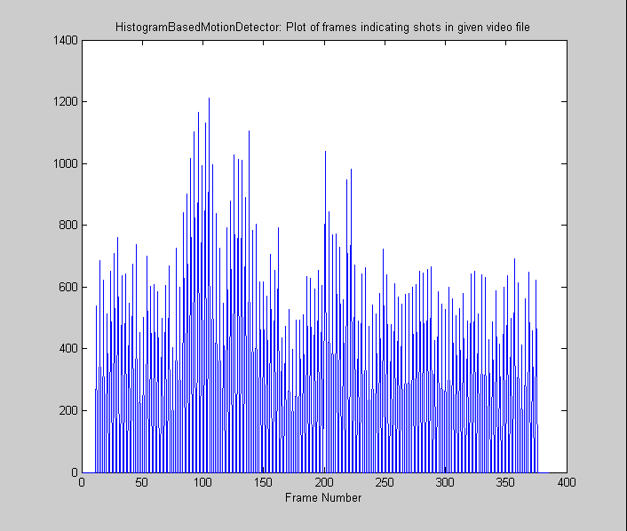

123 out of 387 distinguishing frames obtained with window of 10 frames.

Mov3.avi

Pixel based
pixelBasedMotionDetector(‘Mov3.avi’)

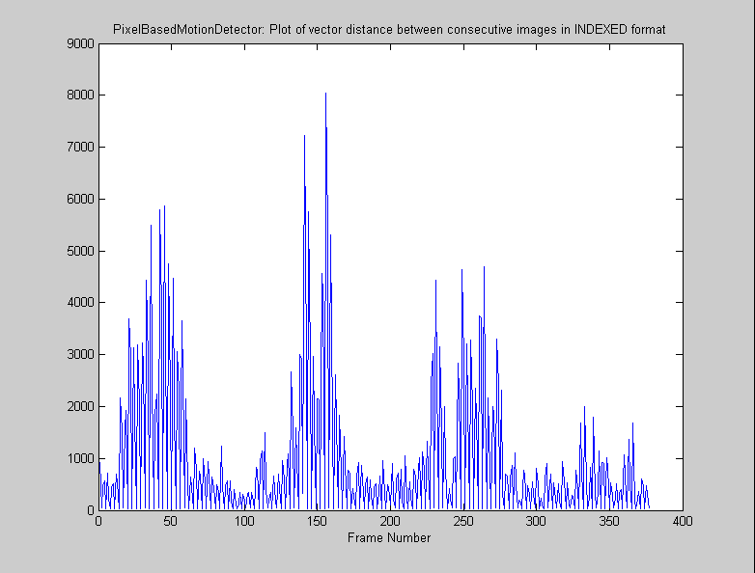

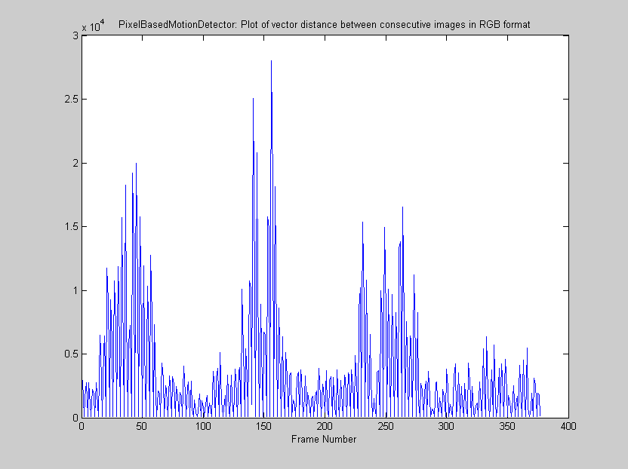

Note: The above plot indicates there were 3 different events where motion occurred in the movie ‘Mov3.avi’. The first group of frames indicates first right arm movement of Rustam, then the second group of frames indicates next right arm movement, and finally the third group indicates left arm movement of Rustam.

Histogram based
[vectorOfShotFrames] = histogramBasedMotionDetector(‘Mov3.avi’,10)

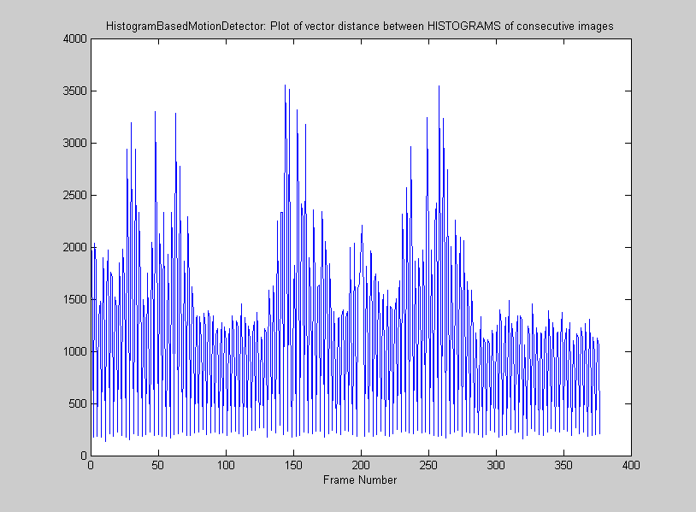

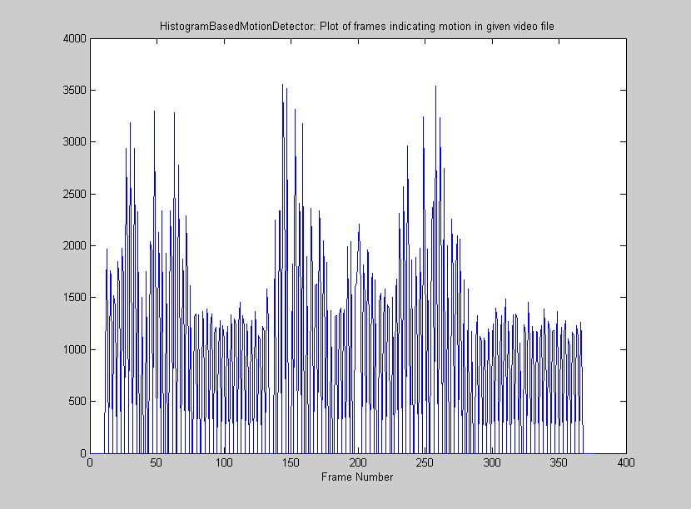

211 out of 377 distinguishing frames obtained with window of 10 frames.

Note: The three groups of frames indicate the similar kind of motion as indicated above by pixel based motion detector.
Hall_monitor.avi

Pixel based
pixelBasedMotionDetector(‘Hall_monitor.avi’)

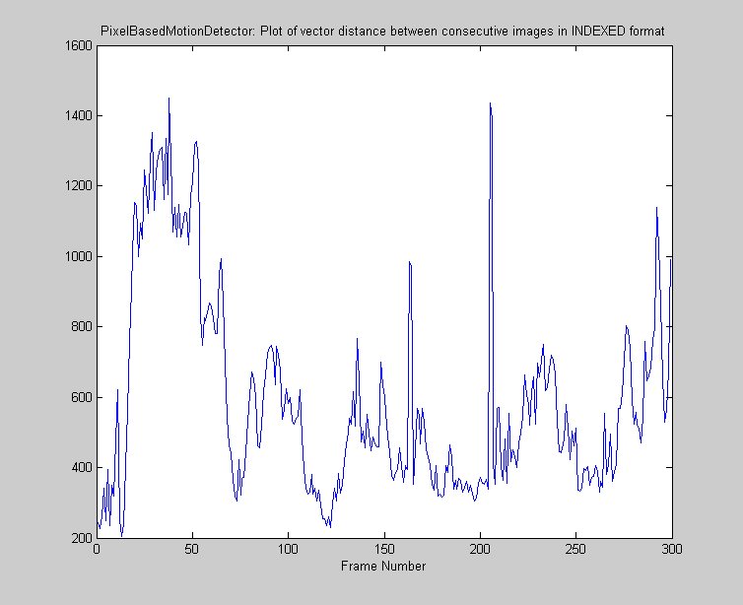

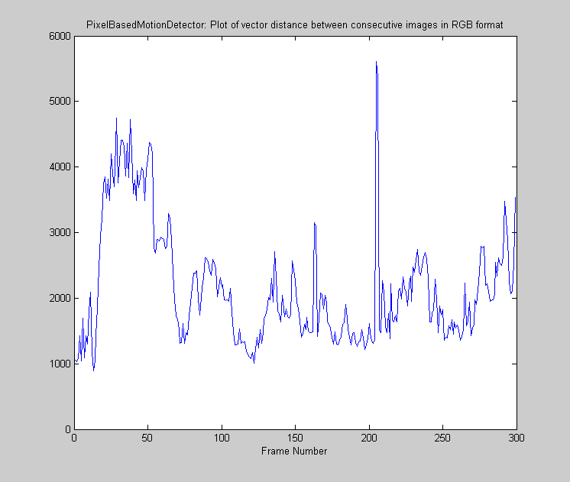

Note: The peaks indicate there was lot of motion in the movie ‘Hall_monitor.avi’ which is true in fact since the two persons in the movie are in non-stop motion through out the movie, one person is moving away from the camera view whereas the other person is coming towards the camera view.

Histogram based
[vectorOfShotFrames] = histogramBasedMotionDetector(‘hall_monitor.avi’,10)

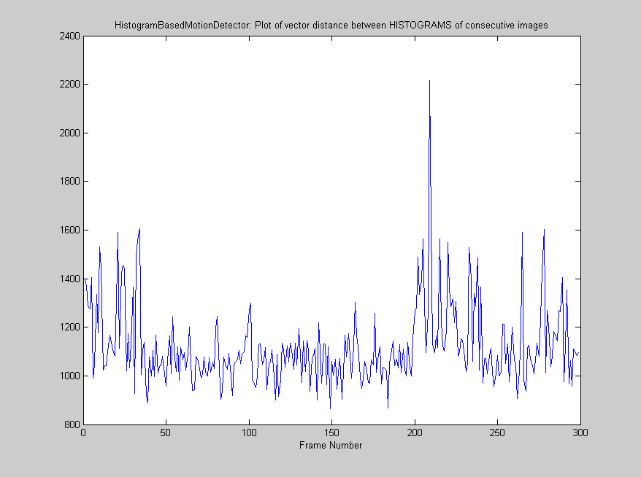

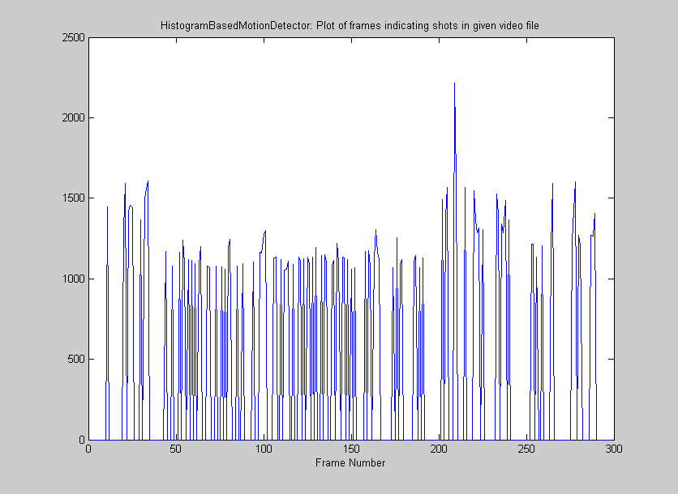

106 out of 300 distinguishing frames obtained with window of 10 frames.

Observation:
The pixel based motion detector seems to perform better relatively to the histogram based motion detector.

Conclusion:
In the histogram based motion detector, we only take into account the intensity distribution for a frame of the movie, while the spatial distribution of the pixels in the frame is not all considered in this method. Hence, when we take the difference of histogram distribution of two consecutive frames, we lose the spatial distribution information while just maintaining the intensity distribution. In the pixel based method, when we take the difference between two consecutive frames, both the intensity difference information as well as spatial information (pixel-wise location) is maintained. This results into better performance of pixel based motion detector as compared to the histogram based method.

Example:
Consider a simple scenario where background image consists of a room with white colored wall. A person in white garment enters the room, performs some activity and then exits from the camera view. Pixel based motion detector easily detects this motion (depicted with security1.avi experiment above) where spatial information is maintained along with intensity difference of the consecutive frames, whereas histogram based method finds it difficult to detect the motion of the person entering the camera view, since the color of the person’s garment is white which is same as the background image (that consists of white wall). The histogram count is increased because of contribution of similar intensity levels from the person’s garment and background image (wall). This histogram distribution persists till the person is in the room and so in the above experiment of security1.avi using histogram based, we see lot of widely spread peaks spanning the range of frames that consist of the person. Therefore histogram based motion detector has performance drawbacks as it is unable to store spatial information.

Note: The histogram based motion detector has shown good results in the experiment on ‘Mov3.avi’. This is because the object in motion has different color intensity distribution as compared to the one in background, and hence histogram based method performs comparatively equally well in such scenarios where it can differentiate between histogram distribution of object in motion and that of the background.

Reliability: The pixel based method seems to be quite sufficient for detecting motion in simple videos (like the toy videos used in our experiment). For more realistic applications (like in security systems, to detect any intruder) one can make use of the concept of “Key frame detection using Discrete Curve Evolution algorithm” which is another topic on its own.

