Comparison of Methods
Of
Motion Detection
in Video

CIS750
Graduate Seminar in CIS
Video Processing and Mining

submitted by:
Ken Gorman
3 March 2003

Objective:
The objective of the problem was to attempt to detect motion in a video sequence by using both pixel-based image difference and histogram-based image difference. Further, an analysis and comparison of the results is supplied.

Problem Description:
There currently exist several different methods for detecting motion in video. This assignment attempted to compare and contrast two classes of motion detection algorithms: pixel based and histogram based.

Pixel Based Methods:
A discrete image is a function of two variables that take values over a discrete set (an integer grid)
E.g.: The intensity of a discretized 320 x 240 photographic image is 2D function f (i, j) of two integer-valued variables i and j.
Thus, f can be represented as a 2D matrix I[320,240]
A color image is usually represented with three matrices:

Red[320,240], Green[320,240], Blue[320,240]

In order to determine whether motion is occurring in the video, it is common to compare subsequent frames in a video sequence. The amount of change between each successive frame is used as an indicator of motion. By setting a threshold, one can determine where motion occurs if the amount of change between successive frames exceeds this threshold.
Several pixel based methods were presented, each with their own unique strengths and weaknesses.

In the formula below, the Euclidean distance is defined. Let f and g be two gray value image functions, then the Euclidean distance between two successive frames (f and g) is defined as follows:

Equation 1- Euclidean Distance
One can refine the formula above in order to get better precision in detecting motion in videos. Alternatives are presented below. In order to save computational time, one can use the “Manhattan” distance. Similar to the Euclidean distance but not requiring a square-root calculation, the Manhattan distance is favorable because of it low computational complexity.

Let a and b bet two images of size w x h.
Let c be some image characteristics that assigns a number to each image pixels, e.g., c(a,x,y) is the gray value of the pixel.

$$\begin{aligned}\text{pd}1(a,b)=\sum_{x=1}^{w}{\sum_{y=1}^{h}{|c(a,x,y)−c(b,x,y)|}} \\ \text{pd}2(a,b)=\sum_{x=1}^{w}{\sum_{y=1}^{h}{(c(a,x,y)−c(b,x,y))^{2}}}\end{aligned}$$

Equation 2 - Alternate Methods

If there is a desire to add a level of stability to the above methods, various refinement can be made to the above formulas.
$$\begin{aligned}\text{spd}(a,b)=\sqrt{\text{wh}}\frac{\overline{d(a,b)}}{s_{d}(a,b)} \\ \overline{d(a,b)}=\frac{1}{\text{wh}}\sum_{x=1}^{w}{\sum_{y=1}^{h}{d(a,b,x,y)}} \\ s_{d}^{2}(a,b)=\frac{1}{\text{wh}−1}\sum_{x=1}^{w}{\sum_{y=1}^{h}{(d(a,b,x,y)}}−\overline{d(a,b)})^{2} \\ d(a,b,x,y)=c(a,x,y)−c(b,x,y)\end{aligned}$$
Equation 3 - Statistical Refinement
Histogram Based Methods:
Histogram based methods are an alternative to using pixel-based methods. Whereas pixel based methods compare a specific pixel in one frame with a corresponding pixel in a successive frame, histogram based methods are location independent. A value is assigned to the histogram color signature of a frame based upon its color histogram. The explanation is that successive similar frames will contain approximately the same color information and similar frames will have a similar histogram. Please note that dissimilar frames “may” have similar histograms.

Let c be some image characteristics and h(a) its histogram
for image a with k histogram bins.

$$\begin{aligned}\text{hd}1(a,b)=\sum_{i=1}^{k}{|h_{i}(a)−h_{i}(b)|} \\ \text{hd}2(a,b)=\sum_{i=1}^{k}{(h_{i}(a)−h_{i}(b))^{2}} \\ \text{hds}(a,b)=\sum_{i=1}^{k}{\frac{(h_{i}(a)−h_{i}(b))^{2}}{\text{max}(h_{i}(a),h_{i}(b))}}\end{aligned}$$
Equation 4 - Histogram Based Methods
Configuration

Case Study
Working with Matlab Release 12 running on a Microsoft 2000 Professional machine, a video application was created that analyzes a stored video clip and identifies the frames in which motion is detected.

Through the use of the Matlab Image Processing Toolkit, a series of supplied test video sequences, an application was developed that created graphical representations of both pixel and histogram based motion detection algorithms.

Learning Process
The creation of the motion detection programs involved primarily the rapid learning of Matlab and various portions of it, including:

- Matlab image processing toolkit and associated functions.
- Ability to have Matlab generate C language files and Dynamic Link Libraries (DLL). The C source files could be compiled into a Microsoft Visual Studio project in order to increase performance. The user could opt to create a DLL which would allow the user to create a more feature rich user interface using the Visual Studio tools while still retaining the functionality of Matlab.

The following tools/utilities were utilized during the creation of the Video motion detection application:

Microsoft Visual Studio 6.0
The Visual Studio 6.0 development suite is a comprehensive developer productivity tool allowing development of applications across all the popular languages. Visual Studio 6.0 Professional Edition includes the complete set of development tools for building reusable applications in many high level languages, including C++. It provides easy integration with the Internet and a full Web page authoring environment.

Implementation/Deployment
The creation of the application involved several parts.

File Reading and Conversion

A sample Matlab .m file was supplied which converted an .avi video file into individual bitmap (.bmp) files representing individual frames of the original video. The frames were distinguished by appending their frame number to their filename, for example:

framedump_1.bmp
framedump_2.bmp
framedump_3.bmp

Because the file conversion from a video into individual frames was time consuming, it was decided to use the Matlab save and load functions.

Description of save and load:
save by itself, stores all workspace variables in a binary format in the current directory in a file named matlab.mat. Retrieve the data with load. MAT-files are double-precision, binary, MATLAB format files. They can be created on one machine and later read by MATLAB on another machine with a different floating-point format, retaining as much accuracy and range as the different formats allow. They can also be manipulated by other programs external to MATLAB.

Source Code:

Convert Video Source:
%Convert from avi file to BMP file
function noOfFrameImages=ConvertVideo(aviFileName)
%extact frames from video and output them as bmp files
movieObj = aviread(aviFileName);
noOfFrameImages = size(movieObj,2);

for count=1:1:noOfFrameImages
global imageFileNamePrefix
imageFileNamePrefix = 'bmp\framedump_';
fileName = strcat(imageFileNamePrefix,num2str(count),'.bmp');
imwrite(movieObj(count).cdata,fileName,'bmp');
end

return;

Detect Motion:
function []=DetectMotion(aviFileName)
%Ken
i = ConvertVideo(aviFileName);
global imageFileNamePrefix
Histogram = CalculateHistogram(imageFileNamePrefix,i);

% plot the result
figure; plot(Histogram(:,1),Histogram(:,2));
xlabel('Frame Number'); ylabel('Histogram Values');

return;

Calculate Histogram Motion:

function [featureA] = CalculateHistogram(imageFileNamePrefix, frame_num)

featureA = [];
% read first frame
fileName = strcat(imageFileNamePrefix,num2str(1),'.bmp');
im = imread(fileName);
imd = rgb2gray(im);
[n1, xnum1] = imhist(imd);

for i = 2: frame_num
fileName = strcat(imageFileNamePrefix,num2str(i),'.bmp');
im = imread(fileName);
imd = rgb2gray(im);
[n2, xnum2] = imhist(imd);
var = (n2-n1).*(n2-n1); %Element-by-element multiplication
var = sum(var);
d = sqrt(var);
featureA = [featureA; i d];
n1 = n2;
end

return;

Sample Videos:
Three sample videos were used to test the algorithms. Each video presented its own unique challenge to the detection of motion.

Name | Description | Size (Mb) | Resolution | Frames | Rate (kb/sec)
mov3.avi | bumpy camera, medium picture quality, not much color shifting between frames. | 1.54 | 320x240 | 378 | 105
security1.avi | steady camera, low picture quality, image compression has several artifacts in the video with some color shifting between frames | .51 | 160x112 | 387 | 33
security7.avi | bumpy camera, low picture quality, image compression has several artifacts in the video with some color shifting between frames | .55 | 160x112 | 387 | 35.4

Table 1- Video Characteristics

Results Summary

Histogram Based Motion Detection
The Histogram Based Motion Detection algorithms outperformed the Pixel Based Motion Detection algorithms in several cases, including videos captured with non-steady cameras. The histogram algorithms performed extremely well when the level of compression wasn’t extremely high. The sample video mov3.avi was approximately 1.5 megabytes and was encoded at 105 Kb/sec – more than triple the encoding rate of the other videos. Because of this, the color information from frame to frame didn’t fluctuate as much as the other two videos.
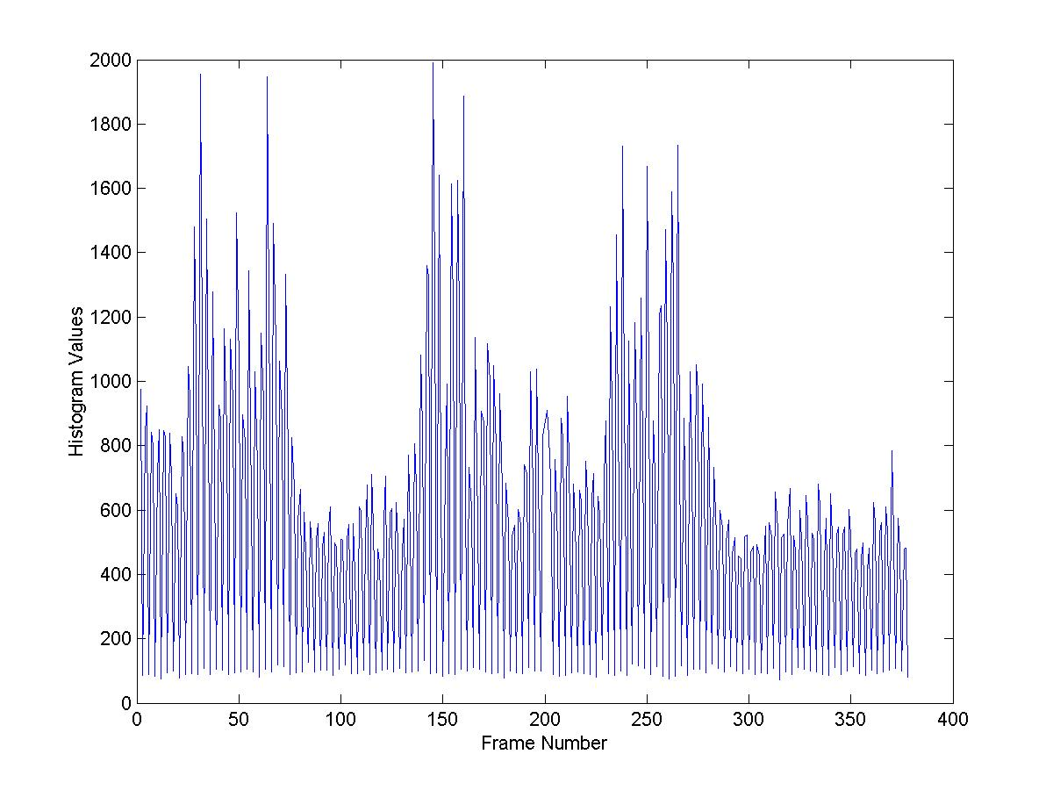
Figure 1 - Histogram Values - mov3.avi
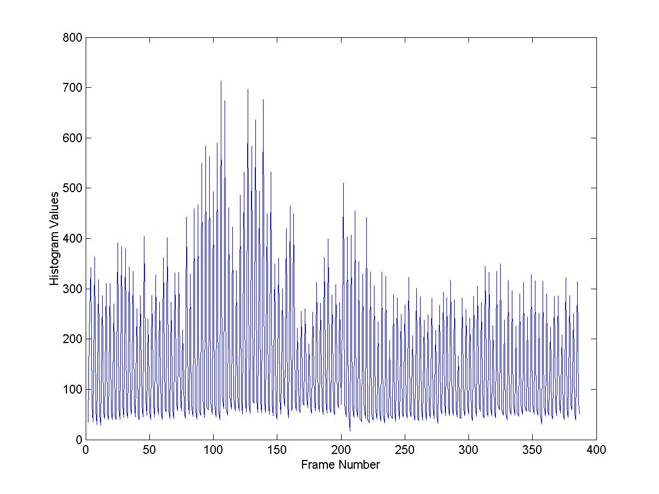
Figure 2 - Histogram Values - security1.avi
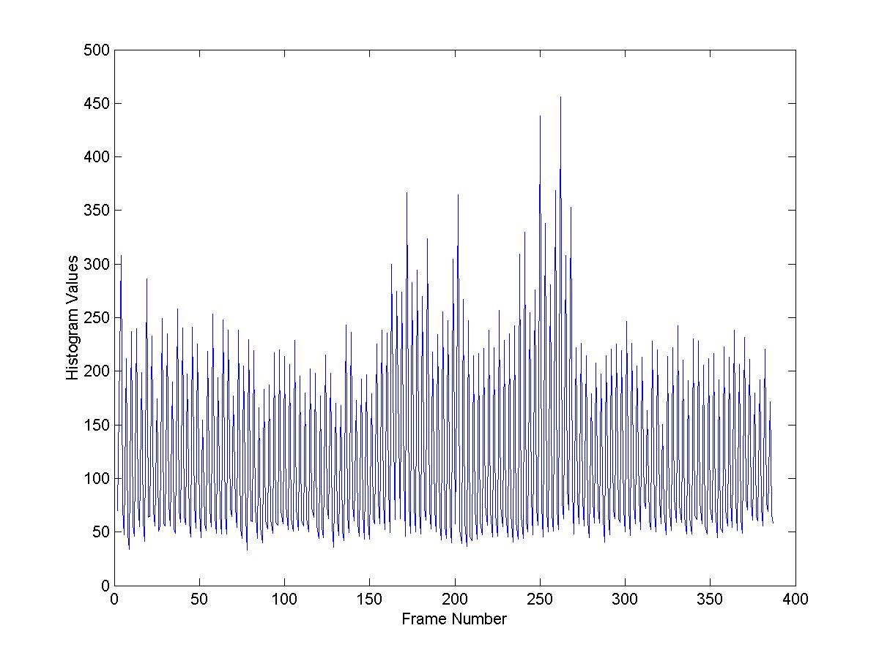
Figure 3 - Histogram Values - security7.avi

Pixel Based Motion Detection
The results showed that Pixel Based Motion Detection was susceptible to motion in the camera. Even if there was no motion per se in the video, if the camera wasn’t steady, the pixel based methods would give false-positives. Pixel Based motion detection seems appropriate for security surveillance where a camera is held in a fixed position with a steady mount. For other applications, i.e. security with a camera that pans and zooms, the pixel based algorithms are less adept at determining motion.

Areas For Improvement
Currently, the program only works with .avi (Audio Video Interleave) files. The author could not find other supported functions to read in other video formats, however, user supplied functionality that supports reading and writing of mpeg streams can be found here:
www.mathworks.com/matlabcentral/fileexchange/loadFile.do?objectType=file&objectId=308

Future Research
tbd

