Jim:
What are the three major methods for image similarity, and discuss for each one how it works?

Sumit:

How is Principle Component Analysis used for Image Description and Data Compression? What is the Principle Components Transform?

What is Cluster Analysis? How is the Mahalanobis Distance between 2 points calculated? Describe the basic method for K- means Clustering.

Archana:
1. What are the common image points distance measures? Give two examples.

2. Give an image below before (left) and after (right) a smoothing filter was applied. The size of the filter is shown as a small square in the upper-left corner in the image (as you can see, its size is rather small compared to the image size). In your opinion, which one of the following filter types most likely produced the image on the right:
1) Mean (unweighted averaging) filter or
2) Median filter
Explain your answer.

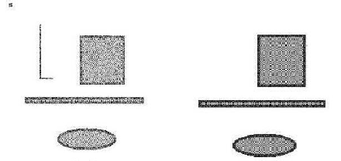

Original image smoothing mask size Smoothed image
is shown in the upper left

3. What do you understand by the term histogram equalization? You have applied histogram equalization to an image. If you apply histogram equalization to an image second time, will you improve image quality even more? Explain your answer.

More questions:
- Given a rectangle: (0,4), (0, 10), (2,4),(2,10). Provide formulas that rotate it by 45 degree around its centroid (1, 7). Use the homogenous coordinate system.
- Provide a definition of discrete convolution. Why it is a linear operation on images?
- Give examples of nonlinear image filters. Why are they called nonlinear?
- Explain Kirsch or Robinson Compass edged detectors.
- Given are 20 face images of size 30x30. What is the size of the covariance matrix used to compute the eigenfaces? What is the size of the projection matrix composed of first 10 eigenvectors?
- Describe k-means clustering. What is bisecting k-means.
- Describe k-medoid clustering.
- Describe hierarchical clustering.
- What cluster quality measures are used, e.g., cohesion and separation.
- Describe image segmentation by clustering in the color space?
- Describe an iterative algorithm to find a threshold for a gray level image histogram with a bimodal histogram.
- Describe template matching by correlation.
- How we compare shape of two objects using Hausdorff distance?
- How we compare shape of two objects using chain code?
- How we compare shape of two objects using shape signatures?

A third set of questions:
1. Provide a definition of a 4 (8)-connected set in a digital image.
Give an example of an 8-connected digital set that is not 4-connected.
Give an example of a 4-connected digital set that is not 8-connected.

2. Give an example of a 3x3 mask for image smoothing. Outline an algorithm for image smoothing that uses this mask.

3. Provide a set of 3x3 operators for edge detection that yield not only edge magnitude but also determine the edge direction.

4. In a binary image (objects represented by 1s and the background represented by 0s), there is noise in form of small blobs that contain at most three ones.
Which filter(s) can we apply to eliminate these blobs, i.e., change their values from 1 to 0? Describe an algorithm that uses this filter(s).

5. Design an algorithm to find the letter “L” given by the following template in a gray value image of size 100x100 with 256 gray values (0 is black, 255 is white).

0 | 255 | 0
0 | 255 | 0
0 | 255 | 0
0 | 255 | 255

6. This question has three parts.
6.1 Please insert the values in the schemes below for
a) Blurring Filter b) Edge Filter (e.g. Laplacian) c) A Filter that does NOTHING (identity)

a | b | c

6.2 The following pictures show typical results of filtering with Blurring, Sobel, Laplacian. Please assign the filter-name to each picture.

 | 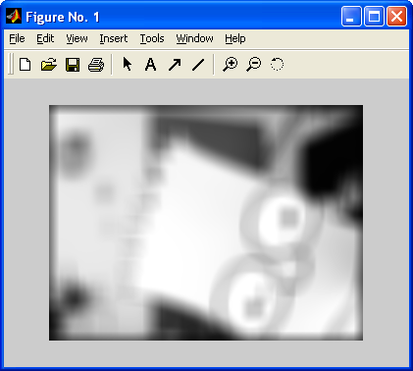 | 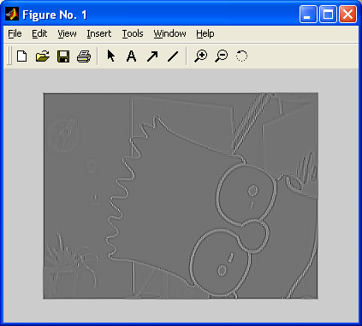
a | b | c

6.3 What would the following filters do ?
0 | 0 | 0
0 | 0 | 0
0 | 0 | 0

0 | 1 | 0
0 | 0 | 0
0 | 0 | 0

0 | 0 | 0
0 | 1 | 0
0 | 0 | 0

7. ‘Salt and Pepper Noise’ are black and white (max. values!) spots on the image.
Is it a good idea to use a blurring filter to reduce this kind of noise?
Which filter could be more effective and why?

8. Please compute the results for median and average filtering for the gray-shaded pixels in the following picture, using the 3x3-neighborhood. Give a definition for both filters.

1 | 4 | 3 | 7
4 | 2 | 7 | 5
6 | 8 | 9 | 6

Median:

Average:

9. Define morphological closing. Sketch a constellation of 4 pixels, where the morphological closing using the structural elements A and B shows a different result:

A | B
  1 | 1 | 1
  1 | 1 | 1
  1 | 1 | 1
   | 1
  1 | 1 | 1
   | 1

