Image Segmentation using clustering
(Texture with PCA)

By
Vasudha Anugonda

Project description:

Summary:

This project deals with image segmentation using clustering based on textures.
A central problem, called segmentation, is to distinguish objects from background. This is used in many fields such as medicine and biology. Image segmentation has come a long way. Using just a few simple grouping cues, one can now produce rather impressive segmentation on a large set of images.
For intensity images (i.e., those represented by point-wise intensity levels) four popular approaches are: threshold techniques, edge-based methods, region-based techniques, and connectivity-preserving relaxation methods.
Threshold techniques, which make decisions based on local pixel information, are effective when the intensity levels of the objects fall squarely outside the range of levels in the background. Because spatial information is ignored, however, blurred region boundaries can create havoc.
Edge-based methods center around contour detection: their weakness in connecting together broken contour lines make them, too, prone to failure in the presence of blurring.
A region-based method usually proceeds as follows: the image is partitioned into connected regions by grouping neighboring pixels of similar intensity levels. Adjacent regions are then merged under some criterion involving perhaps homogeneity or sharpness of region boundaries. Over stringent criteria create fragmentation; lenient ones overlook blurred boundaries and over merge. Hybrid techniques using a mix of the methods above are also popular.
A connectivity-preserving relaxation-based segmentation method, usually referred to as the active contour model, was proposed recently. The main idea is to start with some initial boundary shapes represented in the form of spline curves, and iteratively modify it by applying various shrink/expansion operations according to some energy function. Although the energy-minimizing model is not new, coupling it with the maintenance of an “elastic”' contour model gives it an interesting new twist.

In this project we are using region based segmentation.

This project is mainly implemented in four steps

Step 1:

The image is split into blocks.

Step 2:

PCA is applied on all the blocks and the data set is reduced. This data set can be taken as the one which represents the whole data with the textures.

Step 3:

These values are taken and labeled using a clustering algorithm. In this project I have used K-means clustering algorithm.

Step 4:

The image is reconstructed using the labels of these blocks. The blocks are colored depending on the label and the image contains these colors as blocks

Each step is explained in detail below:

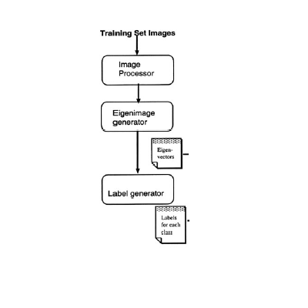

Step 1:

The image is split into blocks using the Matlab function im2col . This function takes the block size as one of the parameters and gives out the blocks as columns in a matrix.

These are sliding blocks. This mean s that each pixel can be represented using a block which contains its neighbors. This neighborhood represents the texture and intensity of the pixel, because in almost all the images the value of a particular pixel depends on its neighbors.

We can usually expect the value of a pixel to be more closely related to the values of pixels close to it than to those further away. This is because most points in an image are spatially coherent with their neighbors; indeed it is generally only at edge or feature points where this hypothesis is not valid. Accordingly it is usual to weight the pixels near the centre of the mask more strongly than those at the edge
In this project we are using region based segmentation so the special features of the edges are not of much importance.

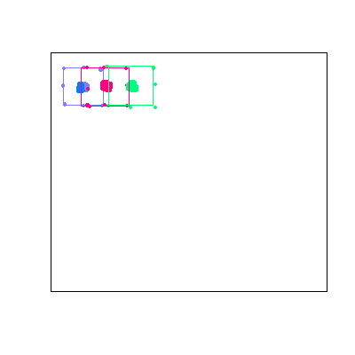

In the above figure we can see that there are three sliding blocks. The pixels for which the neighborhood is considered is shown as a thick pixel. Each color represents the block which also represents the neighborhood of the pixel.

Step 2:

This is the most important module in this project.

This is the part where we find out the statistical values of the blocks which are then used in the next part of the project to segment it.

The PRINCIPAL COMPONENT ANALYSIS also known as Hotelling, or Karhunen and Leove (KL), transform is used to find the patterns in the pictures. These patterns represent textures and these can also be used to represent colors in the image.

PCA is a way of identifying patterns in data, and expressing the data in such a way as to highlight their similarities and differences. Since patterns in data can be hard to find in data of high dimension, where the luxury of graphical representation is not available, PCA is a powerful tool for analyzing data. The other main advantage of PCA is that once you have found these patterns in the data, and you compress the data, i.e. by reducing the number of dimensions, without much loss of information. This technique used in image compression also.

PCA is, at its essence, a rotation and scaling of a data set.

The rotation is selected so that the axes are aligned with the directions of greatest variation in the data set.

The scaling is selected so that distances along each axis are comparable in a statistical sense. Rotation and scaling are linear operations, so the PCA transformation maintains all linear relationships.

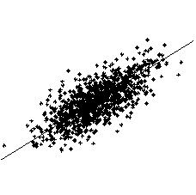

Principal component analysis of a two-dimensional data cloud. The line shown is the direction of the first principal component, which gives an optimal linear reduction of dimension from 2 to 1 dimensions

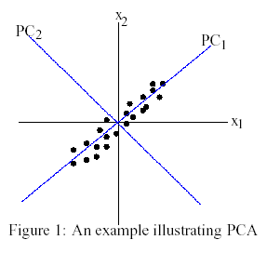

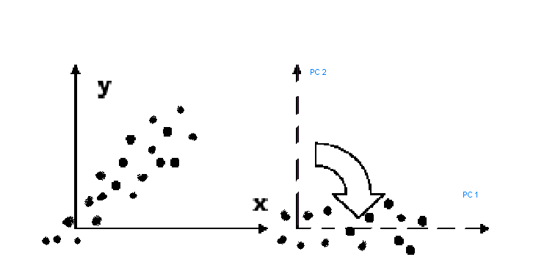

One way to think about PCA is that it generates a set of directions, or vectors in the data space. The first vector shows you the direction of greatest variation in the data set; the second vector shows the next direction of greatest variation, and so on. The amount of variation represented by each subsequent vector decreases monotonically.

Method:

Step 1. Get the data from the image

This is done by taking the first pixel from all the images arranging it in a column. This part is done in the first step of the project, in which we take all the first pixel of all the sub images and arrange them as the first column in a matrix .Next we take the second pixel and arrange it as the second column in the matrix, this is continued until we have all the pixels in all the columns of the matrix.

Step 2 :Subtract the mean:

Take one column of the matrix and subtract from each pixel value, the mean value of all the pixels in that column. Thus ,we get a mean adjusted data , that means that we have data which has a mean of zero.

Step 3 : Calculate the covariance matrix:

For a one dimensional matrix the covariance is defined by

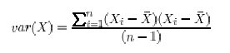
Where X_{i} is the value in the ith value

And is the mean of the column.

Extending it to two dimensions

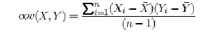>
F or an n dimensional data set, you can calculate

different covariance values.

All these values are stored in a matrix called the covariance matrix .The covariance matrix is a square matrix

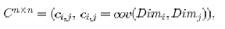

An example:

We’ll make up the covariance matrix for an imaginary 3 dimensional
data set, using the usual dimensions x, y and z. Then, the covariance matrix has 3 rows
and 3 columns and the values are this:

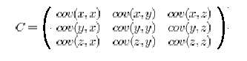

Step 4: Calculate the eigenvectors and eigenvalues of the covariance matrix

We can multiply two matrices together, provided they are compatible sizes. Eigenvectors are a special case of this. Consider the two multiplications between a matrix and a vector in Figure shown below.

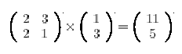

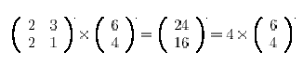

In the first example, the resulting vector is not an integer multiple of the original Vector, whereas in the second example, the example is exactly 4 times the vector we began with.

It is the nature of the transformation that the eigenvectors arise from. Imagine a transformation matrix that, when multiplied on the left, reflected vectors in the line y = x. Then you can see that if there were a vector that lay on the line y =x, it’s reflection it itself. This vector (and all multiples of it, because it wouldn’t matter how long the vector was), would be an eigenvector of that transformation matrix. Eigenvectors can only be found for square matrices. And, not every square matrix has eigenvectors.
And, given an n X n matrix that does have eigenvectors, there are n of them. Given a 3 x 3 matrix, there are 3 eigenvectors.

Eigenvalues are closely related to eigenvectors, Notice how, in both the examples, given above the amount by which the original vector was scaled after multiplication by the square matrix was the same. In that example, the value was 4. Four is the eigen value associated with that eigenvector. No matter what multiple of the eigenvector we took before we multiplied it by the square matrix, we would always get 4 times the scaled vector as our result.

Step 5: Choosing components and forming a feature vector

Here is where the notion of data compression and reduced dimensionality comes into it. If you look at the eigenvectors and eigenvalues from the previous section, you will notice that the eigenvalues are quite different values. In fact, it turns out that the eigen vector with the highest eigen value is the principle component of the data set. In our example, the eigen vector with the larges eigen value was the one that pointed down the middle of the data. It is the most significant relationship between the data dimensions.

In general, once eigen vectors are found from the covariance matrix, the next step is to order them by eigen value, highest to lowest. This gives you the components in order of significance. Now, if you like, you can decide to ignore the components of lesser significance. You do lose some information, but if the eigenvalues are small, you don’t lose much. If you leave out some components, the final data set will have fewer dimensions than the original. To be precise, if you originally have n dimensions in your data, and so you calculate n eigen vectors and eigen values, and then you choose only the first 10 eigen vectors, then the final data set has only 10 dimensions. What needs to be done now is you need to form a feature vector, which is just a fancy name for a matrix of vectors. This is constructed by taking the eigenvectors that you want to keep from the list of eigen vectors, and forming a matrix with these Eigen vectors in the columns.

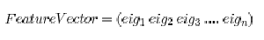

This feature vector is the set of vectors we use in our project to represent the data.

Step 6: Deriving the new data set
This is the final step in PCA, and is also the easiest. Once we have chosen the components( eigen vectors) that we wish to keep in our data and form a feature vector, we simply take the transpose of the vector and multiply it on the left of the original data set, transposed.

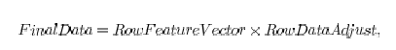

where is the matrix with the eigenvectors in the columns transposed so that the eigenvectors are now in the rows, with the most significant eigen vector at the top, and is the mean-adjusted data transposed, i.e. the data items are in each column, with each row holding a separate dimension.

Basically we have transformed our data so that is expressed in terms of the patterns between them, where the patterns are the lines that most closely describe the relationships between the data. This is helpful because we have now classified our data point as a combination of the contributions from each of those lines.

Say we have 20 sub images. Each sub image is N pixels high by N pixels wide. For each image we can create an image vector. We can then put all the images together in one big image-matrix like this:

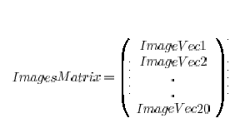

which gives us a starting point for our PCA analysis. Once we have performed PCA, we have our original data in terms of the eigenvectors we found from the covariance matrix.

Since all the vectors are N² dimensional, we will get N² eigenvectors. In practice, we are able to leave out some of the less significant eigenvectors, and the method still performs well.

Performing texture re-synthesis on the image does an improvisation in this technique.

We present a method for analyzing and re-synthesizing in homogeneously textured regions in images. PCA has been used for analytic purposes but rarely for image compression. This is due to the fact that the transform has to be defined explicitly,

PCA produces a transform that is especially adapted to the data it is applied to. Those data are used to determine how each component of a vector (e. g., gray values) correlates with another one. The correlation matrix is used to derive the optimal transform that packs the signal‘s energy into as few coefficients as possible.

The PCs have an inherent natural interpretation in that they span the data space with base vectors in order of decreasing importance. A popular application of PCs is face recognition. The first and most important PC can be interpreted as an average face that is ‚switched on‘ to a certain degree using the first coefficient. The subsequent components of a data vector describing a face add additional characteristics to it so that they further characterize the specific appearance of ears, nose or mouth, some of them possibly at the same time. Based on a training set of faces the PCA can extract the typical characteristics of a face into a significantly smaller number of coefficients than the number of image pixels of a facial image. However, the storage of the covariance matrix can be very demanding since it is of size n*n if n is the number of image pixels. We will see later that it is not necessary to storage the full transformation matrix.

PCA-BASED TEXTURE RESYNTHESIS

Let us consider an image block of a fixed size n*n as a data vector of gray values. Next a correlation matrix is calculated for all n*n gray values.

Following the standard PCA, n * n eigenvectors Ei (which are column vectors) are now computed. Note that E_{i} must be sorted according to their eigenvalues i.e. in declining order.

The resulting matrix    is already the transform that concentrates the energy of an average n * n texture block in the best possible manner. Each texture block in the original image can now be transformed using that transform.

Re-synthesizing texture

The eigen values in the PCA have been sorted according to their magnitude. The resulting coefficients can be interpreted such that the first one is most important for a typical texture block and that the final one is least important.

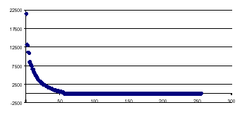

Plot of the 256 sorted eigenvalues of a 16x16 pixel texture block. For typical textures only about ¼ of the eigenvalues are non-zero and thus of a certain importance.

Once the optimal transform T is found, each texture block must be transformed and the resulting coefficients must be stored in turn. T linearly maps the image in the spatial domain to coefficients in the domain defined by T. For each of these n*n coefficients the average value and variance must now be computed.

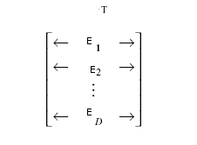

Once this has been done the original image data can be 'forgotten'. The information about the texture is now captured only in the mean value and variance. For a typical texture sample block of about 64x64 pixels, 64 mean values and 64 variance values will be kept. An analysis of the statistical distribution of the coefficients reveals that following a Gaussian distribution all are scattered around a mean value. The re-synthesis of texture blocks can now be done in a straightforward manner. For each of the coefficients a Gaussian distributed random number with its mean value and variance is generated. Using the inverse transform T ⁻¹ such a random vector can then be transformed back into the spatial domain.

Based on the knowledge of the typical distribution of the coefficients, one could evaluate the probability that an image block still belongs to a textured region. Taking into account how likely each of the block’s coefficients meets the Gaussian distribution for that particular coefficient could do this.

Step 3 :

This matrix is given to a clustering algorithm such as k-means which gives a label to each block. The block is colored according the label.

The mat lab already provides the k-means algorithm. But I used a different program, which was provided to us by our professor.

[distance,label,tse] = kmeans1(projX,num_cluster);

projX → the eigen vector matrix , from which only the important ones are taken depending on the eigen values.

Num_cluster → the number of clusters which we specify depending on the image taken.

Distance → matrix, which is returned by the function kmeans1 which contains the distances of the blocks from the cluster centers.

Label → the matrix, which contains the labels of the all the blocks.

Tse → total squared error

The algorithm automatically computer the labels of all the clusters and returns them in the label matrix.

Step 4:

We use these labels to build the image back . Each label is assigned a specific color and thus all those blocks, which are assigned that label, are colored according to the label . All these blocks are then put together to build the segmented image.

Results :

Some of the results are shown

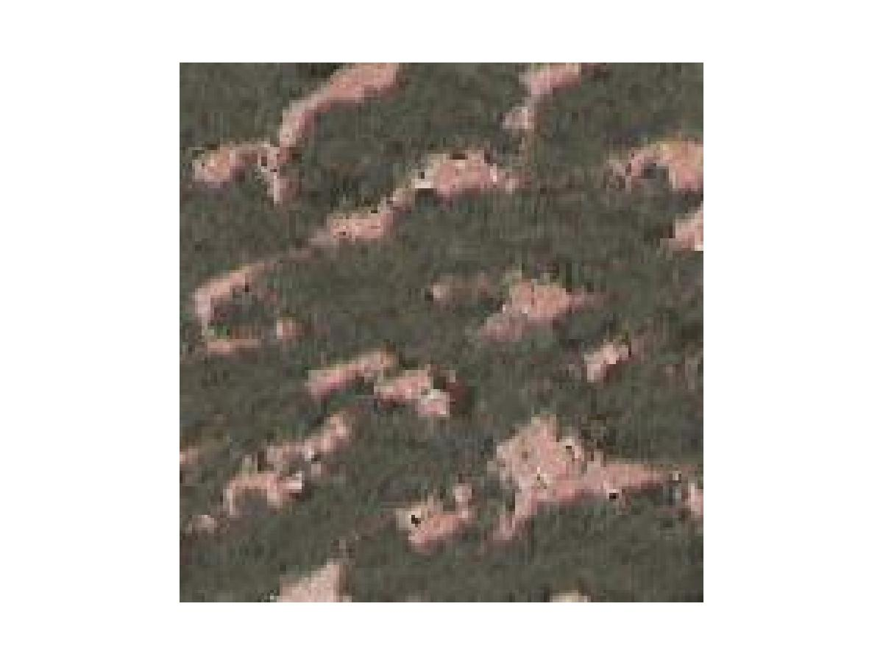

Original image
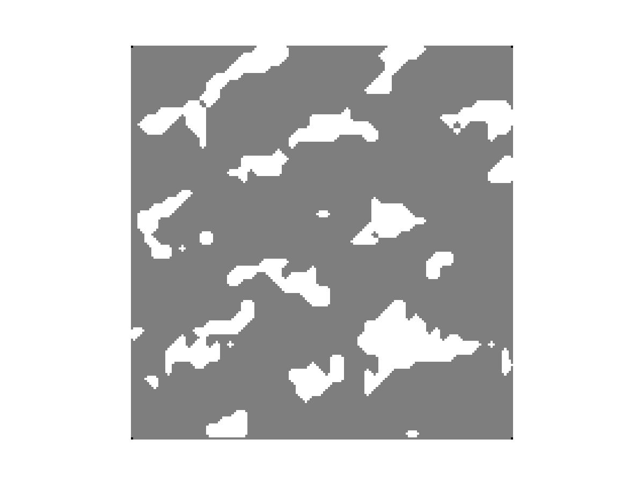
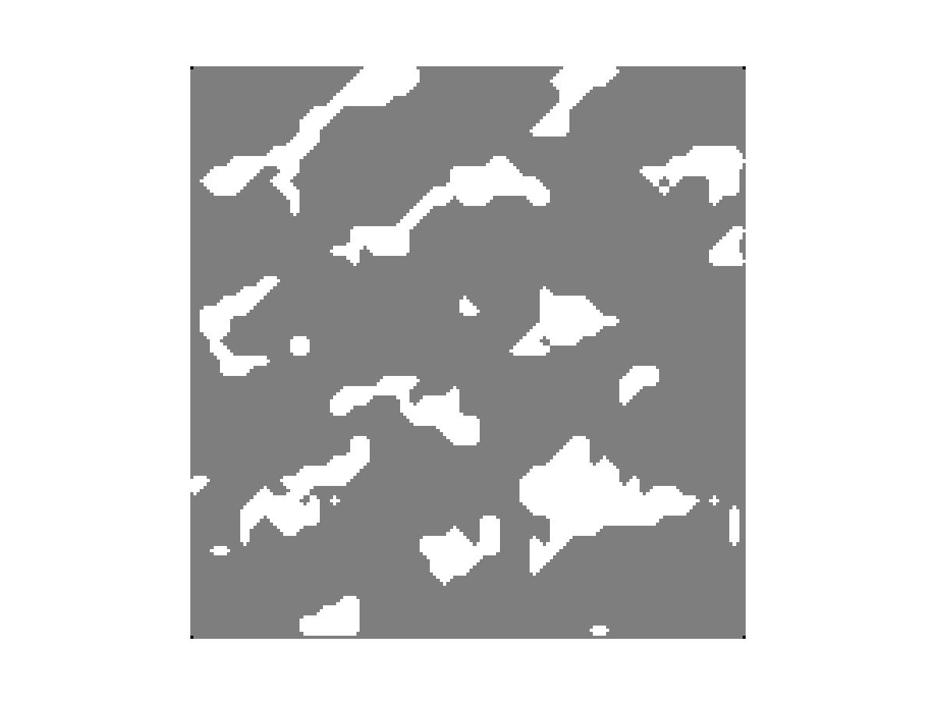

image which is segmented using PCA image which is segmented
after resynthesis

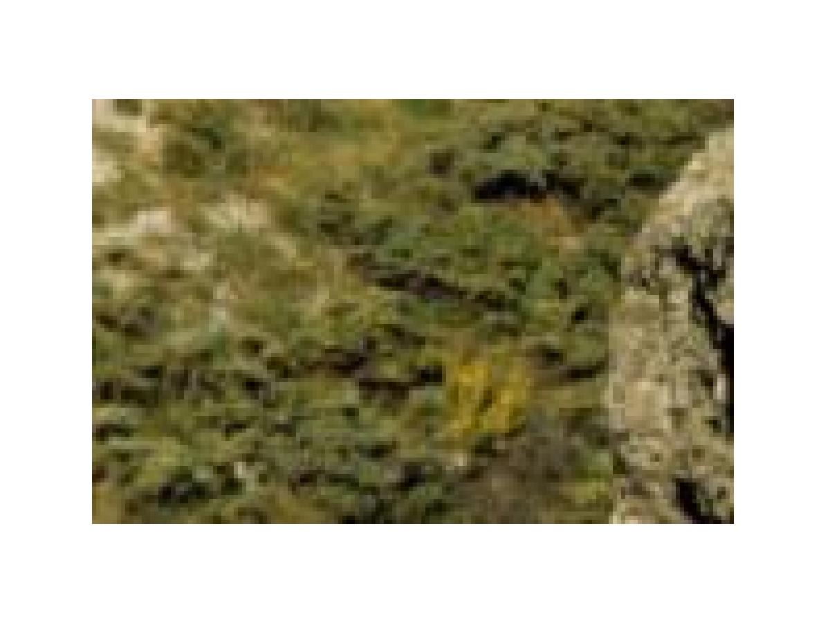

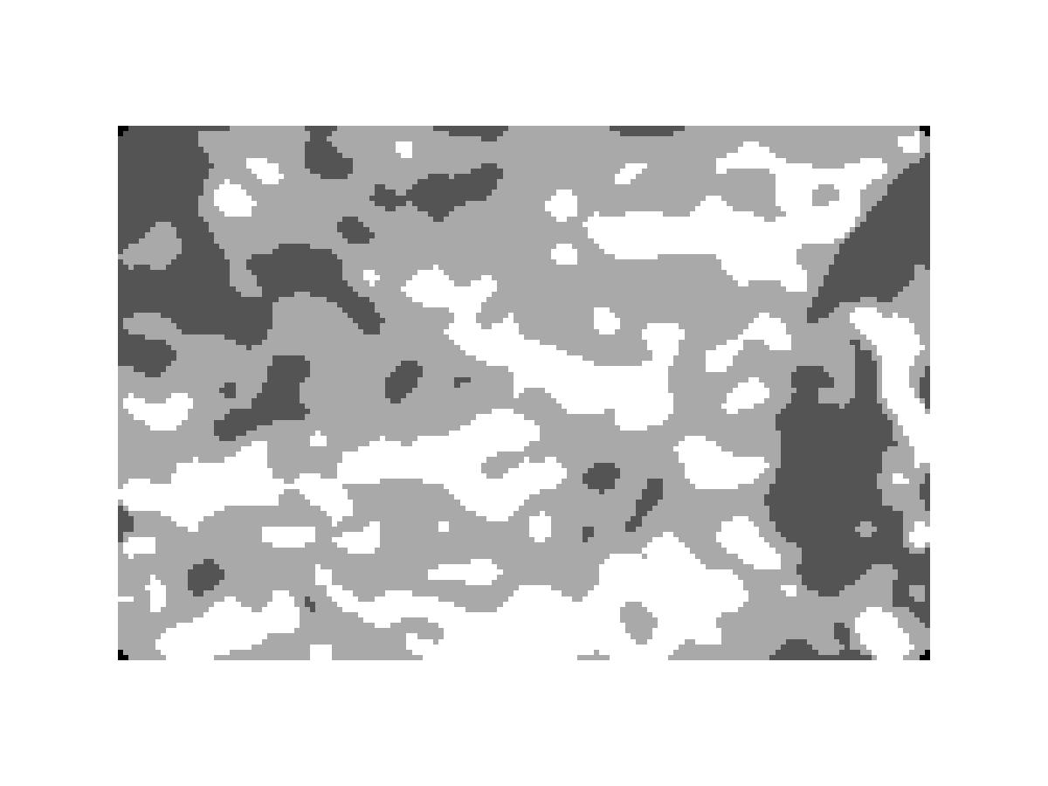

Original image

Image which is segmented
after resynthesis

But PCA doesn’t help us in some of the cases.

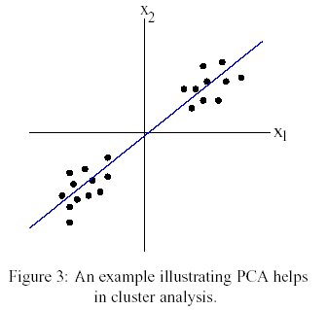

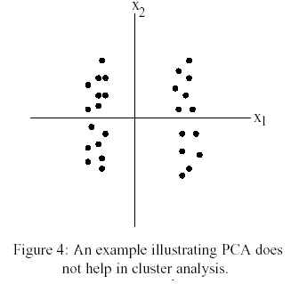

An example is shown below

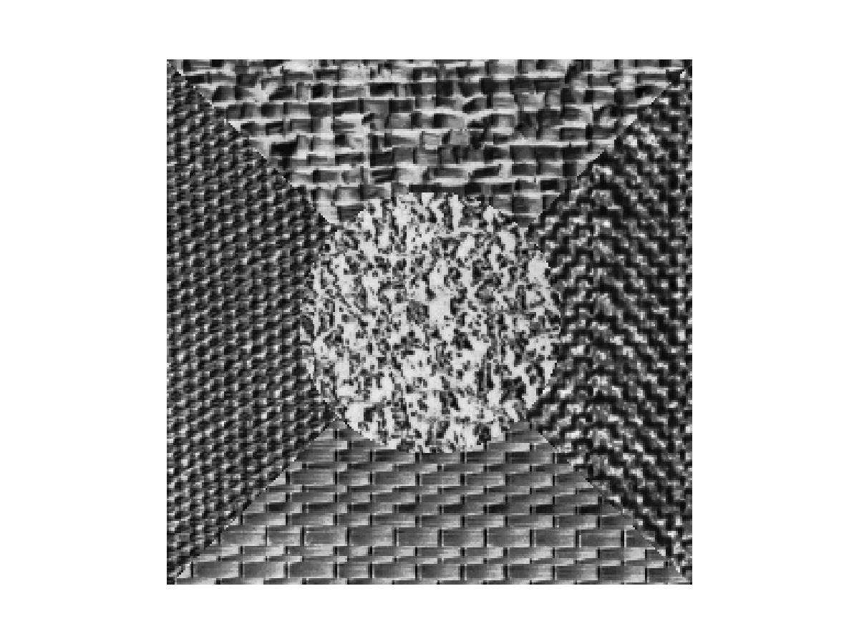

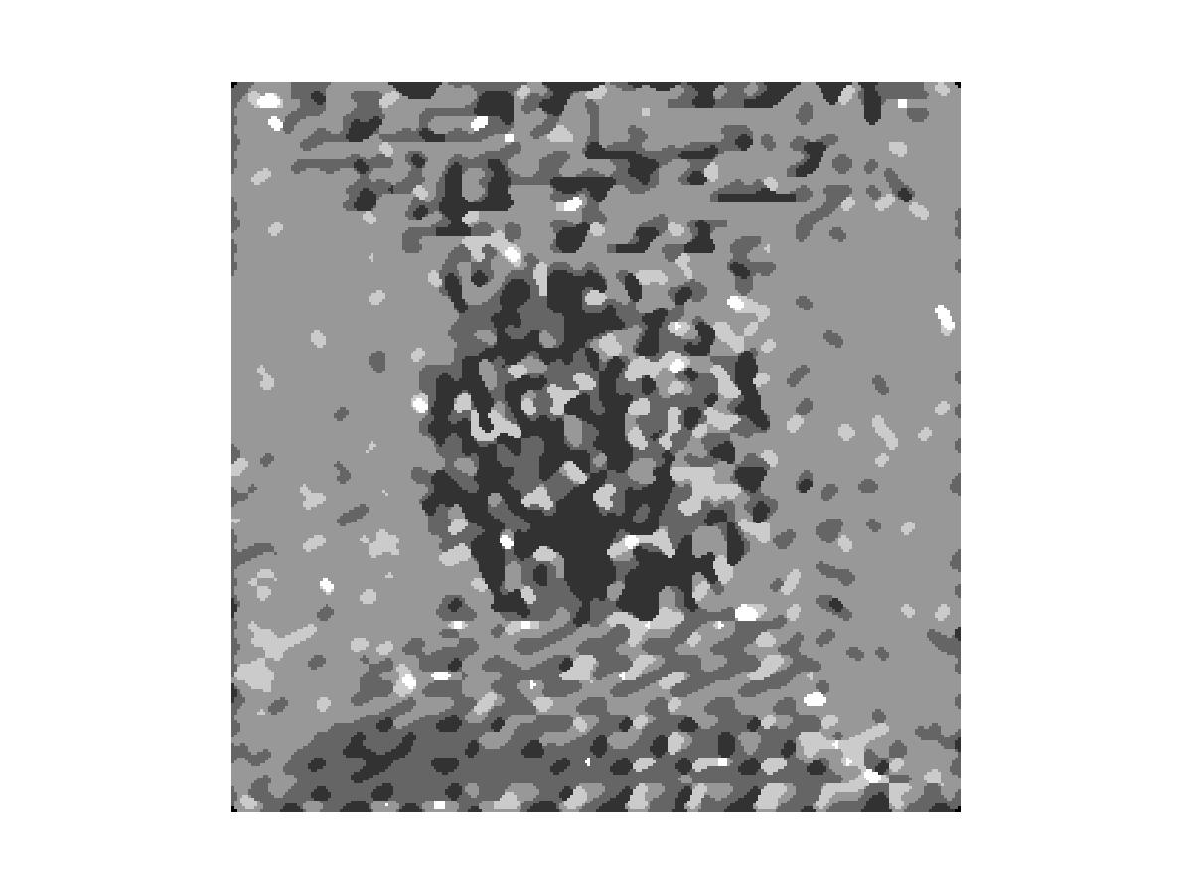

We observe that the image is segmented , but we cannot distinguish regions clearly .

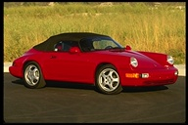

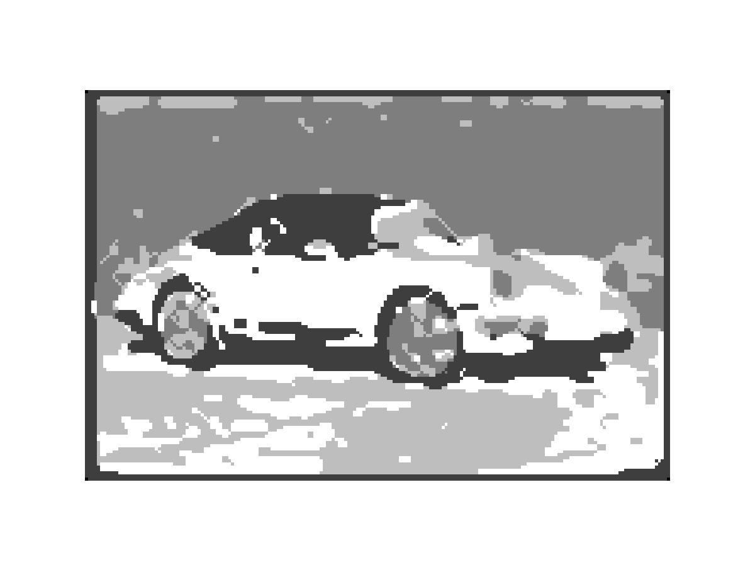

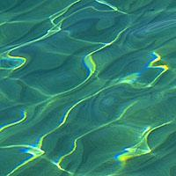

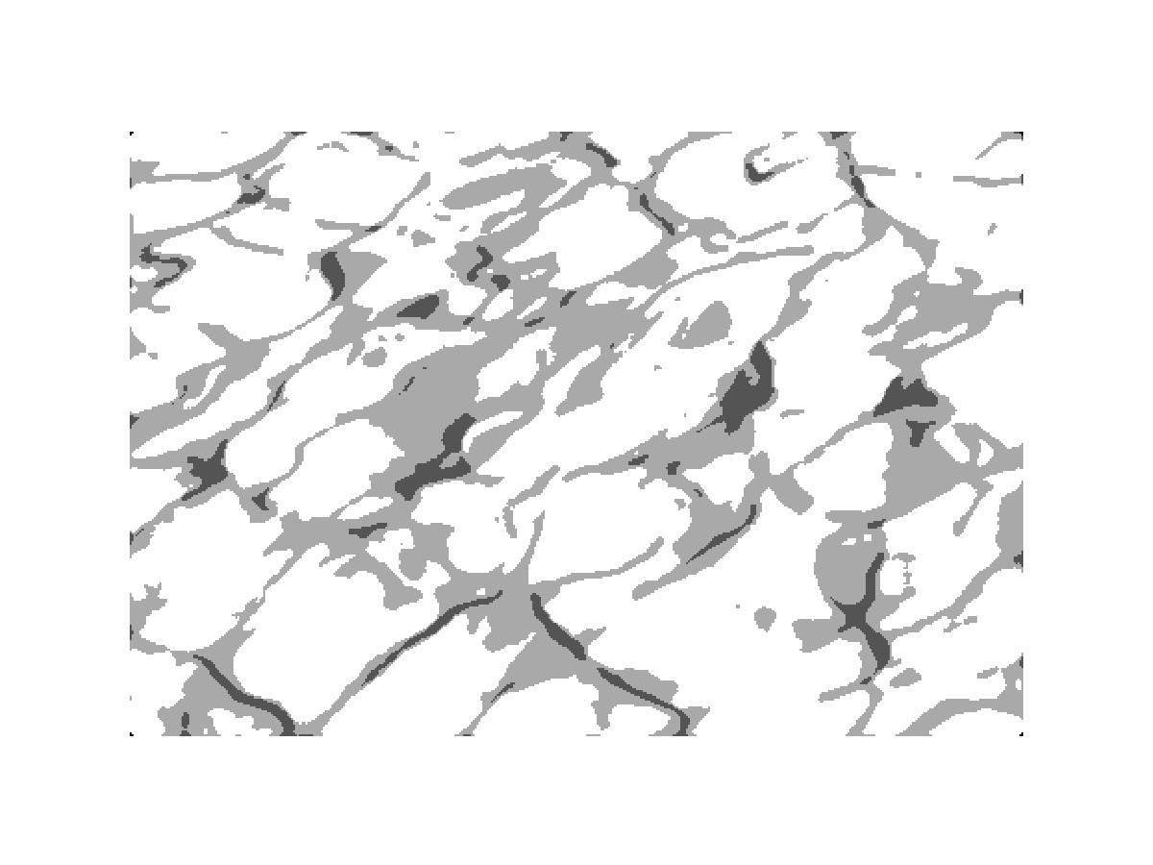

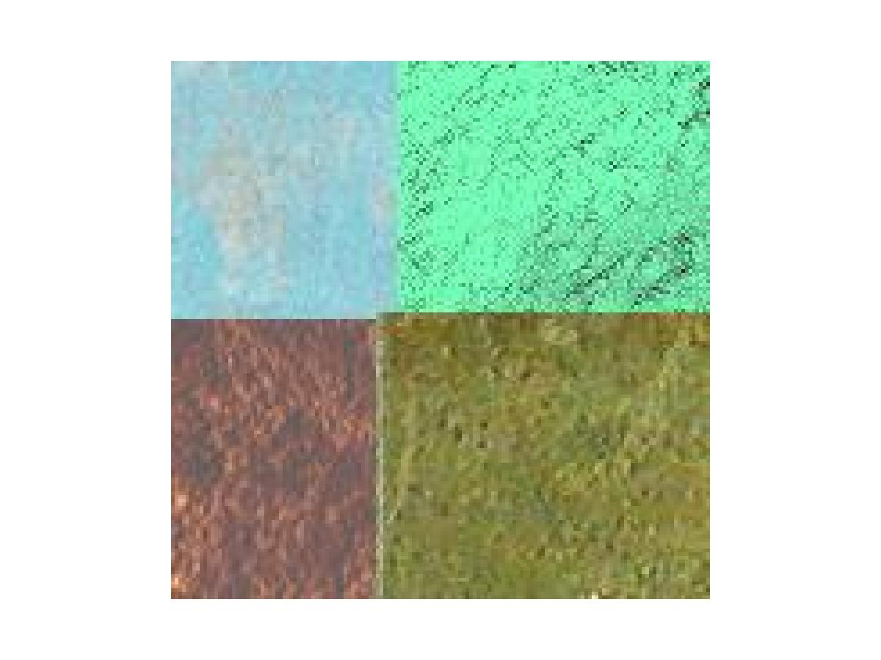
PCA fails sometimes because of the texture similarity , but difference in color values.



We see that even though we use 4 clusters to represent the segmented image , it is not properly segmented because the green and blue blocks have the same texture.

Conclusions :

1)PCA performs image segmentation based on the patterns of values in the image. This pattern represents texture.

2)This pattern can also represent color , hence this segmentation can be used for segmentation based on color

3) The whole program depends on the clustering algorithm used.

4)The re-synthesis of textures using gaussian distribution can be used as an image enhancement technique.

5) Using texture re-synthesis and PCA together produces a good segmented image.
6)This can also be used to transmit images in a compact form.

