Tom McGrath
CIS 601, Fall 2004
Temple University

Object Recognition

Introduction:
This paper is a report for a project on object recognition, as presented in class. The project includes a presentation in Microsoft powerpoint format, this report, three matlab programs, and a supply of sample images. The three matlab programs perform different tasks concerning object recognition: histograms, template matching with correlation, and structural analysis. The goal of the program experiments is to realize the ability of current object recognition techniques to find similar objects when input is entirely in image form. As it turns out, barring natural language descriptors from an object recognition approach creates significant limitations.

Conclusions:
Object recognition techniques used today require a controlled environment. The theoretical limitations of object recognition using computer algorithms are very vague, and considering the fact that the limitations of humans ability for object recognition is still yet to be realized, there are many unanswered questions. This makes object recognition, otherwise called pattern recognition, a live research topic.
Having experimented with the various object recognition techniques available in matlab’s image processing toolbox, I’ve found that the problem of automatic extraction and definition of objects given any input image is well beyond the various approaches used for something application specific. As a result, I conclude that the best approach to implement an image search engine requires that humans maintain the database of images, assigning each image to the object classes of the objects it contains. This way, we can take input as text, and reduce the problem of object searching to searching a tree.

Program Description and Methods:
There are three matlab programs supplied with this project: HistSearch.m, ObjectSearch.m, and BoundarySearch.m. I will discuss their details separately.

HistSearch.m:

This program is used to show images and their corresponding histograms. Since preliminary analysis showed that this approach is ineffective when the target object in an image is a small subset of the image, or when there is too much noise, I never adapted this program to perform statistical analysis and find best matching histograms. As the user of this program can see, the histograms of the various images supplied show almost no similarity whatsoever, so having the computer attempt to match them would be futile.
The design of the program is simple:
For all images used in programs {
Display image and pause;
Display histogram and pause;
}
This program, like the others, require that the ‘source’ images supplied with the program are in the current directory, and that the ‘target’ images are in their respective directories: coins, flowers, and stapler off of the current working directory.
Some program results follow:
Sample A:
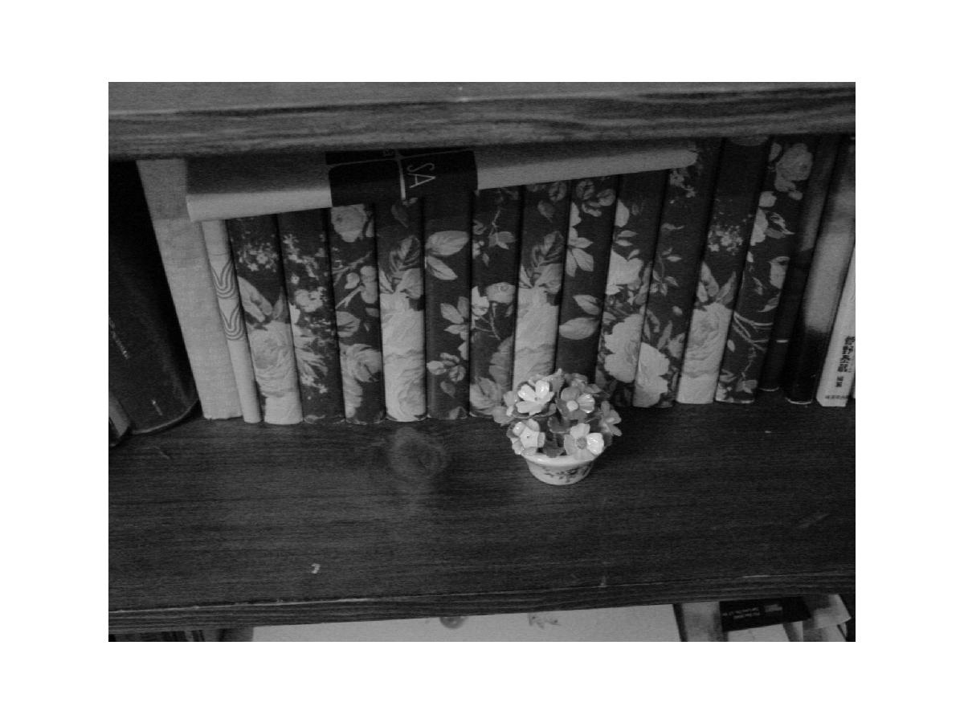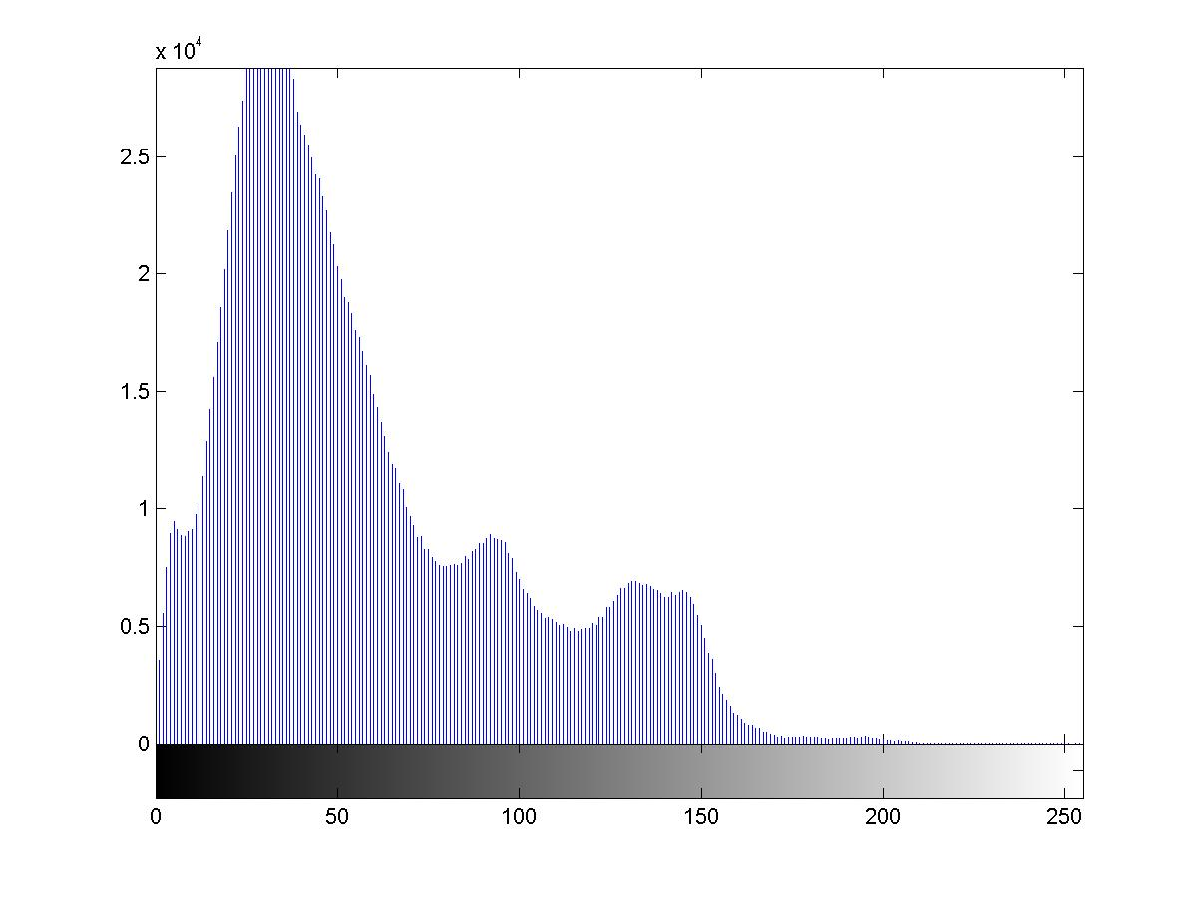

Sample B:
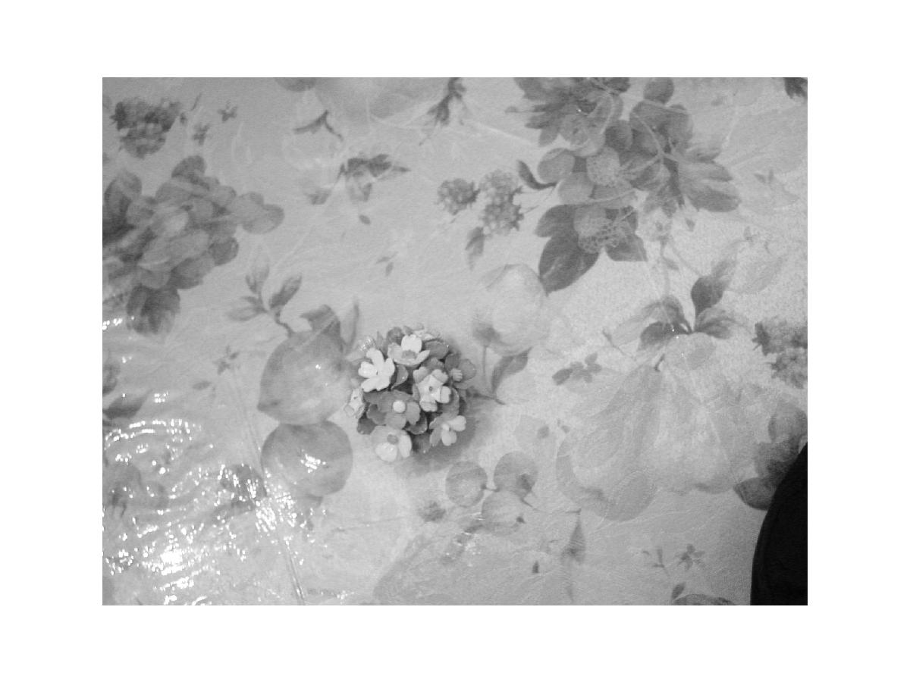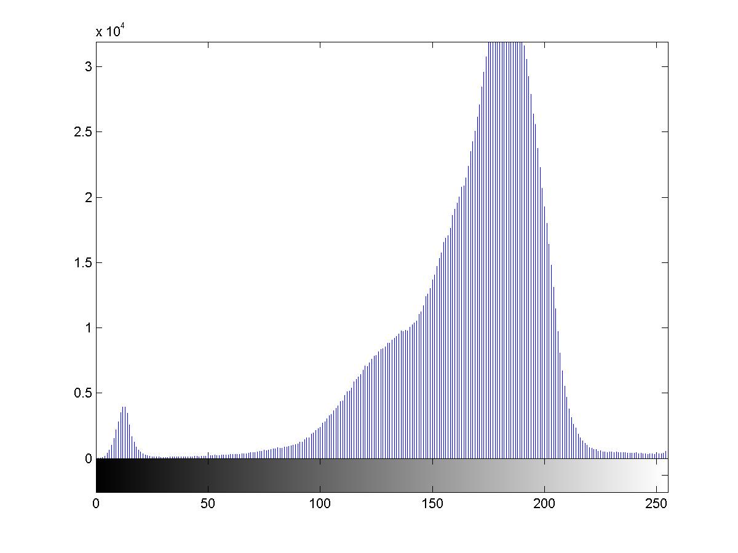

Sample C:
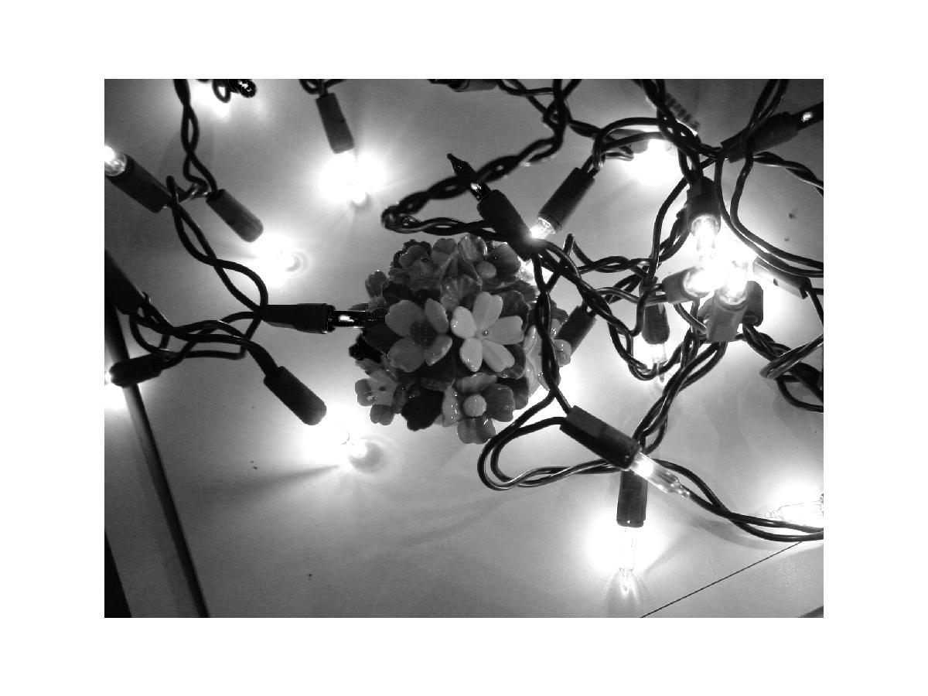
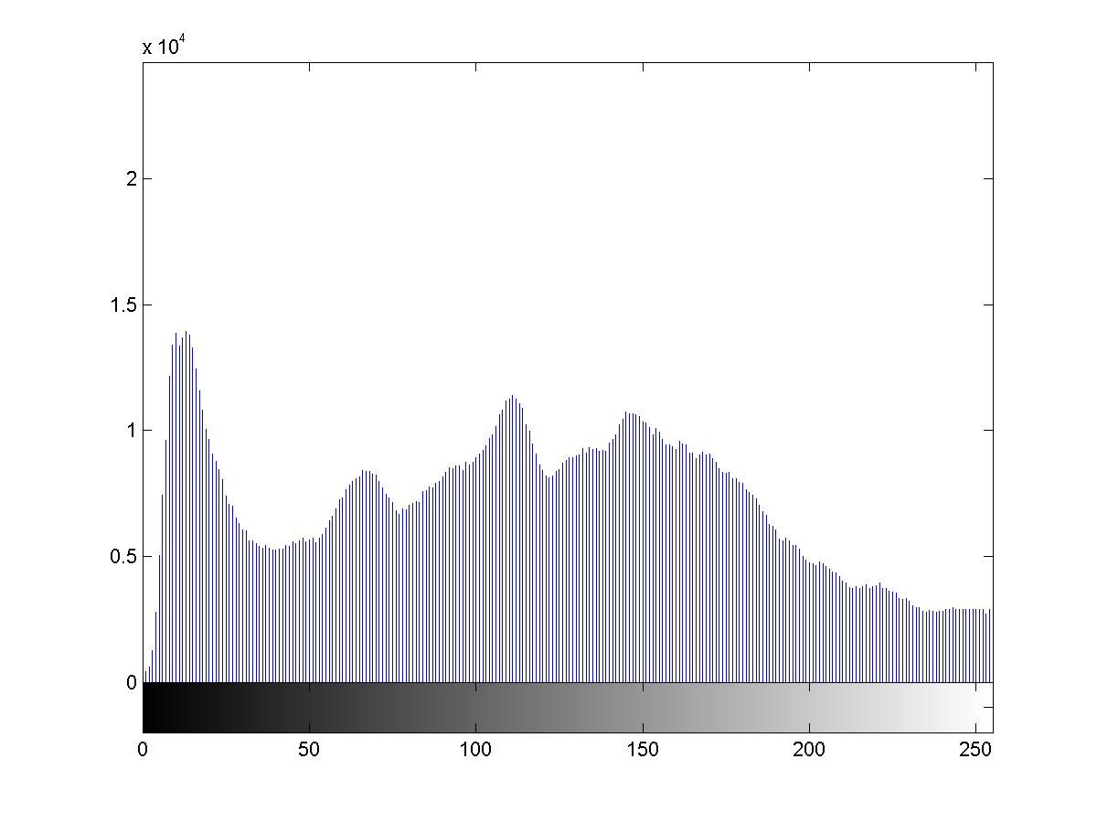
It was easy to see from these samples, and all others, that any histogram approach to image similarity given my sample images would not work.

ObjectSearch.m:

This program performs template matching with correlation on 3 sample templates and corresponding target images. The program design is as follows.
This program uses template matching with correlation to find instances of a template image in a target image. The program uses 3 different objects as examples: a coin, a flower, and a stapler. Templates for these images are supplied, as are several example target images for each. Each set of target images must be in a subdirectory off of the current working directory named “coins”, “flowers”, and “stapler.” The template images should be place in the current working directory. This program relies on functions provided by our textbook, and available on the web in .p file format at: www.prenhall.com/gonzalezwoodseddins

The basic algorithm is:
For each template
For each target image supplied for that temple
Perform template matching with correlation and show results;

Some program results follow:

Template:
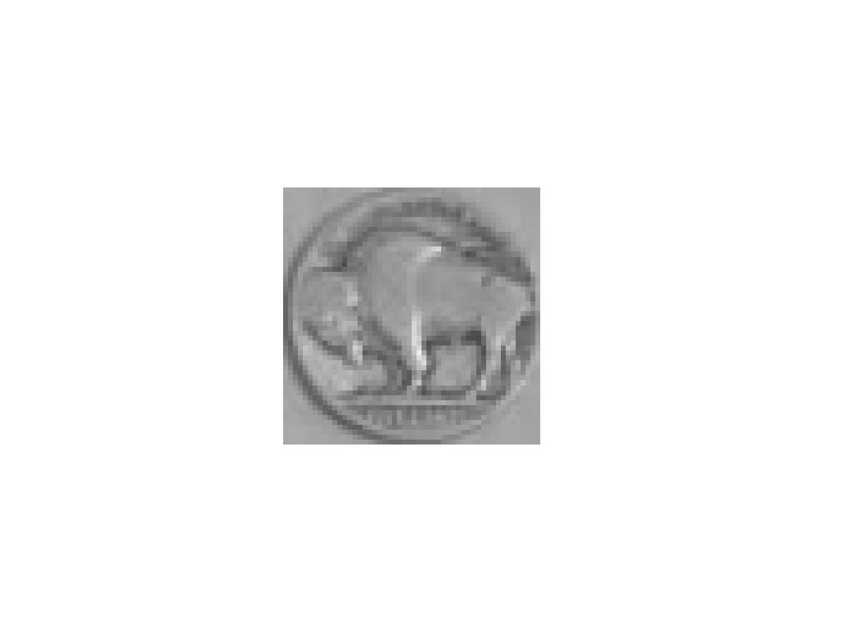
Target:

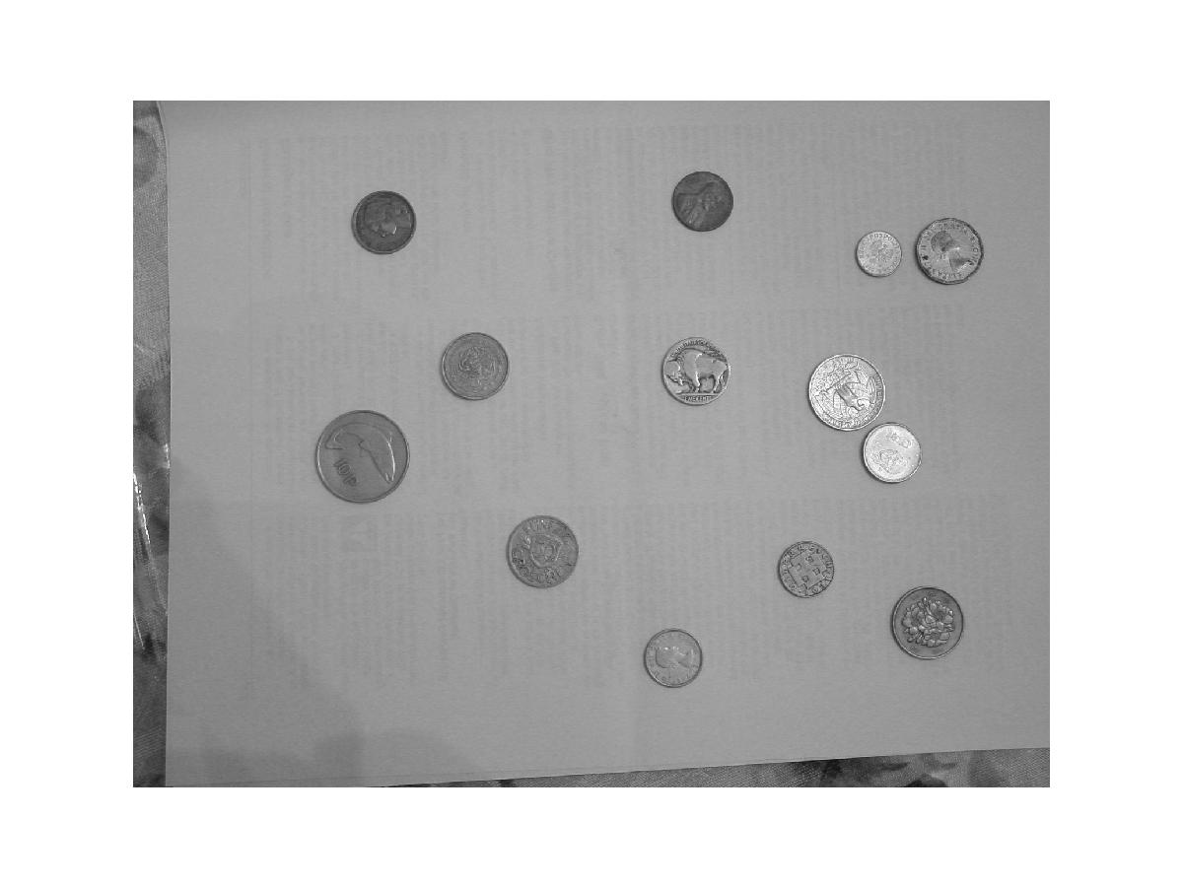
Result:

The white dot is the point of closest match. This attempt failed. It found the brightest coin instead.

Target:
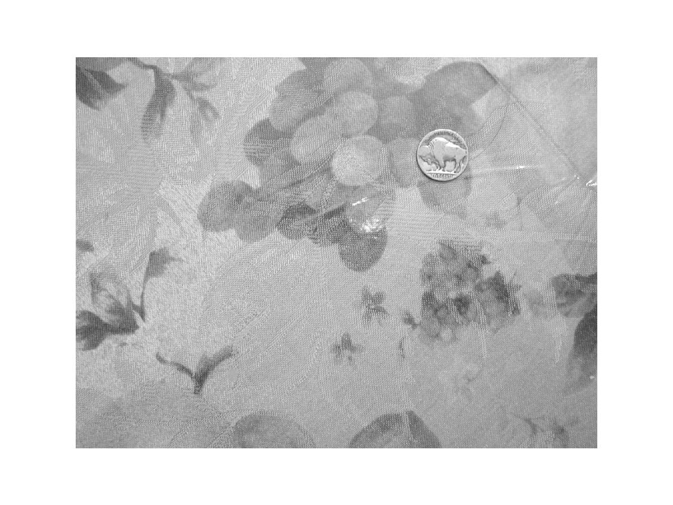
Result:
This attempt worked, and the little white dot is in the position aligned with the center of the coin.

Target:
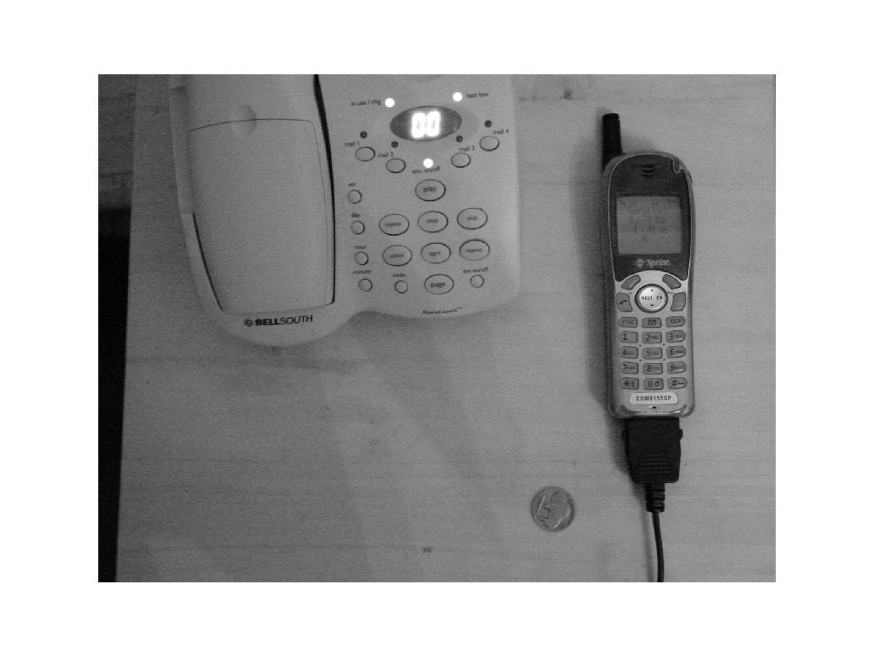
Result:
This attempt failed, as the little white dot aligns with the LED on the phone.

Target: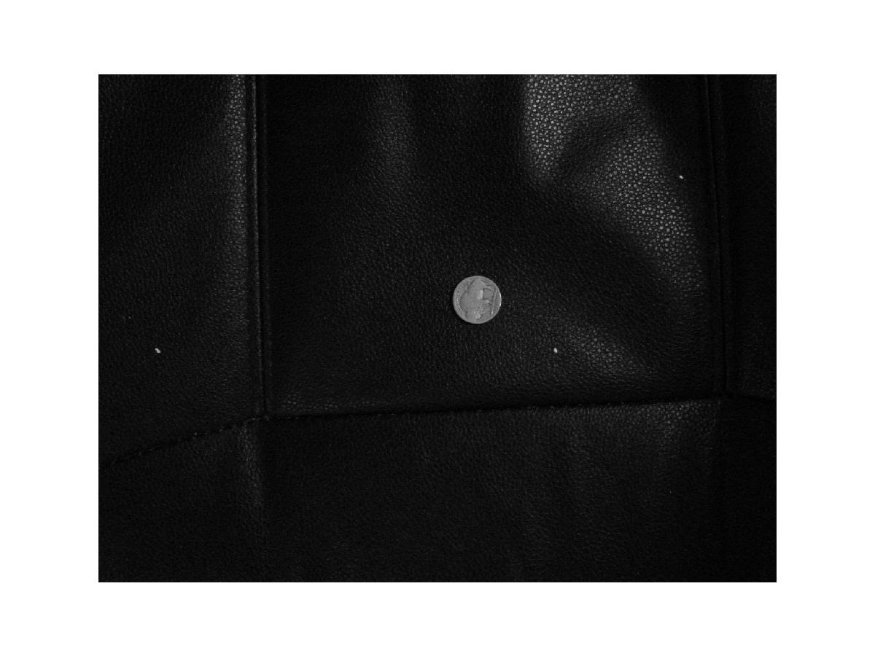
Result:
This attempt worked. The little white dot aligns with the coin.

Results with the flower example were not quite as good as the results from the coin example. Coin success was about 50%, flower success was about 20%, and the stapler, given its large template size, didn’t work at all.
Results were quite mixed, with fewer successes than failures. It turns out that the right noise will invalidate template matching with correlation.

BoundarySearch.m:

This program finds the boundaries of 2 images, extracts a chain code for each, and performs a string similarity on the chain codes. This program requires the libraries supplied with the textbook for our course, mentioned earlier in this document. Program design is as follows.

Acquire image 1;
Segment image 1;
Compute boundary of image 1;
Acquire image 2;
Segment image 2;
Compute boundary of image 2;
Compare the two boundaries;

Results:
This approach is not suitable for images with noise or various other object within them, single it’s no possible to guarantee a good line of our desired object. In order to produce even vaguely similar character codes I had to use sample images with no noise. The object I chose was the stapler.

First stapler: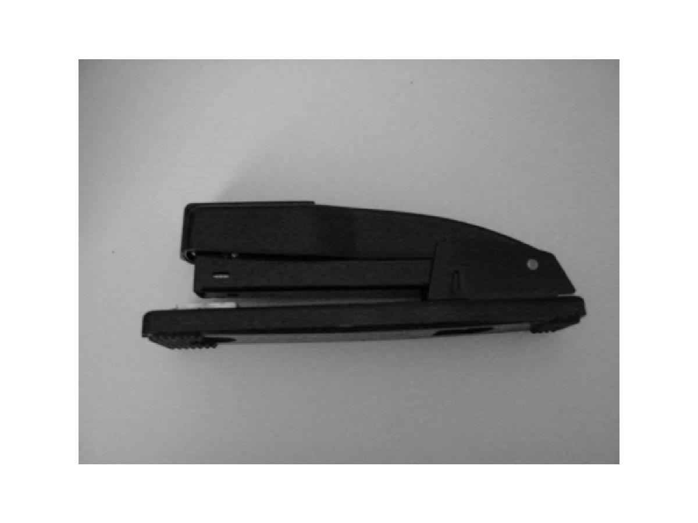
Second stapler: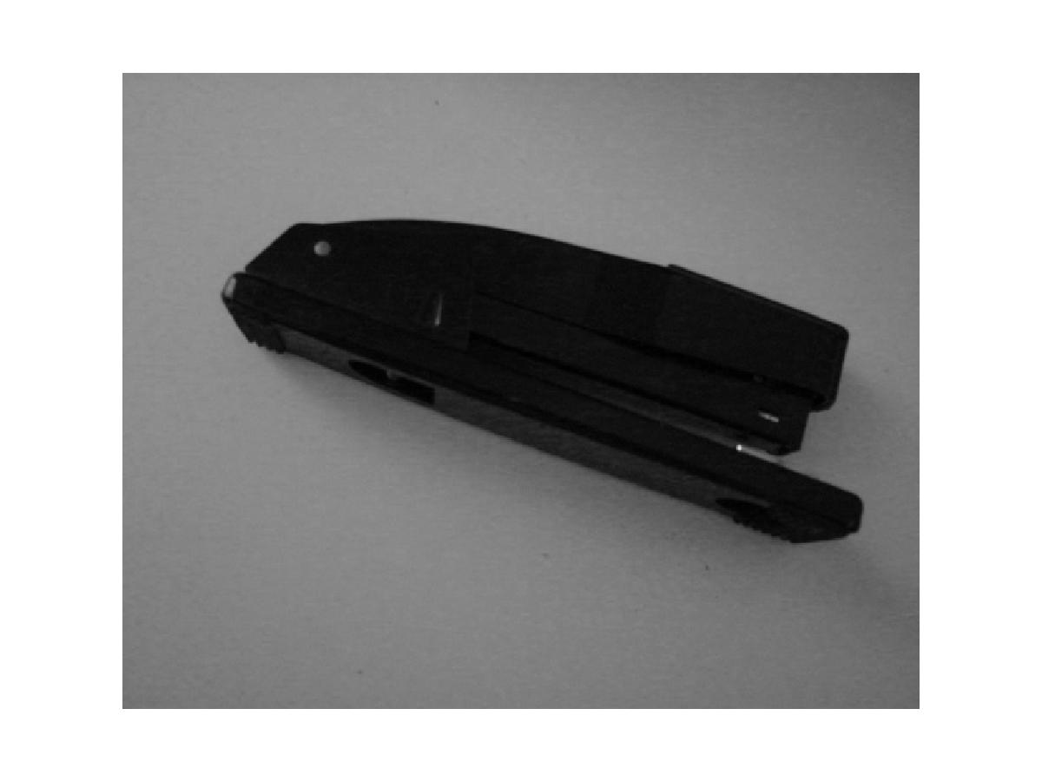

Boundaries: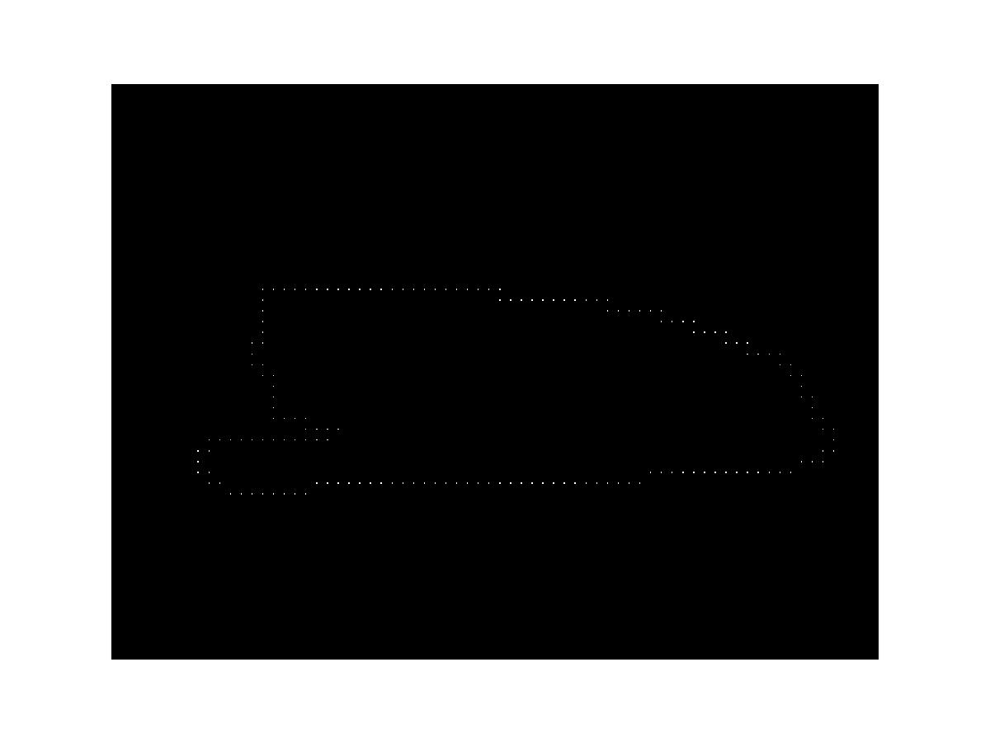

The above two stapler boundaries were far more similar to each other than between various other objects, but still were remarkably different given that they are both simple stapler images.

References:
Digital Image Processing using Matlab
Prentice Hall, ISBN 0-13-008519-7
Michael Tarr, Brown University
http://www.cog.brown.edu/~tarr/pdf/Tarr02ECS.pdf#search='object%20recognition‘
3D Object Recognition by Neural Trees http://csdl.computer.org/comp/proceedings/icip/1997/8183/03/81830408abs.htm
Longjin Jan Latecki, Temple University CIS 601 Lecture notes
http://www.cis.temple.edu/~latecki/CIS601-04/lectures_fall04.htm

