Image segmentation by Clustering
(using Mahalanobis distance)

- Manjit Chintalapalli

ABSTRACT:

In this work the way is described an algorithm, which are used to segmentation of images with clustering methods. This algorithm is tested on ten color images, which are firstly transformed to R*B*G* color space. Conditions, results and conclusions are described lower. The results are compared using both Mahalanobis and Euclidean distances in the clustering algorithm.

INTRODUCTION:

Image segmentation was, is and will be a major research topic for many image processing researchers. The reasons are obvious and applications endless: most computer vision and image analysis problems require a segmentation stage in order to detect objects or divide the image into regions which can be considered homogeneous according to a given criterion, such as color, motion, texture, etc.

Clustering is the search for distinct groups in the feature space. It is expected that these groups have different structures and that can be clearly differentiated. The clustering task separates the data into number of partitions, which are volumes in the n-dimensional feature space. These partitions define a hard limit between the different groups and depend on the functions used to model the data distribution.

Image segmentation:

To humans, an image is not just a random collection of pixels; it is a meaningful arrangement of regions and objects. There also exits a variety of images: natural scenes, paintings, etc. Despite the large variations of these images, humans have no problem to interpret them. Considering the large databases on the WWW, in our personal photograph folders, a strong and automatic image analysis would be welcome.

Image segmentation is the first step in image analysis and pattern recognition. It is a critical and essential component of image analysis system, is one of the most difficult tasks in image processing, and determines the quality of the final result of analysis. Image segmentation is the process of dividing an image into different regions such that each region is homogeneous.

Image segmentation methods can be categorized as follows (this is not an exhaustive list):

- Histogram thresholding: assumes that images are composed of regions with different gray (or color) ranges, and separates it into a number of peaks, each corresponding to one region.

- Edge-based approaches: use edge detection operators such as Sobel, Laplacian for example. Resulting regions may not be connected, hence edges need to be joined.

- Region-based approaches: based on similarity of regional image data. Some of the more widely used approaches in this category are: Thresholding, Clustering, Region growing, Splitting and merging.

- Hybrid: consider both edges and regions.

The project is done using Image Segmentation by Clustering. It is based on Color image segmentation using Mahalanobis distance. Euclidean distance is also used for comparing between the quality of segmentation between the Mahalanobis and Euclidean distance.

Image Segmentation by Clustering

Clustering is a classification technique. Given a vector of N measurements describing each pixel or group of pixels (i.e., region) in an image, a similarity of the measurement vectors and therefore their clustering in the N-dimensional measurement space implies similarity of the corresponding pixels or pixel groups. Therefore, clustering in measurement space may be an indicator of similarity of image regions, and may be used for segmentation purposes.

The vector of measurements describes some useful image feature and thus is also known as a feature vector. Similarity between image regions or pixels implies clustering (small separation distances) in the feature space. Clustering methods were some of the earliest data segmentation techniques to be developed.

Similar data points grouped together into clusters.

Most popular clustering algorithms suffer from two major drawbacks

- First, the number of clusters is predefined, which makes them inadequate for batch processing of huge image databases

- Secondly, the clusters are represented by their centroid and built using an Euclidean distance therefore inducing generally an hyperspheric cluster shape, which makes them unable to capture the real structure of the data.

- This is especially true in the case of color clustering where clusters are arbitrarily shaped

CLUSTERING ALGORITHMS:

- K-means
- K-medoids
- Hierarchical Clustering

There are many other algorithms used for clustering.

K-means algorithm was used in the project and the distances were calculated using Mahalanobis and Euclidean distances

K-Means Clustering Overview

K-Means clustering generates a specific number of disjoint, flat (non-hierarchical) clusters. It is well suited to generating globular clusters. The K-Means method is numerical, unsupervised, non-deterministic and iterative.

K-Means Algorithm Properties
- There are always K clusters.
- There is always at least one item in each cluster.
- The clusters are non-hierarchical and they do not overlap.
- Every member of a cluster is closer to its cluster than any other cluster because closeness does not always involve the center of clusters.

The K-Means Algorithm Process
- The dataset is partitioned into K clusters and the data points are randomly assigned to the clusters resulting in clusters that have roughly the same number of data points.
- For each data point:
- Calculate the distance (Mahalanobis or Euclidean) from the data point to each cluster.
- If the data point is closest to its own cluster, leave it where it is. If the data point is not closest to its own cluster, move it into the closest cluster.
- Repeat the above step until a complete pass through all the data points results in no data point moving from one cluster to another. At this point the clusters are stable and the clustering process ends.
- The choice of initial partition can greatly affect the final clusters that result, in terms of inter-cluster and intra-cluster distances and cohesion.

How the problem was approached?

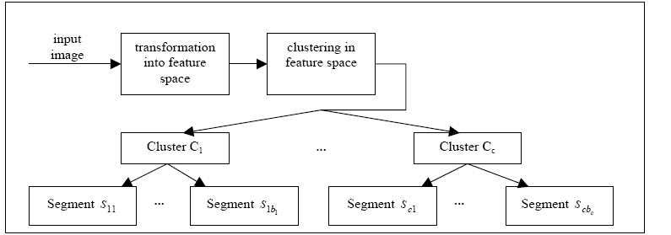

Flow-chart of an image segmentation method

Step 1:
First, an image is taken as an input. The input image is in the form of pixels and is transformed into a feature space (RBG).

Step 2:
Next similar data points, i.e. the points which have similar color, are grouped together using any clustering method. A clustering method such as k-means clustering is used to form clusters as shown in the flow chart. The distances are calculated using Mahalanobis and Euclidean distant.
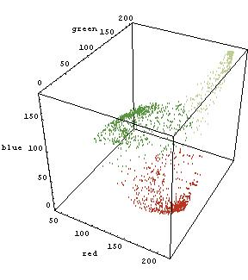
The above figure shows how the data points are clustered in the 3-d RGB space. As one can see all similar colors are grouped together to form a cluster.

The data points with minimum Mahalanobis distance or Euclidean distance are grouped together to form the clusters. Mahalanobis and Euclidean are described later below.

Step 3:
After clustering is done, the mean of the clusters is taken. Then the mean color in each cluster is calculated to be remapped onto the image.

How Mahalanobis and Euclidean distance is calculated?

Both Mahalanobis and Euclidean distances are described below clearly.

Mahalanobis Distance:

- Mahalanobis Distance is a very useful way of determining the ”similarity” of a set of values from an ”unknown”: sample to a set of values measured from a collection of ”known” samples

- Superior to Euclidean distance because it takes distribution of the points (correlations) into account

- Traditionally to classify observations into different groups

- It takes into account not only the average value but also its variance and the covariance of the variables measured

- It compensates for interactions (covariance) between variables

- It is dimensionless
The formula used to calculate Mahalanobis distance is given below.
Dt(x) = (x – Ci) * Inverse(S) * (x – Ci)`

Here X is a data point in the 3-D RGB space,
Ci is the center of a cluster
S is the covariance matrix of the data points in the 3-D RGB space
Inverse(S) is the inverse of covariance matrix S.

Mahalanobis
Distance
The above figure shows how the mahalanobis distance is calculated considering the variances of the data points in the 3-D RGB space.

The function used for Mahalanobis distance is user defined in the program.

Mahalano2( );

Euclidean Distance:

- The Euclidean distance is the straight-line distance between two pixels

- Euclidean distance = √((x1 - x2)² + (y1 - y2)²) ,

where (x1,y1) & (x2,y2) are two pixel points or two data points.

How the function Mahalano2( ) was used for both Mahalanobis and Euclidean distances ?

The only difference between Mahalanobis and Euclidean distance is that Mahalanobis considers the Inverse of the covariance matrix of the set of data points in the 3-d space.

So,

Mahalanobis distance = (P – Q) * INV(Cov(S)) * (P – Q)’

Euclidean distance = (P – Q) * (P – Q)’

Here P is a data point and Q is the center of a cluster.
S is a vector containing all the data points the 3-d color space.

Results

Original Images:

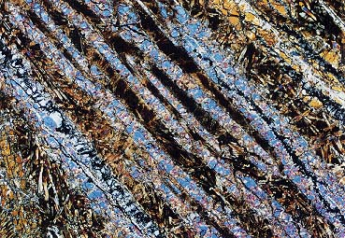
Texture
Rose



Painting
Landscape

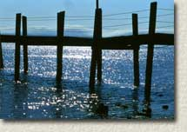
Beaver
China camp


Car
Canoe

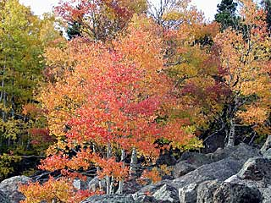
The Tree

Segmented Color Images

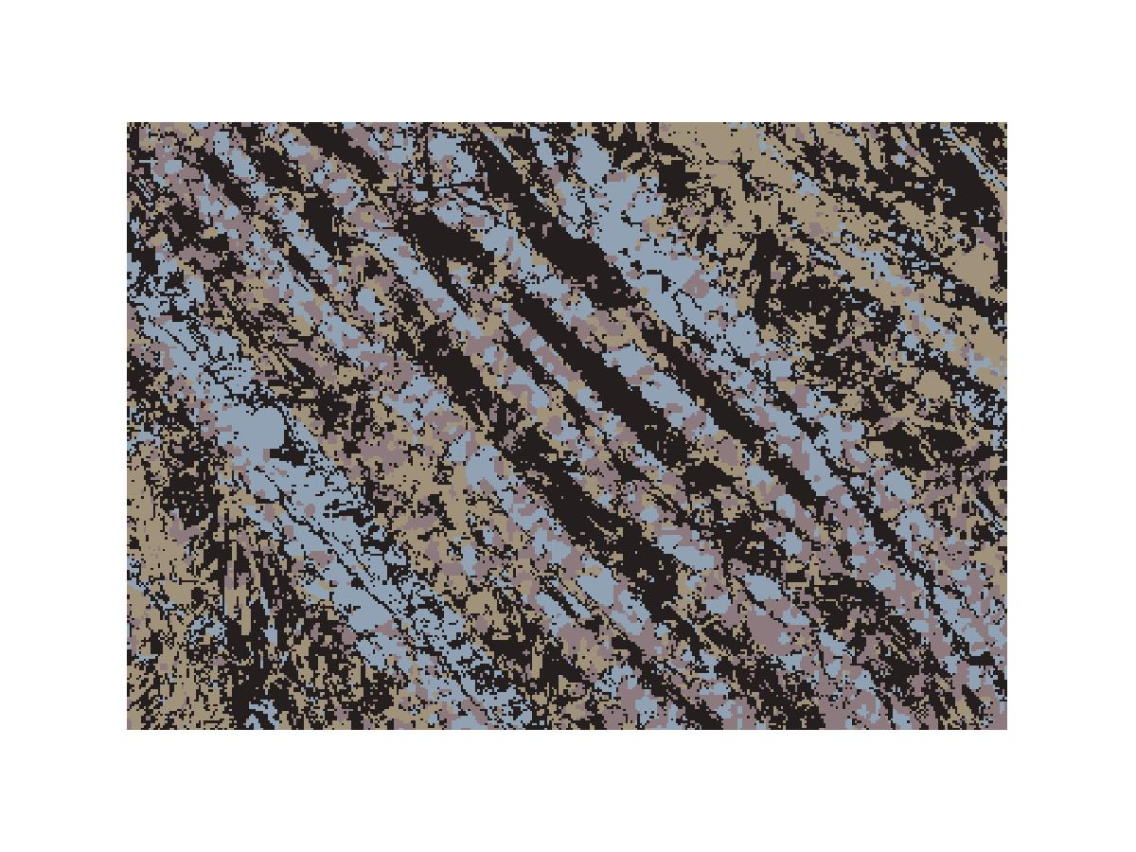

Original Image Image segmented with 4 clusters

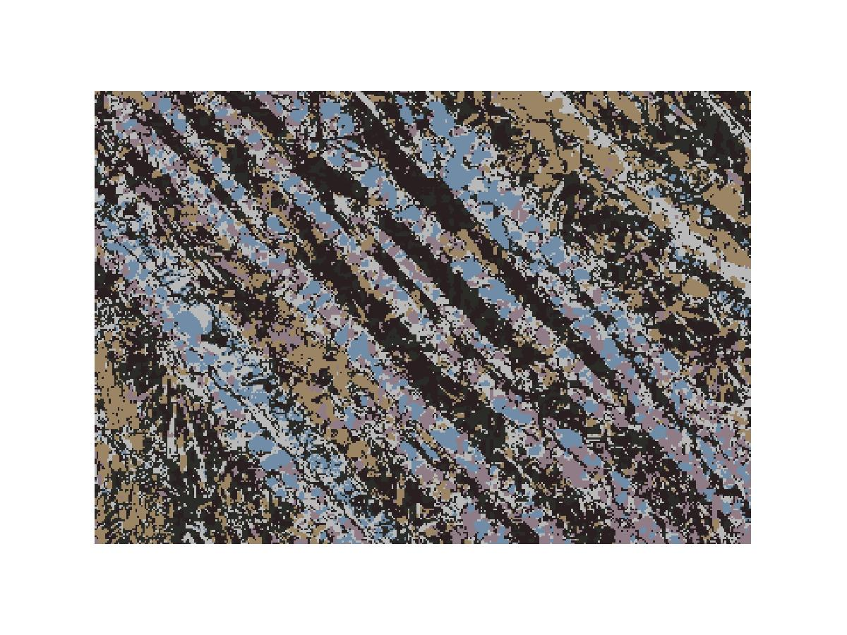
Image segmented with 6 clusters

Beaver:

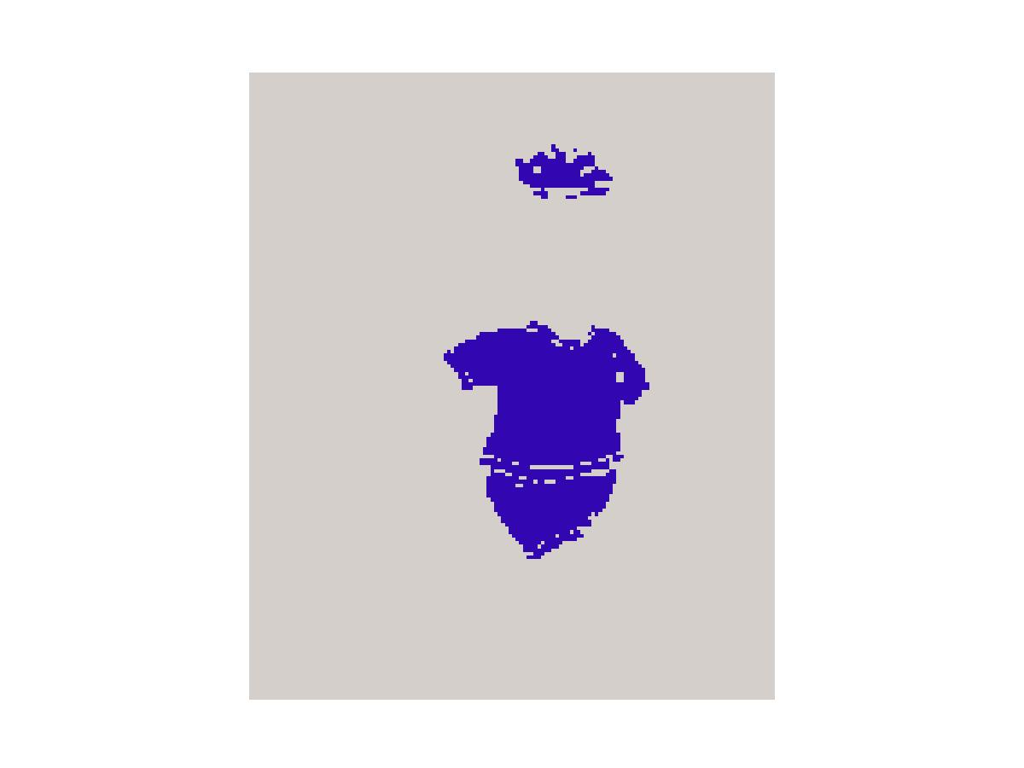
2-Clusters
Only two colors can be seen after segmentation
Beaver (original)



4-Clusters
Four colors can be seen with four clusters
6-Clusters
Six colors can be seen after segmentation

Comparison between Mahalanobis and Euclidean

Rose (original)

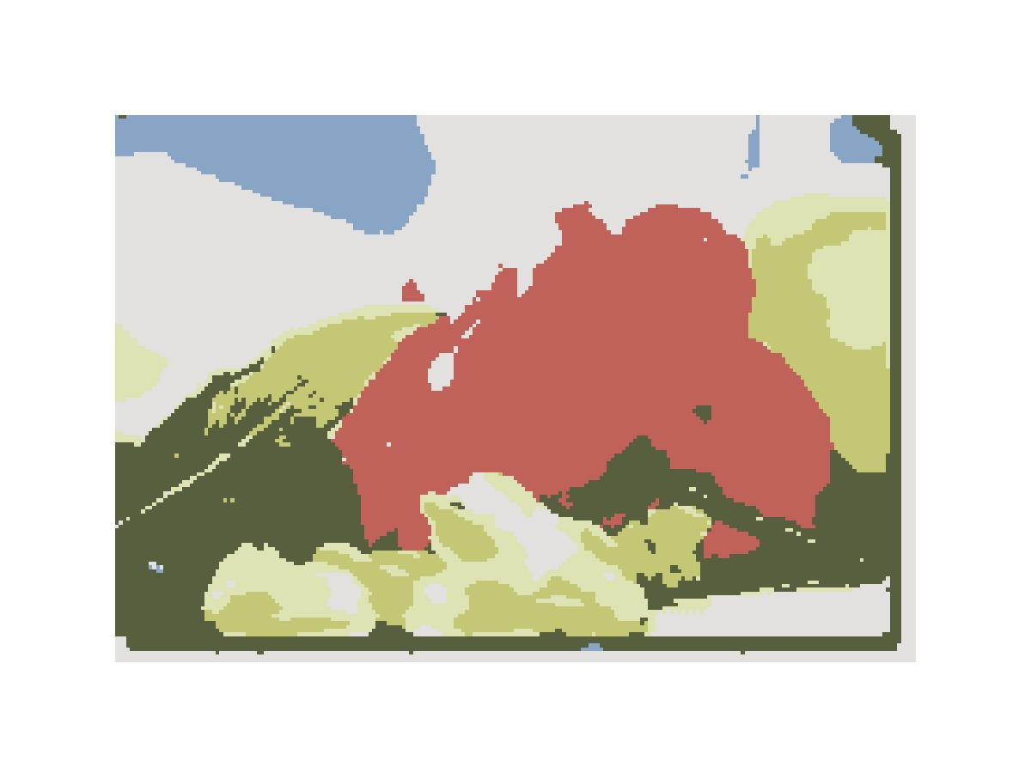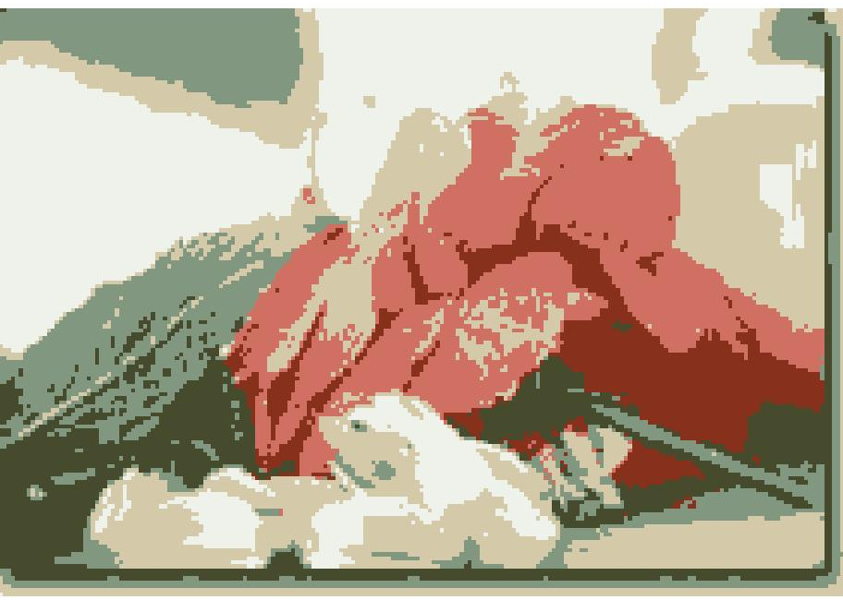
Image Segmented with 6 clusters using Mahalanobis Distance
Image Segmented with 6 clusters using Euclidean Distance

Car (Original)

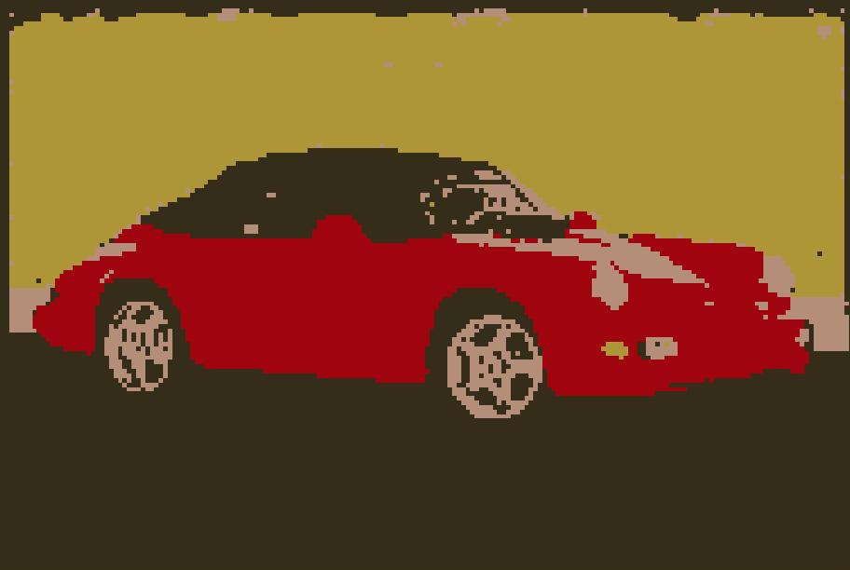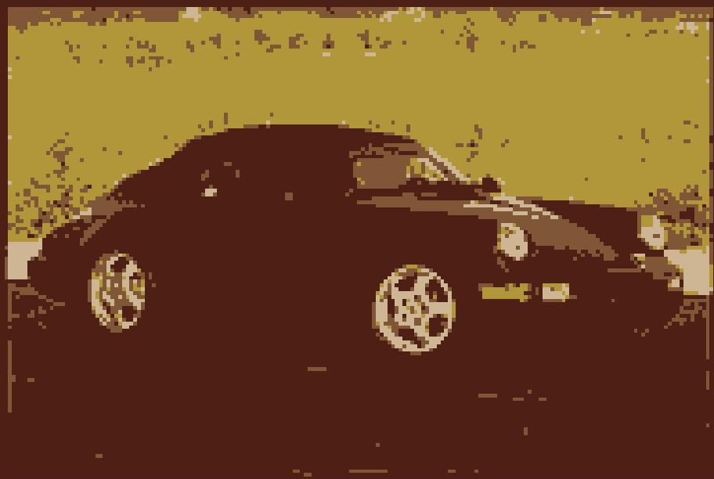
Image segmented with 4 clusters using Mahalanobis Distance
Image segmented with 4 clusters using Euclidean Distance

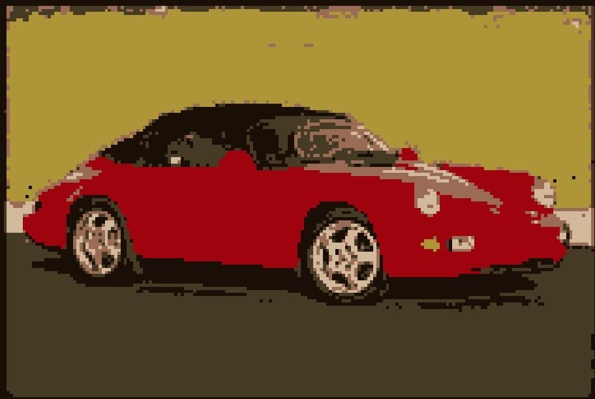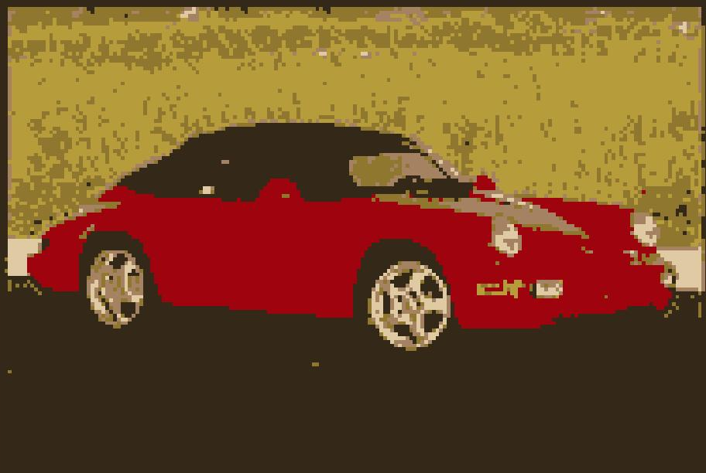
Image segmented with 6 clusters using Mahalanobis Distance
Image segmented with 6 clusters using Euclidean Distance

CONCLUSION

- The image segmentation is done using k-means clustering in 3-D RGB space, so it works perfectly fine with all images.
- The clarity in the segmented image is very good compared to other segmentation techniques.
- The clarity of the image also depends on the number of clusters used.
- One disadvantage of the procedure used is that the number of clusters is to be defined in each iteration.
- The results are compared using both Mahalanobis and Euclidean distance.
- As one can see from the above image in the previous page that the image segmented with Mahalanobis distance did come better than Euclidean Distance when the image is segmented with 4 clusters.
- That has to be true because the Mahalanobis distance considers the variances also.

REFERENCES:

[1] Schmid, P.: Colorimetry and color spaces, http://www.schmid-saugeon.ch/publications.html, 2001

[2] Schmid, P.: Image segmentation by color clustering, http://www.schmid-saugeon.ch/publications.html, 2001

[3] Digital Image Processing , R.C. Gonzalez, R.E. Woods, S.L. Eddins.

