Joe Jupin
CIS 601 – Image Processing
Project Proposal - Steganography
October 12, 2004

Clandestine communication has been used since some of the earliest Roman Legions marched across Europe and parts of Asia and Africa to provide a more secure method of communication. One of the earliest cryptographic methods developed is the Caesar or “shift-by-n” cipher. It simply replaces characters in the message with those shifted n positions to the right or left from the alphabet to produce the cipher text. Over the centuries, technology has progressed with respect to mechanizations and concepts. Mechanical devices and mathematical transforms have produced ciphers with much greater security than traditional substitution ciphers. During World War II, Alan Turing, one of Computer Sciences most famed researchers, worked at Bletchley Park, the British government's wartime communications headquarters, at Buckinghamshire, U.K. His main task was to master the Enigma (pictured right), the German Navy’s enciphering machine, which he was eventually able to crack. The Mark 1 COLOSSUS computer, designed by Max Von Newman, et al., was constructed in 1943 at Dollis Hill Post Office Research Station in the U.K. for cryptanalysis of the German Fish teleprinter ciphers used during World War II. This electromechanical implementation of a one-time pad was the German military’s most secure method of communication. Hence because of high computational complexity and an extremely vast problem domain, we have an inseparable connection between Computer and Information Science and clandestine communication.

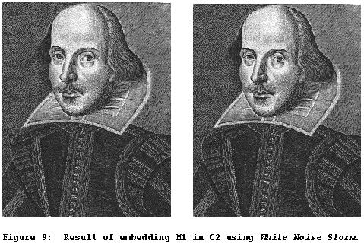
With the advent of the Internet, Web pages and other digital media, a new clandestine communication method has emerged. Steganography is a method that hides messages in various types of digital media, such as Web page HTML text, Microsoft Word documents, executable (EXE) and dynamic link library (DLL) files, digital audio files (WAV, CDA, MP3) and digital image files (BMP, GIF, JPG), which can be accessed at any time via the Internet. The image on the left contains two pictures of William Shakespeare. The leftmost contains the original image. The rightmost contains a hidden message encoded with “White Noise Storm”, a steganographic application, which is undetectable to the human eye. The message is:

Steganography is the art and science of communicating in a way which hides the existence of the communication. In contrast to cryptography, where the "enemy" is allowed to detect, intercept and modify messages without being able to violate certain security premises guaranteed by a cryptosystem, the goal of steganography is to hide messages inside other "harmless" messages in a way that does not allow any "enemy" to even detect that there is a second secret message present [Markus Kuhn 1995-07-03].

The United States Government released a statement in an online ABC article (that has since disappeared) that terrorists may be using steganography as a method to communicate, thereby foiling attempts to monitor them. An article at Wired reported that:

USA Today reported … that bin Laden and others "are hiding maps and photographs of terrorist targets and posting instructions for terrorist activities on sports chat rooms, pornographic bulletin boards and other websites, U.S. and foreign officials say."

My project proposal is to implement a steganographic encoding and decoding system in Matlab and/or C to demonstrate the process of hiding/retrieving a message within/from a digital image. The next part of the project will be performed on a highly “restricted complexity and domain problem” to explore and demonstrate potential methods for the possible detection and acquisition of hidden messages in digital images using image processing techniques and traditional hacking/cracking implementations.

The article from ABC news Web site was formerly located at: http://abcnews.go.com/sections/scitech/DailyNews/webwatch011011.html
The article from Wired is presently available at: http://www.wired.com/news/politics/0,1283,41658,00.html

