Joe Jupin
Final Project

Steganography

Table of Contents

Introduction 3
Background 4
Uncompressed images 4
Compressed images 6
Steganalysis 6
The Images 6
Finding and Extracting Linear Unencrypted Text Messages in Grayscale Bitmapped Images 7
Problem 7
Procedure 7
Observation 10
Conclusion 11
Detecting the Presence of Messages in Grayscale Jpeg Images 12
Problem 12
Procedure 12
Observation 17
Conclusion 18
Problems 18
Other Classifiers 18
Future Work 18
Appendices 19
Appendix 1: Trial results 19
Appendix 2: Other Classifier Results 22
References 26

Joe Jupin
Final Project - Steganography
November 29, 2004

Introduction

Clandestine communication had been used before the earliest Roman Legions marched across Europe and parts of Asia and Africa to provide a more secure method of communication. One of the earliest cryptographic methods developed is the Caesar or “shift-by-n” cipher. It simply replaces characters in the message with those shifted n positions to the right or left from the alphabet to produce the cipher text. Over the centuries, technology has progressed with respect to mechanizations and concepts. Mechanical devices and mathematical transforms have produced ciphers with much greater security than traditional substitution ciphers. During World War II, Alan Turing, one of Computer Sciences most famed researchers, worked at Bletchley Park, the British government's wartime communications headquarters, at Buckinghamshire, U.K. His main task was to master the Enigma (pictured right), the German Navy’s enciphering machine, which he was eventually able to crack. The Mark 1 COLOSSUS computer, designed by Max Von Newman, et al., was constructed in 1943 at Dollis Hill Post Office Research Station in the U.K. for cryptanalysis of the German Fish teleprinter ciphers used during World War II. This electromechanical implementation of a one-time pad was the German military’s most secure method of communication. Hence because of high computational complexity and an extremely vast problem domain, we have an inseparable connection between Computer and Information Science and clandestine communication.

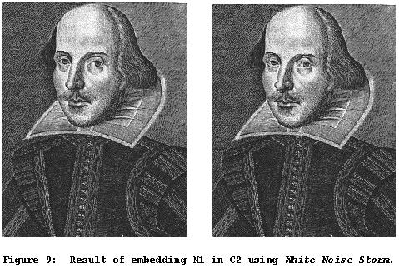
With the advent of the Internet, Web pages and other digital media, a new clandestine communication method has become more popular. Steganography is a method that hides messages in various types of media. The Greek definition of steganography roughly translates to “hidden writing.” Herodotus mentioned two methods of steganography in his Histories. In the first, a Greek in the Persian court, Demeratus, wanted to send a warning of an impending invasion by Xerxes by writing the message on a piece of wood and covering it with wax. This would appear to be a blank writing tablet. The message could be recovered by removing the wax, when it arrived in Sparta. The other was by Histiaeus, who shaved the head of a trusted slave and tattooed the message to his head. After the hair grew back, the slave was sent to the recipient, who again shaved his head to retrieve the message.

Modern steganography includes messages hidden in digital media, such as Web page HTML text, Microsoft Word documents, executable (EXE) and dynamic link library (DLL) files, digital audio files (WAV, CDA, MP3) and digital image files (BMP, GIF, JPG), which can be accessed at any time via the Internet. The image on the right contains two pictures of William Shakespeare. The leftmost contains the original image. The rightmost contains a hidden message encoded with “White Noise Storm”, a steganographic application, which is undetectable to the human eye. The message is:

Steganography is the art and science of communicating in a way which hides the existence of the communication. In contrast to cryptography, where the "enemy" is allowed to detect, intercept and modify messages without being able to violate certain security premises guaranteed by a cryptosystem, the goal of steganography is to hide messages inside other "harmless" messages in a way that does not allow any "enemy" to even detect that there is a second secret message present [Markus Kuhn 1995-07-03].

The United States Government released a statement in an online ABC article (that has since disappeared) that terrorists may be using steganography as a method to communicate, thereby foiling attempts to monitor them. An article at Wired reported that:

USA Today reported … that bin Laden and others "are hiding maps and photographs of terrorist targets and posting instructions for terrorist activities on sports chat rooms, pornographic bulletin boards and other websites, U.S. and foreign officials say."

Background

This paper addresses the subset of steganography that uses digital images for the message container. There are two types of images considered: compressed and uncompressed. Grayscale bitmap images will be used for the uncompressed and grayscale jpeg will be used for the compressed.

Uncompressed images

Bitmap images consist of matrices of numbered points with two dimensions for grayscale and three dimensions for RGB color images. The grayscale images, also called intensity images, contain numbered values at these points, called pixels, between 0 for black and 255 for white, which can be represented as 8-bit binary strings (2⁸ = 256). The numbers between represent gradient gray values between black and white. The RGB, abbreviated for Red, Green and Blue, images are actually three two-dimension image layers, a red, a green and a blue layer, that are combined to produce the full color image. Each layer of a color image also contains values from 0 for black to 255 for the lightest shade of the color. The RGB color scheme is referred to as an additive scheme because adding the effective value of the three layers usually produces a lighter color at that pixel. For instance if all three values that comprise a pixel are 0, i.e. (0, 0, 0) for (red, green, blue), they produce the color black. If the three are 255, i.e. (255, 255, 255) they add to produce a much lighter shade, white. The product of these three layers can produce over 16 million different colors and is called 24-bit color because 256³ = (2⁸)³ = 2²⁴ = 16,777,216, in which three 8-bit binary strings represent pixel colors. The images below show these properties. They are intensity, color, red layer, green layer and blue layer, from left to right. Notice that the vertical white line that appears in the center of the intensity and color images is lighter than that in the RGB layers and that the blackish colors appear black in all images. This demonstrates the additive nature of RGB color images with respect to intensity.

Messages are hidden in the least significant bits of the 8-bit binary strings representing the color numbers; hence the abbreviated name for this method is “lsb” steganography. For simplicity, we will only consider grayscale images because it’s easier to conceive operations on a two-dimensional matrix. Since the colors in a grayscale image range between integers from 0 to 255, their binary numbers range from 00000000 to 11111111. The least significant bit in a binary number is the rightmost digit. There will be very little difference between the color representation of 00000000 (pure black) and 00000001, as shown on the right.

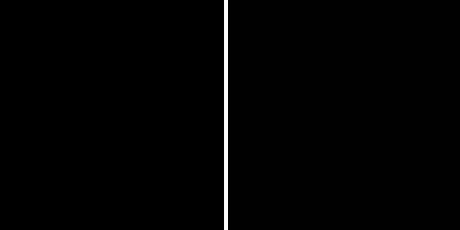

Each character in a message has a binary representation under the ASCII character system, which assigns characters with integer values between 0 and 255. This system represents a way to express all necessary single character letters, numbers, punctuations, symbols, etc. for general communication purposes. For instance, the character ‘A’ has the ASCII value 65. Some commonly used ASCII characters are:

Character Integer Binary
0 – 9 48 – 57 00110000 - 00111001
A – Z 65 – 90 01000001 - 01011010
a – z 97 – 122 01100001 - 01111010

The example below shows the process to hide the message “Hello Stego!” in a 14x8 image fragment. The first image is the cover image in which the message will be hidden. The message is 96 bits in length (12 characters with 8 bits each) and the image has 112 pixels. Each bit of the message is mapped to a single pixel. This leaves 2 bytes in which to encode the length of the message. Hence, to hide an N length message, the image must have 8xN+16 pixels. The first table shows the integer representation of the cover image. The second table shows the integer representation of the stego image after encoding. The last image is the stego image. Some of the pixel numbers have flipped from even to odd and vice versa. The second picture shows the encoded or stego image. Evaluating the even and odd bits in the stego image will reveal the message.

27 28 30 31 32 32 32 31
32 32 33 34 34 34 33 32
36 37 38 39 39 39 38 38
42 43 44 45 46 46 47 47
57 57 57 56 56 56 56 56
70 69 67 64 62 60 59 59
67 66 63 61 59 58 57 57
57 56 54 53 53 53 54 55
47 46 46 45 44 43 43 42
40 40 40 39 38 38 38 37
30 30 30 29 29 29 29 29
20 20 21 21 21 21 21 21
17 17 17 17 17 17 17 17
16 16 16 16 16 16 16 16

26 28 30 31 32 33 32 31
32 32 33 34 34 35 33 32
36 36 38 39 39 38 38 39
42 43 45 45 46 47 47 47
56 56 56 56 56 57 56 57
70 68 67 64 62 61 59 59
66 67 63 60 58 58 57 56
56 56 54 53 52 53 54 54
46 46 47 45 44 42 42 43
40 40 41 38 39 38 39 36
30 30 30 29 28 28 29 28
20 21 20 21 21 21 21 20
17 17 16 17 16 17 16 16
17 16 17 17 16 16 17 17

Compressed images

Jpeg is the standard for compressing images to be stored or transmitted in digital format. Images are compressed by dividing the uncompressed image into YCbCr colorspace 8x8 blocks and using Discrete Cosine Transform (DCT), which is similar to the Fourier Transform, to obtain frequency coefficients. These are scaled in the quantization step to remove some frequencies, thereby compressing the image to a smaller size. If the image quality is set to a high level, the resulting jpeg compression may not be detectible to the human eye.

Messages cannot be hidden in compressed images as they are in uncompressed images. The compression process would wipe them out because they are information lossy methods. Taking advantage of some reversible method in the compression process can facilitate the message hiding in jpegs. The steganographic tool used to encode the file was Jsteg, a patch, written by Derek Upham, for the Joint Photographic Experts Group’s freely available compression and decompression jpeg utility, which is also freely available. This method uses the fact that jpeg compression has both lossy and non-lossy stages. After DCT, it uses Huffman coding to further compress the image, which is information lossless. The message is inserted between DCT and Huffman. This method is reported to hide N kilobytes in an 8xN to 10xN kilobyte image.

Steganalysis

Steganalysis is the task of finding hidden messages in various media. It has been published in articles that the most effective and promising methods to find steganographic messages in pictures are by use of statistical, image processing and classification data mining methods.

The Images

The 1000+ images, used during trials and development, were obtained from the Star Trek Web Site at www.startrek.com. They are all color jpeg images and are either 320x240 or 240x320 in size. The set is a mixture of various environments including indoors, outdoors, outer space and various images containing special effects.

Finding and Extracting Linear Unencrypted Text Messages in Grayscale Bitmapped Images

Problem

A message can be hidden in image’s lsb’s as previously described. If a human had to rigorously search all possible linear combinations of every possible character in images to find messages, it might take hours or days to process a single image. The problem is to develop methods to encode, decode and find messages in bitmap images. Ninety-seven of the thousand jpeg images have been converted to grayscale bitmaps for use in this section. The Pics2Bmp function will convert a directory of color images into intensity images. The function arguments are:

Pics2Bmp(‘sourceDirectory’, ‘targetDirectory’);

where sourceDirectory is the directory with the files to be converted and targetDirectory is where the finished images are placed.

Procedure

The first task is to implement a system to encode and decode text messages in non-compressed images in Matlab. This is necessary not only to demonstrate the process but also to seed images with hidden messages for analysis. It has been proposed that the key to detecting hidden messages in images is to use various statistical methods to check images for evidence that a message has been hidden by determining that the statistical results deviate from some established or expected norm. There are literally greater than billions of potential images that can be generated. Point a digital camera at a subject, take a digital image, hide a message in it and you have a needle in a nearly infinite haystack. There are such a large number of images on the Internet that it is unlikely that it will ever be found. The computational time to find all hidden images by checking every “least significant bit” on every image would be tremendous. I intend to develop a Matlab program that will sample many images to determine the possible existence of a hidden message. Then, the tagged images could be further processed using pattern matching to extract the message. To find potential messages, I intend to develop a sampling method that will perform minimal processing to tag suspicious images by extracting a number of areas of pixels from an image and analyzing them for signs of modification.

The first task is to hide a message in a bitmap image. Flipping the lsb’s of sets of 8 pixels to even or odd in the cover image to represent the 8-bit characters of the message produces the stego image. The HideMsg function hides a message in a bitmap image. It takes the arguments:

HideMsg(encodeName, coverImgName, offset),

where encodeName is the name of the message ASCII text file, coverImgName is the name of the cover image and offset is the starting pixel number. The message-offset allows a message to be hidden anywhere in the image. The steganography message by Markus Kuhn shown in the introduction is encoded by “HideMsg(‘encode.txt’, ‘bw-stkln73.bmp’, 30000)”, producing the stego image: “stego-bw-stkln73.bmp”. The cover image is on the left, the portion of the image containing the message is in the center and the stego image is on the right.

Next, we need to read a hidden message. The GetMsg function retrieves a message from a bitmap image. It takes the arguments:

GetMsg(stegoImageName, offset)

where stegoImageName is the name of the stego image and offset is the starting pixel number. Running “GetMsg2(stego-bw-stkln73.bmp, 30000)” will produce a decode file named containing the original message.

To find a message hidden in an image we need to define a “message”. We can say that a message is an uninterrupted string of “message characters”, which contain certain patterns. We can define “message characters” as those most likely to appear in communication, such as e-mails. It’s less probable that a large number of coherent message characters will appear in sequence when the lsb’s of an image are extracted and all possible character sets are considered. First lets formally define all character classes as:

Character Integer Binary Class Class#
nonchars 0 – 12 00000000 – 00011111 Nonchar 0
carr ret 13 00000000 – 00011111 CarrRet 8
nonchars 14 – 31 00000000 – 00011111 Nonchar 0
space 32 00100000 Space 1
symbols 33 – 43 00100001 – 00101011 Symbol 7
comma 44 00101100 Comma 6
apostrophe 45 00101101 Symbol 7
period 46 00101110 Period 5
slash 47 00101111 Symbol 7
0 – 9 48 – 57 00110000 – 00111001 Number 4
symbols 58 – 64 00111010 - 01000000 Symbol 7
A – Z 65 – 90 01000001 – 01011010 Cap letter 3
symbols 91 – 96 01011011 – 01100000 Symbol 7
a – z 97 – 122 01100001 – 01111010 Low letter 2
symbols 123 – 125 01111010 – 01111101 Symbol 7
nonchars 126 – 255 01111110 – 11111111 Nonchar 0

We are only interested in characters with integer values 13 and those between 32 and 125, which is less than half. To decide the status of a character, the “IsChar2” function returns the class of the character under consideration. Next we can define “stego stems” as a set of three character patterns that are likely to be contained in messages. Consider the three character combinations: “and” and “the”, which are the most common three letter words to occur in written documents. They also occur as parts of larger words. There are 354,984 officially recognized words in the English language, excluding proper names, acronyms, or compound words and phrases. The following stego stems were counted in Moby™ Words II:

Stem | HEL | STE | STA | TRE | COM | CER | PRE | THE | AGE | AND
Count | 1083 | 4928 | 3779 | 1837 | 3162 | 1700 | 6499 | 4654 | 2470 | 3505
Percent | 0.30508 | 1.3882 | 1.0646 | 0.51749 | 0.89074 | 0.47889 | 1.8308 | 1.311 | 0.69581 | 0.98737

The key to finding a potential message is to find the occurrence of words. However, there are too many words to check. Hence, we decrease the work by looking for parts of words. A small number of stems can represent a large number of words, as shown in the table above. Notice that the stem ‘PRE’ occurs in 6,499/354,984 words. That’s three letters the describe 1.83% of ‘single words’ in the English language. The set above should not be considered the best possible set. I chose these stems by intuitively considering common three letter combinations. A truly useful set would not only include those stems commonly occurring in words, it would order them by occurrence in common written documents. Finding these orderings would require some text mining of common communication documents.

Next, we need to take a Boolean snapshot of the even and odd pixels in the image. Remember that we flipped the lsb’s to even or odd to hide the message. We use this 2-color bitmap to enumerate a string of all possible characters that can be linearly constructed by 8 bit sequences. There will be n – 7 characters in the string for an image with n pixels. For the images used in this project, there will be 76,793 possible characters (320 x 240 = 76,800). This string is used to search for potential messages by iteratively constructing substrings from every eighth character and testing for message conditions in the substring. The figure below shows this process for the aforementioned ‘Hello Stego!’ stego image. The process begins at the Boolean snapshot, which is turned into a vector or string form. The string form is processed to enumerate all possible characters and record the class of each. In this case there are 14 x 8 – 7 = 105 characters. The enumerations are then processed by constructing substrings of every eighth character and testing them for the presence of a stego stem. The HEL and STE stems are present. Note: this description is slightly simplified from the program.

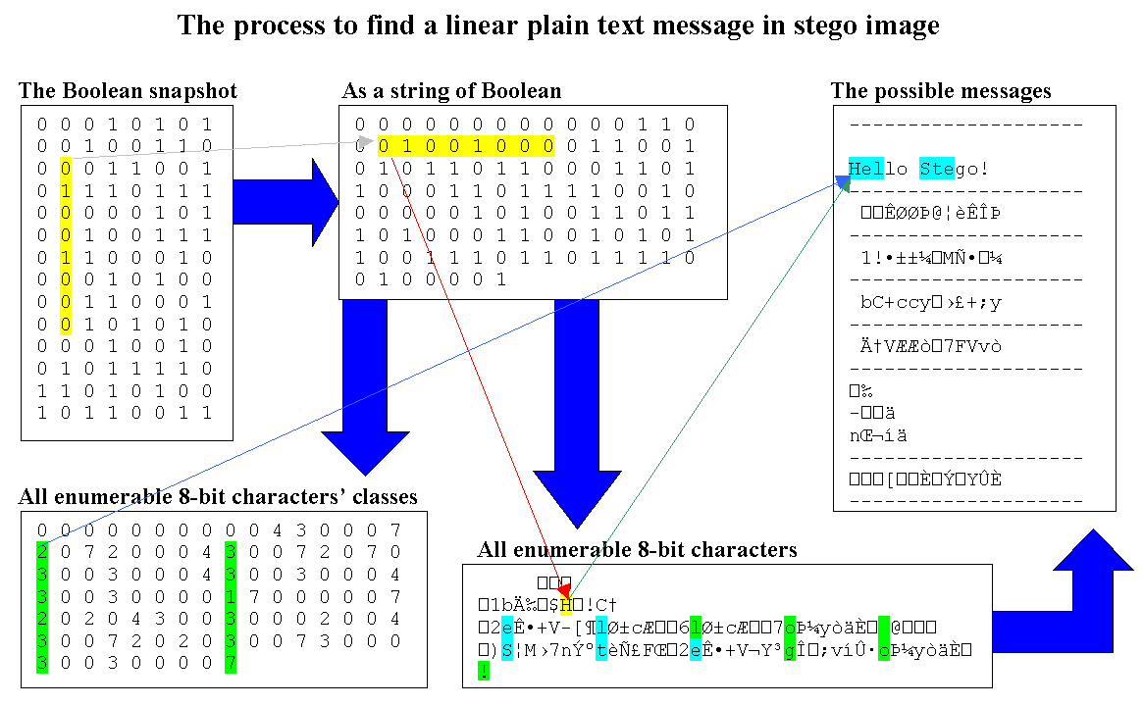
The FindMsg function finds and extracts a message in a bitmap image by using this principal. It takes the arguments:

FindMsg(imageName)

This function took, on average, nine seconds to process an image. Preliminary testing showed that there was low probability of occurrences of message character strings with length 8 or more. To test the possibility of a message in a bitmap image, the TestMsg function checks for the possibility of a message in a bitmap image by sampling parts of the image. It basically selects portions of an image for analysis by tiling the image. The graphics below show this process. The first image is the candidate under consideration; the second is a snapshot of the even and odd pixels; and the third are sampled areas. Notice the banding in the second image near the center of the image. That’s where the message is hidden.

TestMsg will check each white tile for the number of length 8 message characters. It should be noted that this method gives higher weight to longer strings. The tiles are 32 pixels wide and 73 (64+7) pixels high. This allows messages to be examined for all possible message-offset values. Within each tile all possible combinations of message characters are considered. The function TestMsg takes the arguments:

[found size] = TestMsg(imageName)

It returns the number of length 8 message strings found in the image and the size of the image. It should be noted that this function is only three times as fast as the FindMsg function and that it will not find very small messages (less than 200 bytes). If more speed is required, fewer tiles can be processed but this will decrease the accuracy of the function. The last function for this part of the project processes a directory of images. The TestAllImgs function takes the arguments:

[found size] = TestAllImgs(sourceDirectory)

It returns a cell list of candidate images, which can be processed by the FindMsg function to determine if a message is present. The candidates are also printed to the screen.

Observation

Three stego images were encoded with messages of sufficient size and placed into a directory with 97 clean images for testing. They were encoded with offsets as:

>> HideMsg('encode.txt', 'bw-stkln73.bmp', 30000);
>> HideMsg('encode2.txt', 'bw-stkln90.bmp', 20000);
>> HideMsg('encode3.txt', 'bw-stkln16.bmp', 5000);

The TestAllImgs function was run, returning the following:

>> TestAllImgs('bmp-pics');
Processing: bw-stkln01.bmp
Processing: bw-stkln02.bmp
.
.
.
Processing: bw-stkln97.bmp
Processing: stego-bw-stkln16.bmp
Processing: stego-bw-stkln73.bmp
Processing: stego-bw-stkln90.bmp
Possible message in: stego-bw-stkln16.bmp
Possible message in: stego-bw-stkln73.bmp
Possible message in: stego-bw-stkln90.bmp

elapsed_time =

3.128590000000000e+002

All three were processed with the FindMsg function, which extracted the messages. It should be noted that a more extensive set of stego stems will need to be developed for a complete solution.

Conclusion

It has been demonstrated through rigorous methods that messages can be found and retrieved from stego images containing plain text messages of sufficient length. However, this method will fail for non-plain text messages. If a message is encrypted, much more sophisticated methods would have to be employed.

Detecting the Presence of Messages in Grayscale Jpeg Images

Problem

When an image is encoded with a hidden message, the statistical properties of the image are altered. Images compressed with jpeg use a process known as the discrete cosine transform (DCT), which exhibit predictable first and high order wavelet statistical properties. In one method of detection, support vector machines are trained on features obtained by performing statistical analysis on a set of images. The necessary statistics will be obtained by analyzing the idealized multi-scale and orientation decomposition of frequency space in images with and without hidden messages. These properties can be used to establish a means to flag images that may have hidden messages. The task to find images in two classes: cover or stego, where the cover image is the unmodified image and the stego image contains a hidden message. This method has been found to be fairly successful on large messages. However small messages do not alter the image statistics enough for detection. The images below are an image without a message (left) and an image with a 2,000-to-3,000 byte string of random characters injected into it. There are slight differences but unless a viewer actually has the cover image for comparison, the message will be undetectable.

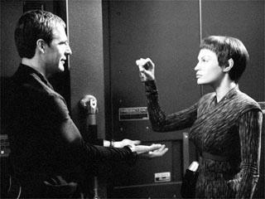
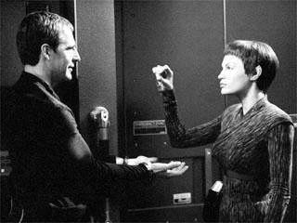

Procedure

The next part of the project is to test the proposition that support vector machines can detect hidden messages in compressed graphics, such as jpeg images, using higher order statistics. I chose to use a stego software package called Jsteg to hide messages in various compressed images. The images were processed gather the necessary statistical information. A support vector machine was trained and tested to determine if it can detect images that may have a hidden message. In [^{viii}], where much of this material was found, Lyu and Farid propose that this will work if images are separated into classes, such as landscape, fractals, etc. This project will focus on images containing science fiction scenery and characters because I wanted to train a very large support vector machine (SVM). The SVM will have images without hidden messages as class ‘0’ and with hidden messages as class ‘1’.

First, the one thousand images were processed into two sets of images by the PrepPics function. The first set contained clean images, called class 0, and the second contained stego images, called class 1. The following tasks were performed to accomplish this:

- The images were converted into gray scale jpeg images to create the clean set class 0
- Messages were placed in the images to create the stego set class 1

The function PrepPics takes the arguments:

PrepPics(sourceDirectory, coverDirectory, stegoDirectory);

where sourceDirectory is the directory containing the color images to be processed, coverDirectory is the directory to contain the clean images and stegoDirectory is the directory to contain the stego images. The messages consist of random strings of characters of sufficient length. The cover (clean) jpegs had to be uncompressed to inject the messages and compressed into the stego images. The compression level used was 75% quality. The clean and stego images were all processed to extract the idealized multi-scale and orientation decomposition of frequency space statistics using the WaveHStats function. Its arguments are:

WaveHStat(class, sourceDirectory, featureFileName, waveDecompFilter);

where class is the class that the processed images belong to, sourceDirectory is the directory containing the images, featureFileName is the name of the feature file to be saved and waveDecompFilter is the wavelet decomposition to be used. This function:

- Extracts the 4-level 2-D wavelet decompositions from the images
- Extracts the idealized multi-scale and orientation decomposition of frequency space statistics from the 4-level 2-D wavelet decompositions
- Prints a file containing the features of all images processed

The image to the left shows the wavelet decomposition (haar) for the previously shown image with the two women. This is actually represented by a string of numerical values returned by the wavelet decomposition function. The ‘a’ is the image approximation, which corresponds to the tiny image in the decomposition graphic. The ‘v’, ‘h’ and ‘d’ elements are the subband data for the vertical, horizontal and diagonal features of the original image at different levels. A representative string is shown below the image for a 3-level decomposition (the elements in the string are actually abbreviated substrings to show relative sizes). Notice that it has the form of a quadrature graph and is why the method is called a quadrature mirror function (QMF). The next image shows the graph structure.
a v₃ h₃ d₃

v₂₁ v₂₂ v₂₃ v₂₄ h₂₁ h₂₂ h₂₃ h₂₄ d₂₁ d₂₂ d₂₃ d₂₄

v₁₁ v₁₂ v₁₃ v₁₄ v₁₅ v₁₆ v₁₇ v₁₈ v₁₉ v₁₁₀ v₁₁₁ v₁₁₂ v₁₁₃ v₁₁₄ v₁₁₅ v₁₁₆ h₁₁ h₁₂ h₁₃ h₁₄ h₁₅ h₁₆ h₁₇ h₁₈ h₁₉ h₁₁₀ h₁₁₁ h₁₁₂ h₁₁₃ h₁₁₄ h₁₁₅ h₁₁₆ d₁₁ d₁₂ d₁₃ d₁₄ d₁₅ d₁₆ d₁₇ d₁₈ d₁₉ d₁₁₀ d₁₁₁ d₁₁₂ d₁₁₃ d₁₁₄ d₁₁₅ d₁₁₆

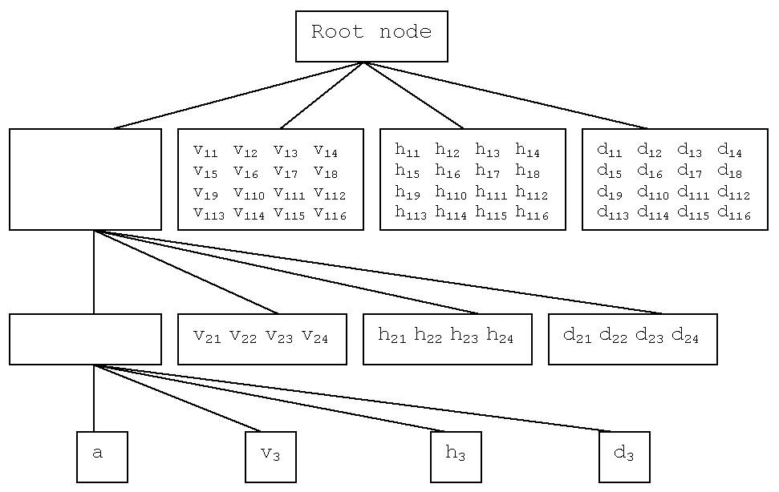

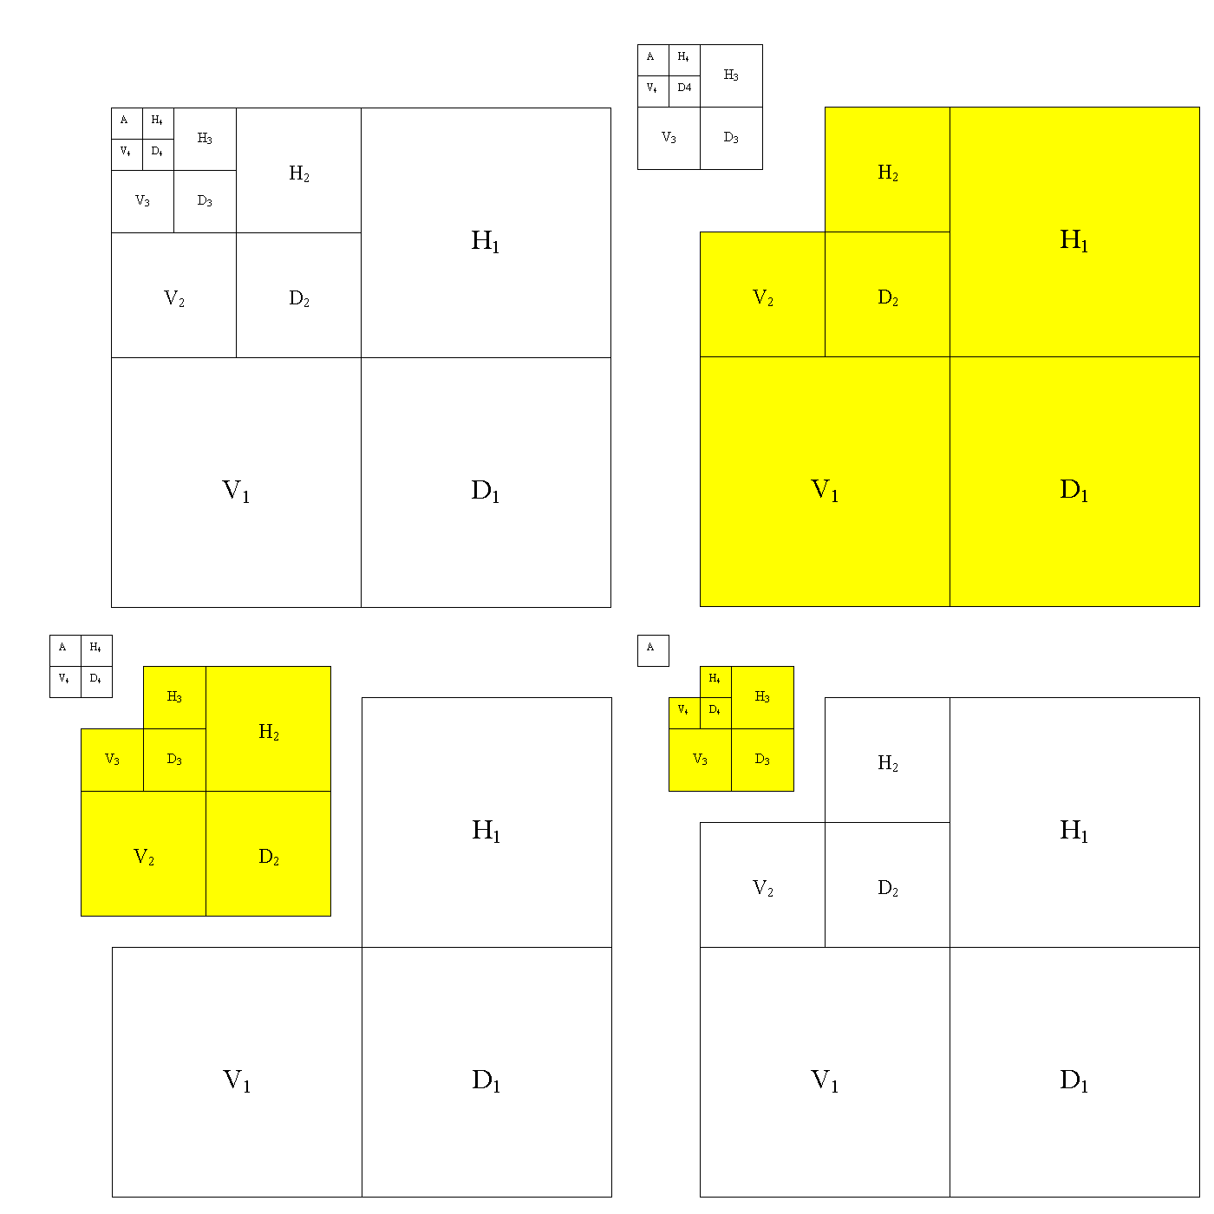
This function also calls the GetHStats function, which has Farid’s computation for these statistics. The computation extracts the features from wavelet decomposition by generating two sets of statistics. The first has the mean, variance, skewness and kurtosis of the subband coefficients. The second set contains the same statistics but derived by the errors from an optimal linear predictor of coefficient magnitude from a comparison with the subband coefficient’s neighbors, with which the spatial, orientation and scale bands will be correlated. The function creates a set of 72 statistics for each image decomposition. Each iteration compares statistics and errors between two subbands. The wavelet decomposition on the above shows the result for the picture shown in the last section. The largest three rectangles are subband 1 and the smallest are subband 4. Each subband has a vertical (lower left band), horizontal (upper right band) and a diagonal (lower right band). The statistics are compared between neighboring bands based on the coefficients and the linear predictor. The figure below shows this iterative process.
The linear predictor for the magnitude of class coefficients in the subset of all possible neighbors for V_{i}(x,y) at scale i is :

$$\begin{aligned}V_{i}(\text{x,y})=w_{1}\left|V_{i}(\text{x-1,y})\right|+{\text{ w}}_{2}\left|V_{i}(x+\text{1,y})\right| \\ +w_{3}\left|V_{i}(\text{x,y-1})\right|+w_{4}\left|V_{i}(\text{x,y}+1)\right| \\ +{\text{ w}}_{5}\left|V_{i+1}(\text{x / 2, y / 2})\right|+w_{6}\left|D_{i}(\text{x,y})\right| \\ +{\text{ w}}_{7}\left|D_{i+1}({x/{\text{2, y}}}/2)\right|\text{; }(1)\end{aligned}$$

The w_{k} values represent scalar weighting values. A simplified matrix representation is:

$\vec{V}=Q\vec{w}$ (2)

The coefficients E are found by minimizing the quadratic error function as:

$E(\vec{w})={\left\|\vec{V}−Q\vec{w}\right\|}^{2}$ (3)
To minimize the error function we differentiate as:

$\frac{\text{dE}(\vec{w})}{d\vec{w}}=2Q^{T}(\vec{V}−Q\vec{w})$ (4)

$\vec{V}$ contains the coefficient magnitudes in a column vector and Q contains the neighboring coefficient magnitudes. The coefficients that maximize the estimator’s squared error is:

$\vec{w}=(Q^{T}Q)^{−1}Q^{T}\vec{V}$ (5)

The linear predictor log error is given by:

${\vec{E}}_{v}={\text{log}}_{2}(\vec{V})−{\text{log}}_{2}(\left|Q\vec{w}\right|)$ (6)

The horizontal subband predictor is:

$$\begin{aligned}H_{i}(\text{x,y})=w_{1}\left|H_{i}(\text{x-1,y})\right|+{\text{ w}}_{2}\left|H_{i}(x+\text{1,y})\right| \\ +w_{3}\left|H_{i}(\text{x,y-1})\right|+w_{4}\left|H_{i}(\text{x,y}+1)\right| \\ +{\text{ w}}_{5}\left|D_{i+1}({\text{x / 2, y}}/2)\right|+w_{6}\left|D_{i}(\text{x,y})\right| \\ +{\text{ w}}_{7}\left|D_{i+1}({x/{\text{2, y}}}/2)\right|\text{; }(7)\end{aligned}$$

The diagonal subband predictor is:

$$\begin{aligned}D_{i}(\text{x,y})=w_{1}\left|D_{i}(\text{x-1,y})\right|+{\text{ w}}_{2}\left|D_{i}(x+\text{1,y})\right| \\ +w_{3}\left|D_{i}(\text{x,y-1})\right|+w_{4}\left|D_{i}(\text{x,y}+1)\right| \\ +{\text{ w}}_{5}D\left|i+1({x/{\text{2, y}}}/2)\right|+w_{6}\left|H_{i}(\text{x,y})\right| \\ +{\text{ w}}_{7}\left|V_{i+1}(\text{x, y})\right|\text{; }(8)\end{aligned}$$

These features are entered into the MakeSetsFLD function for 0-1-min-max normalization, division into randomly generated sets with half its members being of each class and no duplicate images, and training and testing in a Fisher Linear Discriminator (FLD). FLD, published in 1936 by Ronald Fisher in the article "The Use of Multiple Measures in Taxonomic Problems", is a technique that, when data is projected upon it, maximizes the separation between marked classes within the original space by projecting a line through the feature space. The FLD imposes low intra-class dissimilarity and high inter-class dissimilarity, creating a cluster type relationship between the classes’ data. The FLD is described below for x_{i} ∈ ℜ^{n}, i = 1,…,N as original feature vectors. The within class means are:

${\vec{μ}}_{x}=\frac{1}{N_{x}}\left(\sum_{i=1}^{N_{x}}{{\vec{x}}_{i}}\right)$, and ${\vec{μ}}_{y}=\frac{1}{N_{y}}\left(\sum_{j=1}^{N_{y}}{{\vec{y}}_{j}}\right)$ (9)

The mean between classes is defined as:

${\vec{μ}}_{\text{xy}}=\frac{1}{N_{x}+N_{y}}\left(\sum_{i=1}^{N_{x}}{{\vec{x}}_{i}}+\sum_{j=1}^{N_{j}}{{\vec{y}}_{j}}\right)$ (10)

The zero-meaned data is found by:

$M_{x}=(x_{1}−μ_{x},x_{2}−μ_{x},\text{.}\text{.}\text{.},x_{n}−μ_{x})$ and
$M_{y}=(y_{1}−μ_{y},y_{2}−μ_{y},\text{.}\text{.}\text{.},y_{n}−μ_{y})$ (11)

The covariance matrices of the zero-meaned data is found by:

$C_{x}=M_{x}M_{x}^{T}$, and $C_{y}=M_{y}M_{y}^{T}$ (12)

The within class scatter matrix is the sum of the two covariance matrices of the zero-meaned data:

$S_{w}=C_{x}+C_{y}$ (13)

The between class scatter matrix is:

$S_{b}=N_{x}\left({\vec{μ}}_{x}−\vec{μ}\right){\left({\vec{μ}}_{x}−\vec{μ}\right)}^{T}+N_{y}\left({\vec{μ}}_{y}−\vec{μ}\right){\left({\vec{μ}}_{y}−\vec{μ}\right)}^{T}$ (14)

The maximal generalized eigenvalue-eigenvector of S_{b} and S_{w} is:

$S_{b}\vec{e}={λS}_{w}\vec{e}$ (15)

This $\vec{e}$ projects the two-dimensional data onto one dimension, where a threshold t value can be defined to partition the normalized clean and stego features obtained from the previous operation. The training exemplars are projected onto a single dimension by $x_{i}={\vec{x}}_{i}^{T}\vec{e}$ for class 0 and $y_{i}={\vec{y}}_{i}^{T}\vec{e}$ for class 1, which decreases the within class scatter and increases the between class scatter. The image below shows a set of training exemplars in two clusters in regions 1 and 2. After these data points are projected onto a single dimension, the threshold is derived by finding a value that best divides the classes. To test the features chosen for the test set, the instances are projected onto $\vec{e}$ to obtain a value to be compared to t, such that any instance that is above x_{i} < t is in a class different than those where x_{i} ≥ t. The process is basically a variant of PCA.
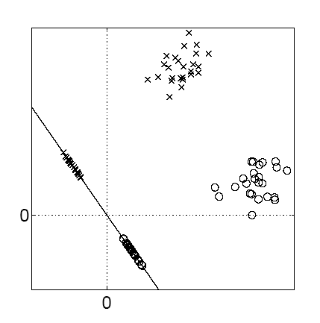

Observation
bior31
TN0FN0TP1FP1
100.0000000.00000099.0000001.000000
100.0000000.000000100.0000000.000000
100.0000000.00000099.0000001.000000
100.0000000.00000097.0000003.000000
100.0000000.00000096.0000004.000000
100.0000000.00000098.0000002.000000
100.0000000.000000100.0000000.000000
100.0000000.00000098.0000002.000000
100.0000000.000000100.0000000.000000
100.0000000.00000099.0000001.000000
-----------------------------------------------------
100.0000000.00000098.6000001.400000
rbio55
TN0FN0TP1FP1
100.0000000.00000099.0000001.000000
100.0000000.00000099.0000001.000000
100.0000000.00000099.0000001.000000
100.0000000.00000099.0000001.000000
99.0000001.000000100.0000000.000000
100.0000000.00000096.0000004.000000
100.0000000.00000097.0000003.000000
100.0000000.00000099.0000001.000000
100.0000000.000000100.0000000.000000
99.0000001.000000100.0000000.000000
-----------------------------------------------------
99.8000000.20000098.8000001.200000

The tests were run on FLD for every wave decomposition filter that worked in Matlab. The training set was 80% of the instances with the remaining left for testing. The best results from the trials are a tie from the wavelet decompositions using the Biorthogonal (bior3.1) and Reverse Biorthogonal (rbio5.5) filters. All of the experimental results are included in the Appendix. All of the experimental results are remarkably high. At first, FLD did not perform well predicting the image classes. The results skyrocketed when 0-1-min-max normalization was applied to the raw feature data.

Conclusion

This method is very successful in detecting hidden messages in the test images. This experiment was performed on a domain restricted to similar size and type of image. A more diverse set may not have such results. My results are a little higher than the authors’ because the authors used 500 images to train the FLD and I used 1000.

Problems

I noticed a couple of problems with the methods used by the author. The first was that the Matlab log2 function was used in the code to extract the high order statistics from the wavelet decompositions and the possibility of a log of zero error was not handled. This caused errors when the program was run. I fixed this by catching the n_{i} = 0 before log2(n_{i}) function was called and replace 0 with 0.000001, a very small value compared to the average in any vector. The second problem that I found is that the jpeg images were of differing sizes and could contain different size messages. I added a loop to attempt to fill the stego jpeg images with sufficiently large messages.

Other Classifiers

I wrote a program to Matlab function to automatically write arff files for Weka given the features created by the idealized multi-scale and orientation decomposition of frequency space statistics. I ran the data from bior3.1 and rbio5.5 in Weka for four classifiers: J4.8, SMO, Logistic and Naïve Bayes. The following table shows the results.

Classification Accuracy by Filter
Filter/Classifier | J4.8 | SMO | Logistic | Naïve Bayes
bior3.1 | 97.5% | 100% | 99% | 95.5%
rbio5.5 | 95% | 99.5% | 98% | 94%

The method is also very accurate on these classifiers.

Future Work

I would like to perform some pattern matching experiments on a complete list of English words and text mining on various types of communications to determine the optimal set of stego stems to decode hidden messages in uncompressed images. I would like to try various cryptanalysis experiments with these stems to test effectiveness on ciphers. This set would be very useful in cryptographic research. I would also like to implement a c/assembly-code version of the system to improve efficiency.

Appendices

Appendix 1: Trial results

sym2
TN0 FN0 TP1 FP1
100.000000 0.000000 98.000000 2.000000
100.000000 0.000000 96.000000 4.000000
100.000000 0.000000 99.000000 1.000000
100.000000 0.000000 98.000000 2.000000
99.000000 1.000000 98.000000 2.000000
100.000000 0.000000 94.000000 6.000000
100.000000 0.000000 99.000000 1.000000
100.000000 0.000000 95.000000 5.000000
100.000000 0.000000 99.000000 1.000000
100.000000 0.000000 100.000000 0.000000
--------------------------------------------
99.900000 0.100000 97.600000 2.400000

sym8
TN0 FN0 TP1 FP1
99.000000 1.000000 98.000000 2.000000
100.000000 0.000000 100.000000 0.000000
100.000000 0.000000 100.000000 0.000000
100.000000 0.000000 97.000000 3.000000
99.000000 1.000000 100.000000 0.000000
100.000000 0.000000 97.000000 3.000000
100.000000 0.000000 99.000000 1.000000
99.000000 1.000000 94.000000 6.000000
99.000000 1.000000 98.000000 2.000000
100.000000 0.000000 97.000000 3.000000
--------------------------------------------
99.600000 0.400000 98.000000 2.000000

haar
TN0 FN0 TP1 FP1
100.000000 0.000000 99.000000 1.000000
100.000000 0.000000 98.000000 2.000000
100.000000 0.000000 95.000000 5.000000
100.000000 0.000000 99.000000 1.000000
100.000000 0.000000 97.000000 3.000000
100.000000 0.000000 99.000000 1.000000
100.000000 0.000000 99.000000 1.000000
98.000000 2.000000 98.000000 2.000000
98.000000 2.000000 98.000000 2.000000
99.000000 1.000000 98.000000 2.000000
--------------------------------------------
99.500000 0.500000 98.000000 2.000000

db4
TN0 FN0 TP1 FP1
100.000000 0.000000 97.000000 3.000000
100.000000 0.000000 99.000000 1.000000
100.000000 0.000000 98.000000 2.000000
100.000000 0.000000 97.000000 3.000000
100.000000 0.000000 99.000000 1.000000
100.000000 0.000000 94.000000 6.000000
100.000000 0.000000 96.000000 4.000000
100.000000 0.000000 99.000000 1.000000
100.000000 0.000000 98.000000 2.000000
100.000000 0.000000 99.000000 1.000000
--------------------------------------------
100.000000 0.000000 97.600000 2.400000

db15
TN0 FN0 TP1 FP1
100.000000 0.000000 97.000000 3.000000
100.000000 0.000000 100.000000 0.000000
100.000000 0.000000 95.000000 5.000000
100.000000 0.000000 98.000000 2.000000
100.000000 0.000000 93.000000 7.000000
100.000000 0.000000 99.000000 1.000000
100.000000 0.000000 97.000000 3.000000
100.000000 0.000000 99.000000 1.000000
100.000000 0.000000 95.000000 5.000000
100.000000 0.000000 100.000000 0.000000
--------------------------------------------
100.000000 0.000000 97.300000 2.700000

bior31
TN0 FN0 TP1 FP1
100.000000 0.000000 99.000000 1.000000
100.000000 0.000000 100.000000 0.000000
100.000000 0.000000 99.000000 1.000000
100.000000 0.000000 97.000000 3.000000
100.000000 0.000000 96.000000 4.000000
100.000000 0.000000 98.000000 2.000000
100.000000 0.000000 100.000000 0.000000
100.000000 0.000000 98.000000 2.000000
100.000000 0.000000 100.000000 0.000000
100.000000 0.000000 99.000000 1.000000
--------------------------------------------
100.000000 0.000000 98.600000 1.400000

bior55
TN0 FN0 TP1 FP1
99.000000 1.000000 99.000000 1.000000
100.000000 0.000000 100.000000 0.000000
100.000000 0.000000 99.000000 1.000000
98.000000 2.000000 100.000000 0.000000
100.000000 0.000000 99.000000 1.000000
100.000000 0.000000 96.000000 4.000000
100.000000 0.000000 98.000000 2.000000
100.000000 0.000000 98.000000 2.000000
100.000000 0.000000 97.000000 3.000000
100.000000 0.000000 99.000000 1.000000
--------------------------------------------
99.700000 0.300000 98.500000 1.500000

rbio31
TN0 FN0 TP1 FP1
100.000000 0.000000 98.000000 2.000000
99.000000 1.000000 100.000000 0.000000
100.000000 0.000000 98.000000 2.000000
100.000000 0.000000 99.000000 1.000000
100.000000 0.000000 95.000000 5.000000
100.000000 0.000000 97.000000 3.000000
100.000000 0.000000 100.000000 0.000000
100.000000 0.000000 96.000000 4.000000
100.000000 0.000000 98.000000 2.000000
100.000000 0.000000 100.000000 0.000000
--------------------------------------------
99.900000 0.100000 98.100000 1.900000

rbio55
TN0 FN0 TP1 FP1
100.000000 0.000000 99.000000 1.000000
100.000000 0.000000 99.000000 1.000000
100.000000 0.000000 99.000000 1.000000
100.000000 0.000000 99.000000 1.000000
99.000000 1.000000 100.000000 0.000000
100.000000 0.000000 96.000000 4.000000
100.000000 0.000000 97.000000 3.000000
100.000000 0.000000 99.000000 1.000000
100.000000 0.000000 100.000000 0.000000
99.000000 1.000000 100.000000 0.000000
--------------------------------------------
99.800000 0.200000 98.800000 1.200000

coif2
TN0 FN0 TP1 FP1
100.000000 0.000000 98.000000 2.000000
100.000000 0.000000 98.000000 2.000000
99.000000 1.000000 97.000000 3.000000
100.000000 0.000000 98.000000 2.000000
100.000000 0.000000 100.000000 0.000000
99.000000 1.000000 92.000000 8.000000
100.000000 0.000000 97.000000 3.000000
100.000000 0.000000 98.000000 2.000000
99.000000 1.000000 100.000000 0.000000
100.000000 0.000000 99.000000 1.000000
--------------------------------------------
99.700000 0.300000 97.700000 2.300000

coif4
TN0 FN0 TP1 FP1
99.000000 1.000000 99.000000 1.000000
99.000000 1.000000 96.000000 4.000000
99.000000 1.000000 99.000000 1.000000
100.000000 0.000000 97.000000 3.000000
100.000000 0.000000 98.000000 2.000000
99.000000 1.000000 100.000000 0.000000
100.000000 0.000000 97.000000 3.000000
99.000000 1.000000 98.000000 2.000000
97.000000 3.000000 99.000000 1.000000
100.000000 0.000000 98.000000 2.000000
--------------------------------------------
99.200000 0.800000 98.100000 1.900000

dmey
TN0 FN0 TP1 FP1
97.000000 3.000000 98.000000 2.000000
100.000000 0.000000 98.000000 2.000000
100.000000 0.000000 97.000000 3.000000
98.000000 2.000000 96.000000 4.000000
97.000000 3.000000 98.000000 2.000000
100.000000 0.000000 97.000000 3.000000
99.000000 1.000000 98.000000 2.000000
98.000000 2.000000 95.000000 5.000000
100.000000 0.000000 97.000000 3.000000
98.000000 2.000000 99.000000 1.000000
--------------------------------------------
98.700000 1.300000 97.300000 2.700000

Appendix 2: Other Classifier Results

bior31

Scheme: weka.classifiers.trees.J48 -C 0.25 -M 2
Test mode: split 80% train, remainder test
Time taken to build model: 0.42 seconds
=== Evaluation on test split ===
=== Summary ===
Correctly Classified Instances 195 97.5 %
Incorrectly Classified Instances 5 2.5 %
Kappa statistic 0.9493
Mean absolute error 0.025
Root mean squared error 0.1581
Relative absolute error 4.985 %
Root relative squared error 31.516 %
Total Number of Instances 200
=== Detailed Accuracy By Class ===
TP Rate FP Rate Precision Recall F-Measure Class
0.966 0.018 0.977 0.966 0.972 0
0.982 0.034 0.973 0.982 0.978 1
=== Confusion Matrix ===
a b <-- classified as
86 3 | a = 0
2 109 | b = 1

Scheme: weka.classifiers.functions.SMO -C 1.0 -E 1.0 -G 0.01 -A 1000003 -T 0.0010 -P 1.0E-12 -N 0 -V -1 -W 1
Test mode: split 80% train, remainder test
=== Classifier model (full training set) ===
Number of kernel evaluations: 49477
Time taken to build model: 0.81 seconds
=== Evaluation on test split ===
=== Summary ===
Correctly Classified Instances 200 100 %
Incorrectly Classified Instances 0 0 %
Kappa statistic 1
Mean absolute error 0
Root mean squared error 0
Relative absolute error 0 %
Root relative squared error 0 %
Total Number of Instances 200
=== Detailed Accuracy By Class ===
TP Rate FP Rate Precision Recall F-Measure Class
1 0 1 1 1 0
1 0 1 1 1 1
=== Confusion Matrix ===
a b <-- classified as
89 0 | a = 0
0 111 | b = 1

Scheme: weka.classifiers.functions.Logistic -R 1.0E-8 -M -1
Test mode: split 80% train, remainder test
Time taken to build model: 4.92 seconds
=== Evaluation on test split ===
=== Summary ===
Correctly Classified Instances 198 99 %
Incorrectly Classified Instances 2 1 %
Kappa statistic 0.9798
Mean absolute error 0.01
Root mean squared error 0.1
Relative absolute error 1.994 %
Root relative squared error 19.9312 %
Total Number of Instances 200
=== Detailed Accuracy By Class ===
TP Rate FP Rate Precision Recall F-Measure Class
1 0.018 0.978 1 0.989 0
0.982 0 1 0.982 0.991 1
=== Confusion Matrix ===
a b <-- classified as
89 0 | a = 0
2 109 | b = 1

Scheme: weka.classifiers.bayes.NaiveBayes
Test mode: split 80% train, remainder test
Time taken to build model: 0.11 seconds
=== Evaluation on test split ===
=== Summary ===
Correctly Classified Instances 191 95.5 %
Incorrectly Classified Instances 9 4.5 %
Kappa statistic 0.9088
Mean absolute error 0.0418
Root mean squared error 0.1894
Relative absolute error 8.3268 %
Root relative squared error 37.7543 %
Total Number of Instances 200
=== Detailed Accuracy By Class ===
TP Rate FP Rate Precision Recall F-Measure Class
0.944 0.036 0.955 0.944 0.949 0
0.964 0.056 0.955 0.964 0.96 1
=== Confusion Matrix ===
a b <-- classified as
84 5 | a = 0
4 107 | b = 1

rbior31

Scheme: weka.classifiers.trees.J48 -C 0.25 -M 2
Test mode: split 80% train, remainder test
Time taken to build model: 0.45 seconds
=== Evaluation on test split ===
=== Summary ===
Correctly Classified Instances 190 95 %
Incorrectly Classified Instances 10 5 %
Kappa statistic 0.899
Mean absolute error 0.051
Root mean squared error 0.2186
Relative absolute error 10.1616 %
Root relative squared error 43.5752 %
Total Number of Instances 200
=== Detailed Accuracy By Class ===
TP Rate FP Rate Precision Recall F-Measure Class
0.955 0.054 0.934 0.955 0.944 0
0.946 0.045 0.963 0.946 0.955 1
=== Confusion Matrix ===
a b <-- classified as
85 4 | a = 0
6 105 | b = 1

Scheme: weka.classifiers.functions.SMO -C 1.0 -E 1.0 -G 0.01 -A 1000003 -T 0.0010 -P 1.0E-12 -N 0 -V -1 -W 1
Test mode: split 80% train, remainder test
Time taken to build model: 0.45 seconds
=== Evaluation on test split ===
=== Summary ===
Correctly Classified Instances 199 99.5 %
Incorrectly Classified Instances 1 0.5 %
Kappa statistic 0.9899
Mean absolute error 0.005
Root mean squared error 0.0707
Relative absolute error 0.997 %
Root relative squared error 14.0944 %
Total Number of Instances 200
=== Detailed Accuracy By Class ===
TP Rate FP Rate Precision Recall F-Measure Class
1 0.009 0.989 1 0.994 0
0.991 0 1 0.991 0.995 1
=== Confusion Matrix ===
a b <-- classified as
89 0 | a = 0
1 110 | b = 1

Scheme: weka.classifiers.functions.Logistic -R 1.0E-8 -M -1
Test mode: split 80% train, remainder test
Time taken to build model: 9.97 seconds
=== Evaluation on test split ===
=== Summary ===
Correctly Classified Instances 196 98 %
Incorrectly Classified Instances 4 2 %
Kappa statistic 0.9596
Mean absolute error 0.0197
Root mean squared error 0.1392
Relative absolute error 3.9255 %
Root relative squared error 27.7508 %
Total Number of Instances 200
=== Detailed Accuracy By Class ===
TP Rate FP Rate Precision Recall F-Measure Class
0.989 0.027 0.967 0.989 0.978 0
0.973 0.011 0.991 0.973 0.982 1
=== Confusion Matrix ===
a b <-- classified as
88 1 | a = 0
3 108 | b = 1

Scheme: weka.classifiers.bayes.NaiveBayes
Test mode: split 80% train, remainder test
Time taken to build model: 0.06 seconds
=== Evaluation on test split ===
=== Summary ===
Correctly Classified Instances 188 94 %
Incorrectly Classified Instances 12 6 %
Kappa statistic 0.8796
Mean absolute error 0.0659
Root mean squared error 0.2391
Relative absolute error 13.1439 %
Root relative squared error 47.6558 %
Total Number of Instances 200
=== Detailed Accuracy By Class ===
TP Rate FP Rate Precision Recall F-Measure Class
0.978 0.09 0.897 0.978 0.935 0
0.91 0.022 0.981 0.91 0.944 1
=== Confusion Matrix ===
a b <-- classified as
87 2 | a = 0
10 101 | b = 1

References

jpeg is abbreviation for Joint Photographic Experts Group
ASCII is an abbreviation for American Standard Code for Information Interchange
Cover is the official term given to the original image (or other media) before message hiding.
Stego is the term official term given to an image (or other media) after the message is hidden.
Petitcolas, F.A.P., Anderson, R., Kuhn, M.G., "Information Hiding - A Survey", July1999, URL: http://www.cl.cam.ac.uk/~fapp2/publications/ieee99-infohiding.pdf (11/26/0117:00)
The article from ABC news Web site was formerly located at: http://abcnews.go.com/sections/scitech/DailyNews/webwatch011011.html
The article from Wired is presently available at: http://www.wired.com/news/politics/0,1283,41658,00.html
Jsteg V4 by Derek Upham is available at: ftp://ftp.funet.fi/pub/crypt/steganogrphy
Farid, Hany, “Detecting Steganographic Messages in Digital Images” Department of Computer Science, Dartmouth College, Hanover NH 03755
Fridrich, Jessica; Goljana, Miroslav; Soukalb, David, “Higher-order statistical steganalysis of palette images”, Department of Electrical and Computer Engineering, Department of Computer Science, SUNY Binghamton, Binghamton, NY 13902-6000
Moby™ Words II, Copyright (c) 1988-93, Grady Ward. All Rights Reserved.
Lyu, Siwei and Farid, Hany, “Steganalysis Using Color Wavelet Statistics and One-Class Support Vector Machines”, Department of Computer Science, Dartmouth College, Hanover, NH 03755, USA
Farid, Hany, “Detecting Hidden Messages Using Higher Order Statistical Models” Department of Computer Science, Dartmouth College, Hanover NH 03755
Lyu, Siwei and Farid, Hany, “Higher Order Wavelet Statistics and Their Application to Digital Forensics”, Department of Computer Science, Dartmouth College, Hanover, NH 03755, USA

