Image Compression with Focus on Wavelets
by Thomas Gradel

Abstract

This document describes image compression in a general fashion, then provides the mathematical foundation for wavelets by presenting Fourier transformations. Wavelet mathematics is sketched, with additional details provided in the references. Source code for an interactive demo of wavelets is provided in an appendix. Two highly cited papers using wavelets are summarized. Finally JPEG 2000 is presented as an example of modern wavelet-based image compression.

Problem

A need exists for better image compression technologies. Satellite and geospatial imaging is being applied more and more, creating both larger and a greater number of images. Since the typical image size of taken by a modern airplane camera is 30 megabytes, and these are being used to map the world in the sub-meter range, there are literally millions of images that need to be stored and manipulated. In addition, we can only guess what the needs are for military imaging, as they strive for even greater clarity in surveillance and satellite images.

Technology drives image technology. MPEG now has four MPEG standards [2]: MPEG 1, 4, 7, and 21 due to the availability of greater bandwidth, and the need to control such things a copyrights for digital images. TIFF, once a preferred format for image editing is running out of space, since it's format is based on 32-bit addressing, and current technology is making images greater than 4 megabytes more and more common. Finally, there are few image formats that easily support multi-spectral formats, for example those that support than RGB channels, infrared, and other sensors simultaneously.

The bulk of the commonly used image formats are based on old formats. GIF is based on GIF87A and PNG, and newer form of GIF, uses LZ77 compression, standards from 1987 and 1977 respectively. Image and compression technology that is 10 to 20 years old is being used for much of our Internet based imagery. JPEG 2000, a relative newcomer, that uses wavelet compression as it's compression engine will be one of formats examined in this document.

Motivation

Compression technology is big business. Cable companies are currently pushing digital cable, a technology that grew because 5 digital channels of information could be compressed in the same bandwidth as used for a single analog channel. This opened up other features, since digital transmission can be bidirectional, leading to cable modem technology and cable internet. Other examples of major industries include audio/video DVD's and the Internet.

Video compression is patentable. Unisys Corporation angered the world when it began to enforce its patent on the compression used in GIF image format after GIF had already been established as an Internet format. Major players such as Microsoft were forced to pay Unisys an undisclosed sum of money for including GIF support in their browser.

Mr. Sid format by LizardTech is the defacto standard for multi-resolution images using wavelets. Portions of this technology related to how wavelet coefficients are efficiently stored in memory are patented, so use of Mr. Sid format is therefore protected by patent, in addition to copyright laws.

Thankfully, JPEG 2000, which uses wavelets, remains an open standard. This opens the way for JPEG 2000 to be included in browsers and other image software without the need to pay royalties.

Methodology

This document will describe the following areas:
- image compression - background
- frequency domain transforms - mathematical preliminary
- multi-resolution images - what they are, and why they are used
- wavelet transforms - mathematics behind wavelets
- MATLAB and texts wavelet implementation - refer to interactive demo
- JPEG 2000 - what is is, and why it will be important

So, this document will provide some background, the mathematics, a sample implementation, then conclude by describing an important modern image format that uses wavelets.

Background

The objective of image compression, or any compression, is to maximize information and eliminate redundancy. For example, the following simple run length encoding (RLE) scheme encodes MISSISSIPPI as a count followed by the number of characters.

1-M | 1-I | 2-S | 1-I | 2-S | 1-I | 2-P | 1-I

If 2 bits were necessary to hold the numbers 1 or 2, and 8 bits for the letter, this encoding scheme would require 8 * (8 + 2) = 80 bits versus 11 * 8 = 88 bits for the unencoded representation. There are numerous extensions to this, including Huffman encoding that uses statistical frequency of the encoded characters to minimize the overall size.

Other forms of encoding use difference encoding, capitalizing on the fact that within a small area, changes are typically small, hence differences can be stored with less data. For example, 1D and 2D FAX encoding stores differences in 1's and 0's for scanned character data both across and down the page. ADPCM (Adaptivie Pulse Code Modulation) uses differences to encode voice.

Finally MPEG uses a differencing scheme that accounts for the fact that many areas within a video image frame remain the same, and some change in predictive ways. Figure 1 illustrates I-frames, which contain a complete image frame, P-frames, which are predictions of how the image will change over time, and B-frames, which are the differences from either I- or P- frames that are how the image actually changes. Thus MPEG uses 3-dimensional differencing in its encoding scheme.

Figure 1: MPEG I,P,B Frame

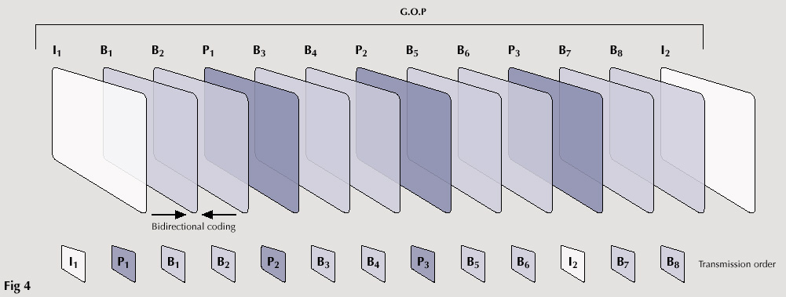

MPEG, JPEG and other image compression formats first transform images data from the spatial domain to the frequency domain before doing difference encoding. The spatial domain is the domain of the sampled image data, normally RGB values. Here is a definition of the frequency domain [3]:

The frequency domain is a space in which each image value at image position F represents the amount that the intensity values in and image vary over a specific distance related to F. In the frequency domain, changes in image position correspond to changes in the spatial frequency, (or the rate at which image intensity values) are changing in the spatial domain image.

So, a small frequency domain value indicates a small change in intensity value in the spatial domain, i.e. an area that is "background", and a large frequency domain value indicates a large change in intensity value in the spatial domain, i.e. and "edge".

Frequency domain translations would be useless unless they were also reversible, meaning that it is possible to translate to the frequency domain -- and back again -- to the spatial domain. Thus, the image in the frequency domain can be manipulated, perhaps by applying filters, then transformed back to the spatial domain so that the results can be viewed. Figure 2 illustrates this process:

Figure 2: Frequency Domain Filtering Process

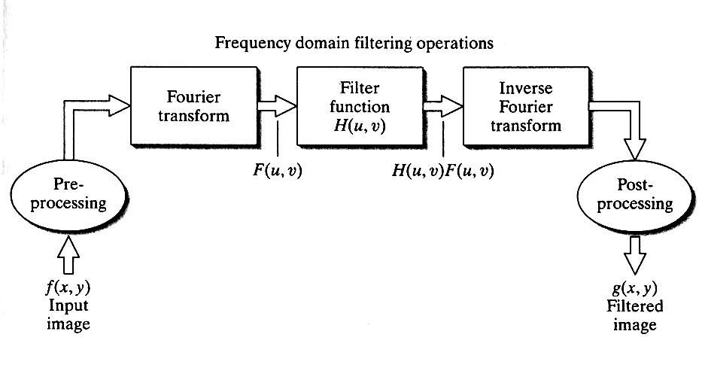

Frequency domain filters can therefore identify special, or redundant information. Both highpass and lowpass filters can be used to either blur or enhance images by applying convolutions to neighborhoods in exactly the same fashion as edge filters could be applied in the spatial domain. Figure 3 illustrates an example of applying filters in the spatial domain. Top-left is the original image; top-right its highpass frequency domain counterpart. Lower-left is a high-frequency emphasis result, and lower-right is the lower-left image after histogram equalization.

Figure 3: Image Enhancement in Frequency Domain
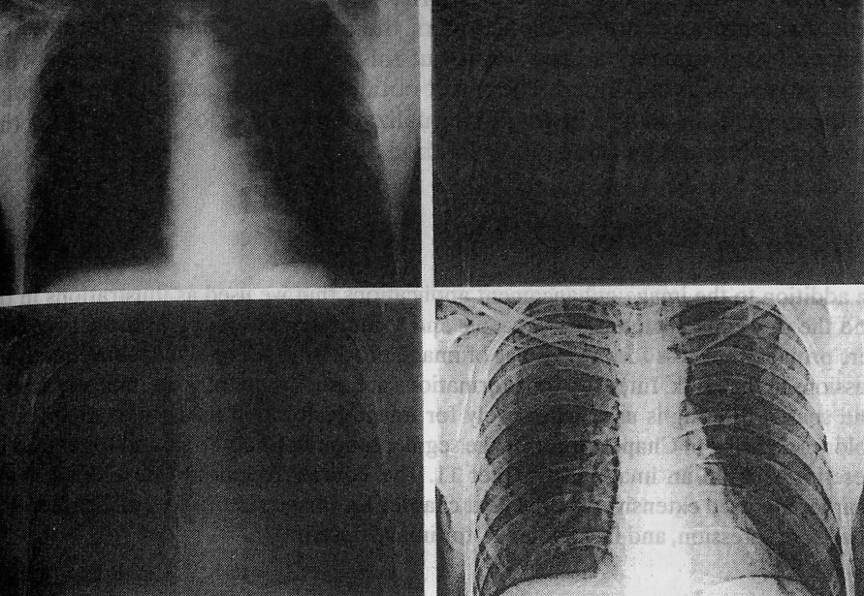

Mathematics

The following briefly discusses the mathematics by gusing Fourier transforms. A parallel discussion introduces wavelet transforms and shows how they differ from their Fourier transform counterparts.

The generalized form of forward and reverse transforms is as follows:
- Forward Transform:
- Reverse Transform
The Discrete Fourier Transform fits into this formulation:
The transform domain variables v and u represent horizontal and vertical frequency. An important characteristic of this equation, called the kernel, is that it is separable, namely

Another characteristic is that it is orthnormal:

The separability of the kernel means that 2-D transformations can be simplified since the 1-D transformations can be used. Orthonormality means that the forward and reverse kernels are complex conjugates of each other.

Discrete Wavelet Transforms (DWT) have similar properties, namely separability, scalability, and translatability. Instead of going through all the mathematics, which is explained in [1], the following simply highlights a couple of the equations illustrating this:
- Separability -- H,V,D are the horizontal, vertical and diagonal wavelets
- Scalability

The result of these and other wavelet properties are the Fast Wavelet Transforms (FWT), which indicates that wavelet properties can be expressed as linear combinations of double-resolution copies of themselves:

Where, h_{φ} and h_{ψ} are called the scaling and wavelet vectors, respectively. The basic idea is to apply the DWT to downsampled copies of the original data. Figure 4 illustrate this, where 2↓ indicates downsampling. The image is decomponsed into four lower resolution components.

Figure 4: Down-sampling in the forward DWT

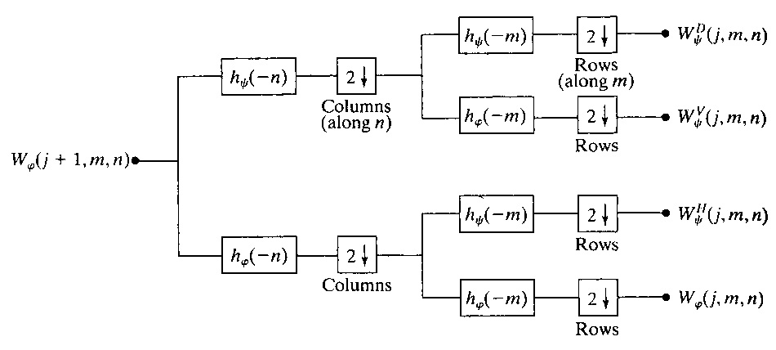

One of the strengths of wavelet compression is as a result of this downsampling. Wavelet compression is a excellent form of compression to store multi-resolution image, since the size of the associated coefficients can be considerable less than the size of the multiresolution data set. Figure 5 illustrates a multi-resolution image [4].

Figure 5: Multi-resolution Image

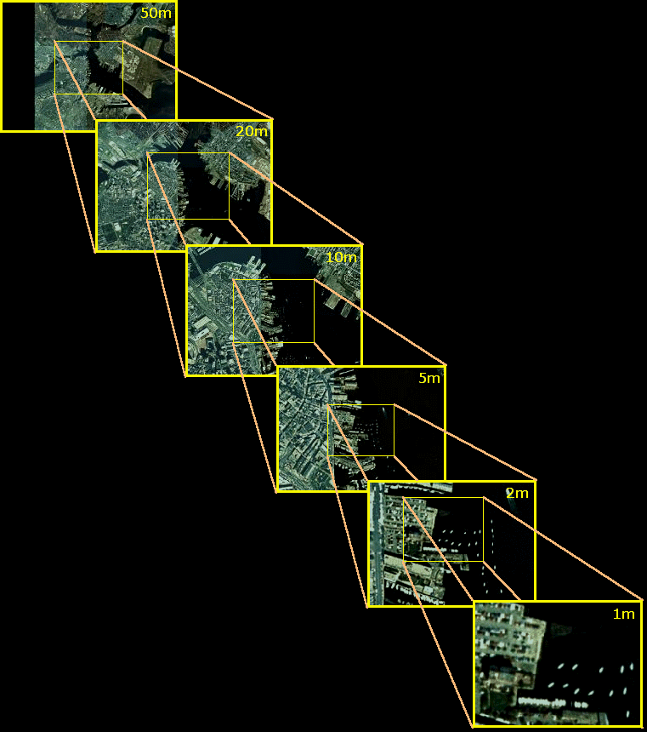

This figure shows a 1 Mbyte window into a 50 Mbyte file. For example the image labeled "1m" might fill a computer screen. As the map is zoomed out, image "2m" is displayed, and more information around the original image is displayed. Image "2m" is the second layer of a multi-resolution image. The first layer is the original image, and layer 2 is downsampled by 2. If the original image was N x N, the layer 2 is N / 2 x N / 2 in size. Each of the layers is illustrated in this figure. The top layer, the smallest layer is N / 50 x N / 50 in size, and encompasses the intire map in a single 1 Mbyte image.
Wavelet Demo

Appendix 1 of this document contains the source code for examples adapted from [1].

JPEG 2000

The JPEG file format is a very important format, used on the Internet, and by most of the images in this document because it produces relatively high quality images with very high compression rates. Unlike some formats, such as GIF, compression is lossy, meaning that successive saves of JPEG images lose more an more information. It is thus suited for read-only, published images, and less suitable for image editing.

JPEG 2000 is a newer form of JPEG that uses wavelets to perform compression. It compresses the same image into roughly half the size of the original JPEG image. It also has a lossless version that compresses approximately 2.5:1 against the original image. As a modern format it also provides support for multi-spectral data sets (RGB + 253 other layers) and mult-resolution data sets. The standard file extension is J2K.

In addition, JPEG 2000 images have higher quality than their JPEG counterparts. Figure 6 show examples of the improvement in quality that is available via JPEG 2000.

Figure 6: JPEG vs. JPEG 2000 Image (JPEG 2000 on right)

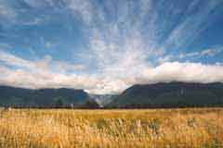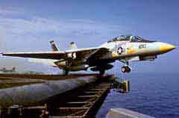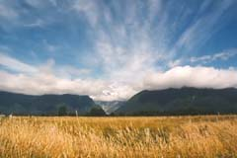

Current Research

Here I look at only two papers that are current research in the wavelet area. These are two of the most highly cited papers on CiteSeer, so represents two of the areas in wavelets where research is focused.

The first is a paper by Eck et al, entitled Multiresolution Analysis of Arbitrary Meshes[6]. The paper focuses on improvements to allow wavelets to be applied to arbitrary meshes, where previously only a simplified subset of meshes could be applied. Evidently wavelets are important tools toward rendering of meshes, since they allow complex meshes to be stored in a more compressed format. Also the properties of wavelets that allow multi-resolution refinement of images with greater and greater detail is well adapted to the role that meshes play when rending an object.

The second paper by Donoho and Johnstone, entitiled Adapting to Unknown Smoothness via Wavelet Shrinkage [7]. This paper develops an algorithm named SureShrink that uses wavelets to determine an underlying function from noisy data. It uses wavelet coefficients to bound the error of successive estimates via an adaptive process. The underlying properties of wavelets can be applied to smooth functions in an interative fashion.

Conclusions

This document provided a brief introduction to wavelet technology and illustrated JPEG 2000 as an example of the improvement available by using wavelets. Wavelet clearly satisfy some of the needs for modern image compression by supporting better compression ratios and multi-resolution data sets. We look forward to the time when JPEG 2000 is implemented in modern web browsers so that Internet applications can begin to make use of this technology. Due to changing technology, additional sensors, and more images, further advances in image compression technology will be necessary.

References

[1] Digital Image processing using MATLIB, Gonzales, Woods, Eddins
[2] MPEG standands - Platforme multimedia SHS
http://plateforme.ish-lyon.cnrs.fr/template/standard.php?rubrique=mpeg&langue=en
[3] Frequency domain definition
http://homepages.inf.ed.ac.uk/rbf/HIPR2/freqdom.htm
[4] MPEG frames
http://www.snellwilcox.com/knowledgecenter/books/books/mpeggencoding_basics.pdf
[5] Multi-resolution images
http://tull.mit.edu/ndop/slides.html
www.research.microsoft.com/~hhoppe/siggraph95.ps.gz

% gradel_project

close all;

FILTER = 'db4';

% -------------------------------------------------------------------------
% Illustrate the forward and reverse wavelet transform, and what the
% coefficient matrix looks like -- a small subsampled image, and a set
% of coefficients that allow it to be reconstructed
% -------------------------------------------------------------------------

% Read sample image convert to grayscale and display
I = imread('turkey.jpg');
f = rgb2gray(I);
figure; imshow(f); title 'Original';

% Forward waveley transform to [c,s]
[c, s] = wavefast(f, 2, FILTER);

% Display standard, 8x and absolute 8x
figure; wave2gray(c, s); title 'Show Coefficients';
figure; wave2gray(c, s, 8); title 'Magnify by 8';
figure; wave2gray(c, s, -8); title 'Magnify by abs(8)'

% Compute the inverse tranform
g = waveback(c, s, FILTER);
I = uint8(g);
figure; imshow(I); title 'Reverse';

disp 'Press ENTER to continue.'
pause;
close all;

% -------------------------------------------------------------------------
% Illustrate what would happen if you eliminated one of the layers (for
% compression purposes presumably)
% -------------------------------------------------------------------------

% Read sample image convert to grayscale and display
I = imread('turkey.jpg');
f = rgb2gray(I);
figure; imshow(f); title 'Original';

% Forward wavelet transform to [c,s] but use 4 levels
FILTER = 'sym4';
[c, s] = wavefast(f, 4, FILTER);

% Zero each layer of wavelet coefficients and show results.
[c, g8] = wavezero(c, s, 1, FILTER); title 'Zero 1';
% figure; imshow(g8); title 'Zero 1';
[c, g8] = wavezero(c, s, 2, FILTER); title 'Zero 2';
% figure; imshow(g8); title 'Zero 2';
[c, g8] = wavezero(c, s, 3, FILTER); title 'Zero 3';
% figure; imshow(g8); title 'Zero 3';
[c, g8] = wavezero(c, s, 4, FILTER); title 'Zero 4';
% figure; imshow(g8); title 'Zero 4';

disp 'Press ENTER to continue.'
pause;
close all;

% -------------------------------------------------------------------------
% Illustrate reconstructing successively larger and images, with more
% detail from a coefficient matrix.
% -------------------------------------------------------------------------

% Read sample image convert to grayscale and display
I = imread('turkey.jpg');
f = rgb2gray(I);
figure; imshow(f); title 'Original';

% Forward wavelet transform to [c,s] but use 4 levels
FILTER = 'jpeg9.7';
[c, s] = wavefast(f, 4, FILTER);
wave2gray(c, s, 8);

f = wavecopy('a', c, s);
figure; imshow(mat2gray(f)); title 'Approximation 1';

[c, s] = waveback(c, s, FILTER, 1);
f = wavecopy('a', c, s);
figure; imshow(mat2gray(f)); title 'Approximation 2';

[c, s] = waveback(c, s, FILTER, 1);
f = wavecopy('a', c, s);
figure; imshow(mat2gray(f)); title 'Approximation 3';

[c, s] = waveback(c, s, FILTER, 1);
f = wavecopy('a', c, s);
figure; imshow(mat2gray(f)); title 'Approximation 4';

