Aim: To segment the following figure using PCA with texture resynthesis.

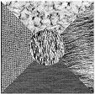

I am including brief results. The main modifications I have done in this program is add the resynthesis and I used Mahalanobis distance instead of Euclidean.
I have taken most of it from Vasudha( the resynthesis part).

There has been much improvement in the segmentation process but as you know about k means it always never gives the same result. Here are some figures.

Resynthesised
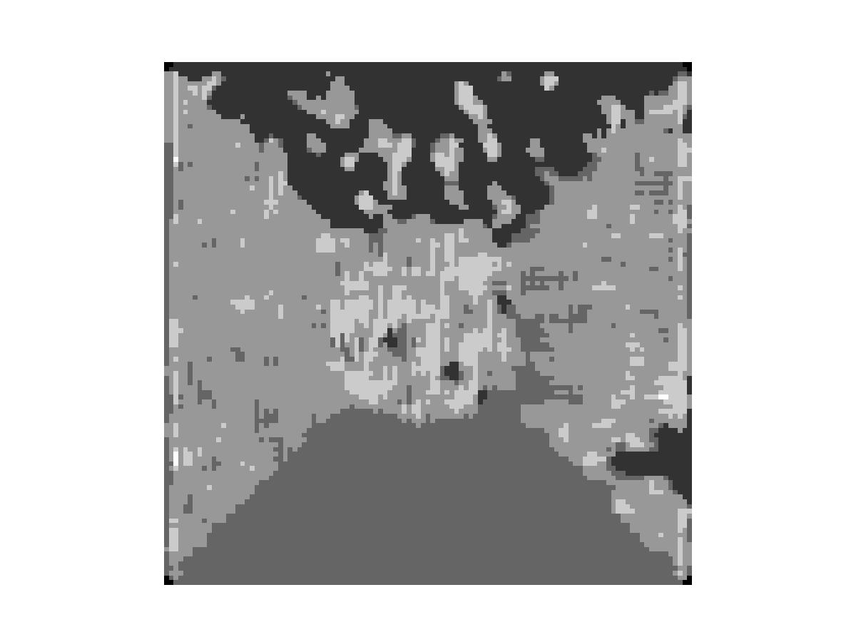Block size 5

Both these images are resynthesised and using Mahalanobis.
We can clearly see that the top and bottom textures are quite distinct but the ones to the sides and the centre though minorly differentiated is almost the same. PCA could not detect the fine textures in these. Thus they fell under the same cluster.
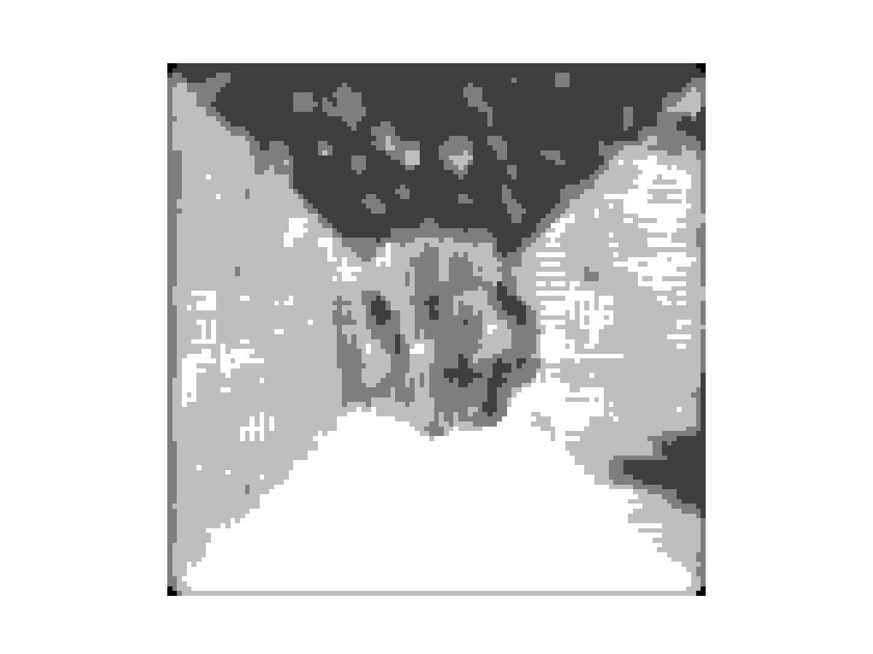block size 8

The results were not so convincing in vasudha s program.

Some other figures:

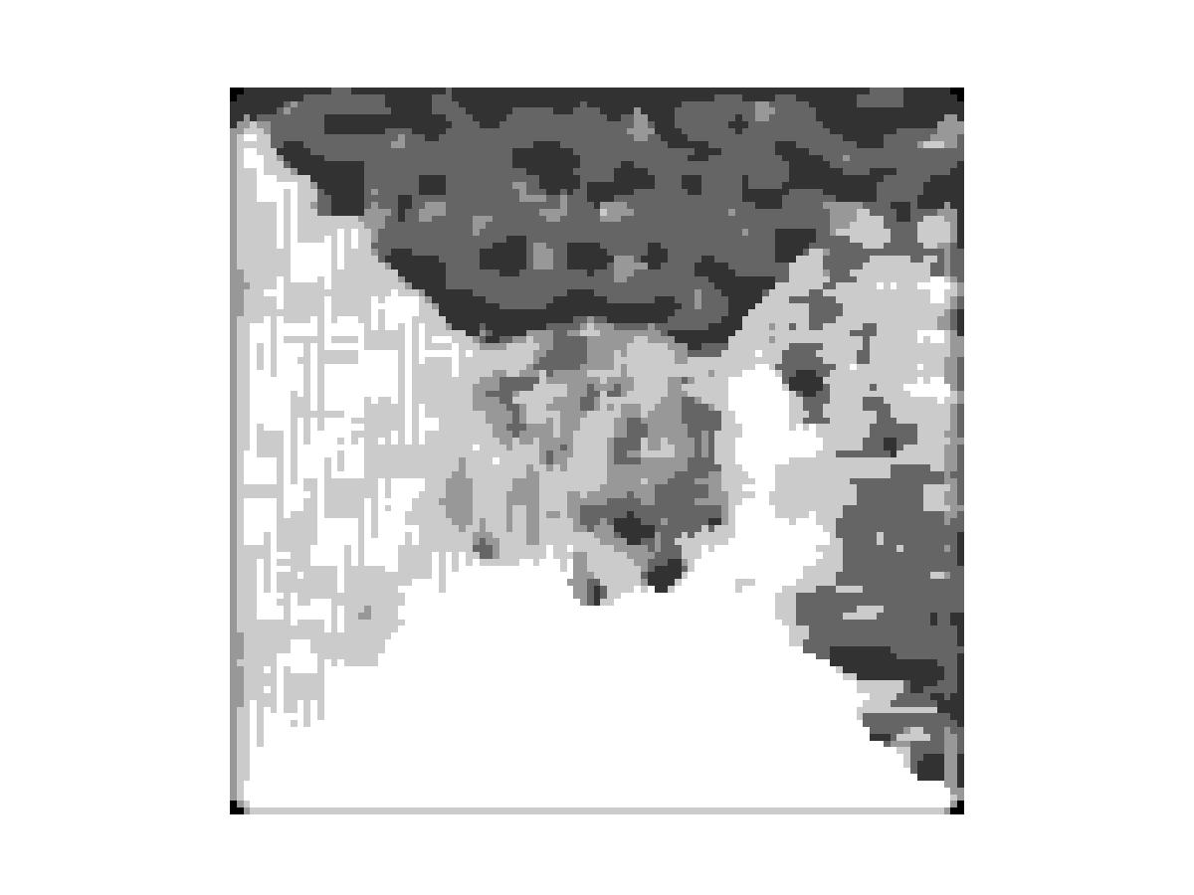Done with Euclidean distance.

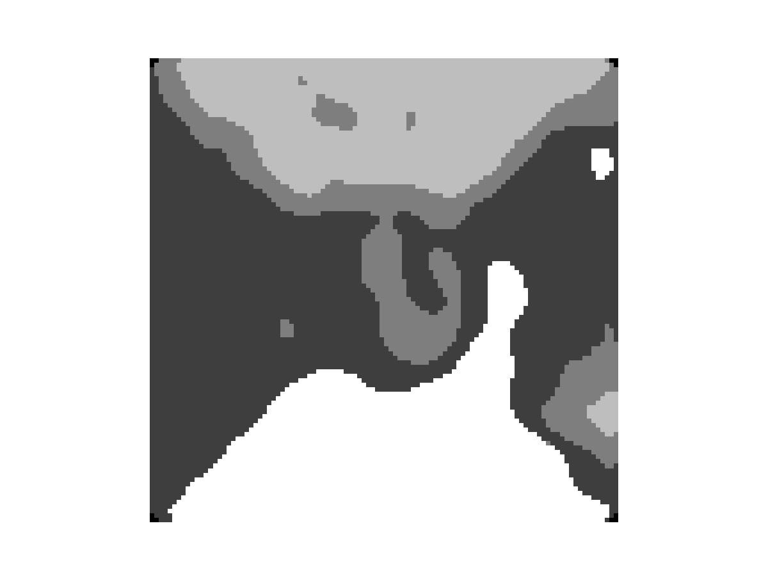Done with a block size of 20 and smoothed.

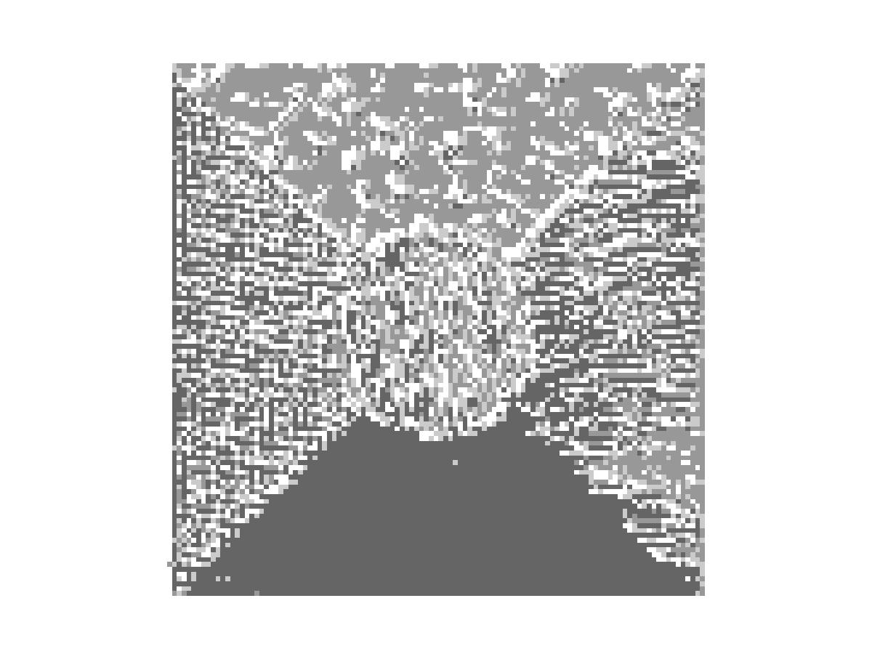This result of resynthesis was good but the colors assigned
were not in contrast in this picture. But we can again see that the textures to the sides were not differentiable. We can observe a slight pattern shift.

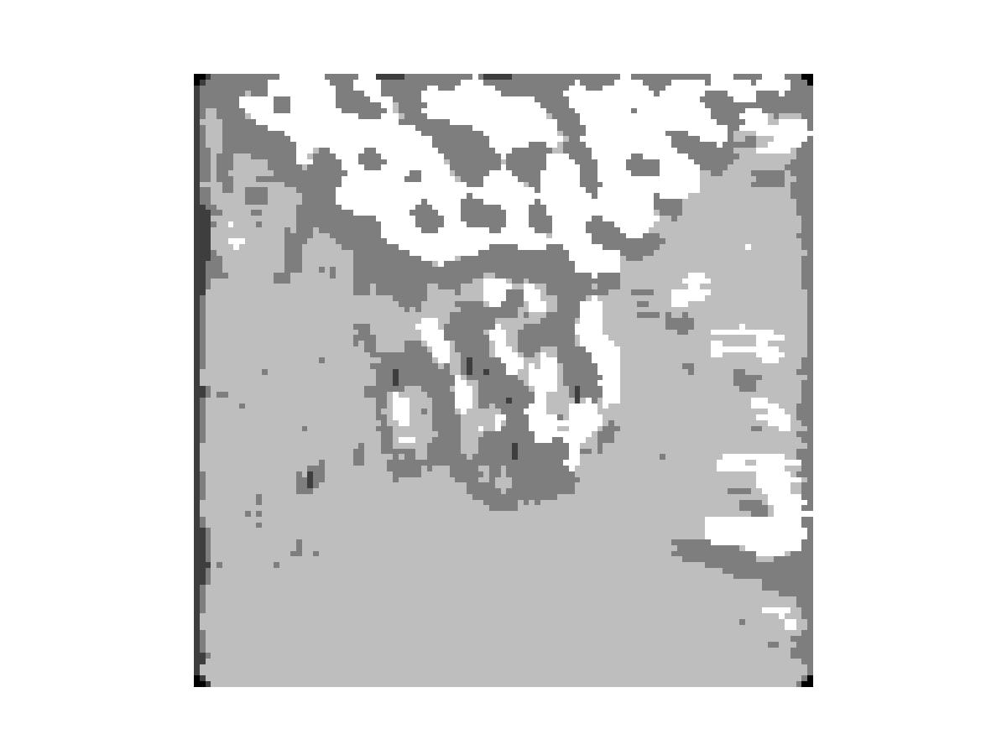Result of vasudha s program.

Overall I feel that mahalanobis has done a good job but takes a lot of time to run.
I am including all the files for the project. KMEANS2 function implements mahalanobis.

All the above figures have 9 principal components.

