A REPORT ON

IMAGE SEGMENTATION BY CLUSTERING
BASED ON
TEXTURE WITH MOMENTS

Prepared for,
Longin Jan Latecki

By,
Dhiraj Sakumalla
(CIS511, Temple University)

Abstract:

Texture segmentation is one of the early steps towards identifying surfaces and objects in an image. In this paper a moment based texture segmentation algorithm is presented. The moments in small windows of the image are used as texture features which are then used to segment the textures. The algorithm has successfully segmented binary images as well as a number of gray level texture images.

Introduction:

Natural images consist of an overwhelming number of visual patterns generated by very diverse stochastic processes in nature. The objective of image understanding is to parse an input image into its constituent patterns.
This can be done by image segmentation. Image segmentation mainly deals with distinguishing objects from its background. It is one of the most important elements in automated image analysis because objects or other entities of interest are extracted from an image for subsequent processing, such as description and recognition. Basically the segmentation is also a process of pixel classification: the picture is segmented into subsets by assigning the individual pixel values to classes. The result may be going into a classification process which assigns some further properties to the previously defined segments.
Image segmentation is a computational process and should NOT be treated as a task.

This means that there cannot a specific output for a segmentation process.
Generally speaking, the more one looks at an image, the more one sees. It seems narrow-minded to think that a segmentation algorithm just outputs one final result. For intensity images (ie, those represented by point-wise intensity levels) four popular approaches are: threshold techniques, edge-based methods, region-based techniques, and connectivity-preserving relaxation methods.
Threshold techniques, which make decisions based on local pixel information, are effective when the intensity levels of the objects fall squarely outside the range of levels in the background. Because spatial information is ignored, however, blurred region boundaries can create havoc.
Edge-based methods center around contour detection: their weakness in connecting together broken contour lines make them, too, prone to failure in the presence of blurring.
A region-based method usually proceeds as follows: the image is partitioned into connected regions by grouping neighboring pixels of similar intensity levels. Adjacent regions are then merged under some criterion involving perhaps homogeneity or sharpness of region boundaries. Over stringent criteria create fragmentation; lenient ones overlook blurred boundaries and over merge. Hybrid techniques using a mix of the methods above are also popular.
A connectivity-preserving relaxation-based segmentation method, usually referred to as the active contour model, was proposed recently. The main idea is to start with some initial boundary shape represented in the form of spline curves, and iteratively modify it by applying various shrink/expansion operations according to some energy function. Although the energy-minimizing model is not new, coupling it with the maintenance of an ``elastic'' contour model gives it an interesting new twist. As usual with such methods, getting trapped into a local minimum is a risk against which one must guard; this is no easy task.

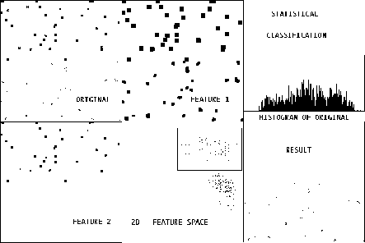

Real world images consist of multiple layers of stochastic processes, such as texture, texton, stochastic point, line, curve, graph, region, and object processes, which generate images through spatial organizations. Thus an appropriate formulation should be image decomposition or parsing, which decomposes an image into its natural constituents as various stochastic processes. This subsumes image segmentation as region process, and naturally integrates object recognition and perceptual organization. The latter deal with point, line, curve, and object processes. Implicit in this formulation is the notion of generative models for image interpretation in contrast to classification and discrimination methods. This observation motivated my work and many others in modeling and learning various stochastic patterns. A segmentation algorithm must be general enough to handle many families of image models in a principled way. For example images with textures.

Image segmentation becomes particularly difficult in the case of textured images. This is because texture is difficult to define and analyze. Texture analysis has been studied for a long time using various approaches. Various methodsperform texture analysis directly upon the gray levels in an image. These include gray levelco-occurrence matrix (GLCM) [11], autocorrelation function analysis [11], generalized cooccurrencematrices (GCM) [8], second order spatial averages [10], and two-dimensional filteringin the spatial and frequency domain [6,5,26,27]. Other approaches operate at a symbolic level where a textured image is organized or represented in terms of primitives.Examples of this can be seen in Julesz’s work [17,18] and in syntactic texture analysis. Some texture analysis methods, for example, Beck et al. have examined the role of spatial frequency channels (signal processing level) and perceptual grouping (symbolic level) in texture segregation [1,2]. Model based analysis of textures is another approach that has often been utilized. These methods include statistical modeling such as Markov random fields (MRF) [7,21] and fractal based modeling [23]. For a more detailed review of the various methods in texture analysis see [25].

Computing features that capture textural properties is at the heart of most of these approaches. What is meant by textural properties often depends on perceptual and psychophysical considerations. That is, the success of a particular feature is in its ability to describe textures that agree with human perception. The perceptual task can be both classification and segmentation.

In this paper we propose a method of obtaining texture features directly from the gray-level image by computing the moments of the image in local regions. Section 2 defines the moments of a two-dimensional function, describes the computation of texture features from the moments, and presents an algorithm that uses these features to segment the texture images.
Section 3 gives experimental results, and Section 4 makes some concluding remarks.

Implementation:
The basic algorithm extends in five steps:
- Step 1:
To break the image into blocks.
- Step 2:
Compute moments for each block.
- Step 3:
Obtain texture feature by applying a non-linear transformation.
- . Step 4:
Perform an unsupervised clustering of the image.
- Step 5:
Classify every pixel in the image according to its features

The flowchart for the following algorithm is given below
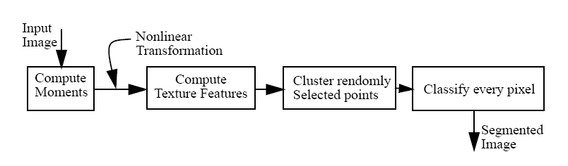

Step 1:
First the input image is broken down into a number of blocks using a function in matlab called IM2COL or the BLOCPROC function. To cut the image into parts i.e windows we use a method called sliding. What this does is, instead of taking the image as distinct blocks of m*n we consider every individual pixel and take the window around it i.e it being the centre. Thus we take a window around every pixel.

Step 2:
MOMENTS:
Our algorithm uses the moments of an image to compute texture features.
The (p+q)th order moments of a function of two variables f(x,y) with respect
to the origin (0,0) are defined as :

m_{pq} = Σ_{x} Σ_{y} f(x,y) x_{p} y_{q}

The central moments are defined as

µ _{pq} = Σ_{x} Σ_{y} (x-x’)p(y-y’) f(x,y)

where,

x’ = m ₁₀/m ₀₀ and y’ = m ₀₁/m ₀₀

And the normalized moments are given by

ŋ _{pq} = µ _{pq} /µ ₀₀

In this way seven 2D moments are calculated and are applied to each block of the image.
m10 / m00 and m01 / m00 give the x and y coordinates of the centroid for the region, respectively. The m20, m11, and m02 can be used to derive the amount of elongation of the region, and the orientation of its major axis. The higher order moments give even more detailed shape characteristics. In this paper we consider the first seven moments i.e for p = 0,1,2,3
In this paper, we regard the intensity image as a function of two variables, f(x,y). We compute a fixed number of the lower order moments for each pixel in the image (we use p+q <=3). The moments are computed within small local windows around each pixel. Each window size is decided upon
the complexity of the image i.e how fine the texture is or how coarse it is.
The size of the window is important. As the window size gets larger, more global features are detected. This suggests that the choice of window size could possibly be tied to the contents of the image. The images with larger texture tokens would require larger window sizes whereas finer textures would require smaller windows. It is also possible to regard the window size as a space parameter and use a multi-scale filtering approach. In this work, there have been experiments in both aspects.

The set of values for each moment over the entire image can be regarded as a new feature image. Let Mk be the kth such image. If we use n moments, then there will be n such moment images. In our experiments, we used up to second order moments. That is, we used m00, m20, m21, m30, m11, m02 and m03 which result in the images M1, M2, M3, M4, M5, and M6, respectively.

Step 3:
The moments alone are not sufficient to obtain good texture features in certain images. Some iso-second order texture pairs which are preattentively discriminable by humans, would have the same average energy over finite regions. However, their distribution would be different for the different textures. Thus to make the feature stronger we apply a non-linear transformation function on each value. This is given by,

tanh(M_{k}(a,b) – M’)

where M_{k} is the kth moments of the point a,b
M’ is the mean of the values of the moments of each point

Thus the output of this step would be a matrix of the size M*N where
M is the total number of pixels in the image and
N is the seven moments for each image

Step 4:
Clustering Algorithm:
Clustering is a classification technique. It involves grouping similar data
together.

Given a vector of N measurements describing each pixel or group of pixels (i.e., region) in an image, a similarity of the measurement vectors and therefore their clustering in the N-dimensional measurement space implies similarity of the corresponding pixels or pixel groups. Therefore, clustering in measurement space is an indicator of similarity of image regions, and is used for segmentation purposes

If n moments are computed over the image, then each pixel will have n feature values associated with it. For a pixel at (i,j), we define a textural feature vector T ij = <F1(i,j), ... , Fn(i,j)> which is a point in an n-dimensional feature space. We perform the texture segmentation by
applying a general purpose clustering algorithm to the texture features Tij. Because the number of pixels and hence the number of feature points is too large, we use a computationally efficient algorithm called K-Means clustering.

K-Means
The K-Means algorithm finds k clusters by choosing k data points at random as initial cluster centers. Each data point is then assigned to the cluster with center that is closest to that point. Each cluster center is then replaced by the mean of all the data points that have been assigned to that cluster. This process is iterated until no data point is reassigned to a different cluster.

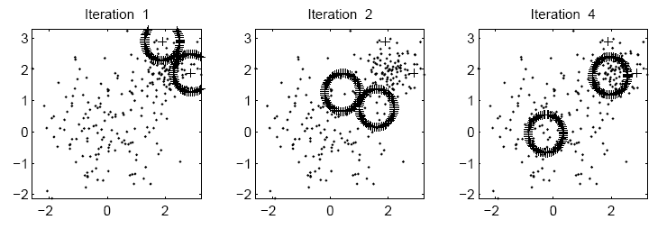
The progress of the K-Means algorithm with k=2 and random initialization on
the two-Gaussian data set (note: some data points omitted for clarity).

Kmeans clustering finds a grouping of the measurements that minimizes the within-cluster sum-of-squares. In this method, each measurement, represented by a vector of length N, is grouped so that it is assigned to one of a fixed number of clusters. The number of clusters is determined by the number of seeds given as the second argument of KMeans. Measurements are transferred from one cluster to another when doing so decreases the within-cluster distances. The algorithm stops when no more transfers can occur.

In the present project we use a function called kmeans1 which takes as arguments the number of clusters needed i.e k and the data matrix which is needed to be clustered. This function returns the distance matrix and the labels allocated to each cluster.

In the kmeans algorithm the distances between the centroids and the points can be calculated using either the Euclidean distance or the Mahalanobis distance. If there are two points p and q then the distance between them will be given by
Euclidean
(p-q) (p-q)⁻¹
Mahalanobis
(p-q) Σ⁻¹ (p-q)⁻¹
where Σ is the covariance matrix.

The Mahalanobis distance yielded better results in most cases. We use both the Euclidean and Mahalanobis distance here.

Step 5:
The labels thus obtained from the clustering algorithm are then remapped back to each pixel in the image and a specific gray value is given to each distinct label. The image which was broken is to be reassembled back into a single image. This is done by a function called col2im which is the reverse process of the im2col function. Thus we obtain the segmented image.

Results:

Several gray level images of textures were put together in pairs to test our segmentation algorithm. These are 128x256 images (each texture is 128x128) and they have a range of 256 gray levels.

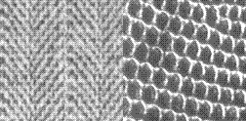



The segmentation obtained for the texture pair in the above figure. The different texture regions are shown as different gray levels.

The above figure, two clusters were taken. But in some cases we observe that the segmentation is not done properly. For example

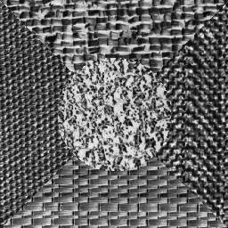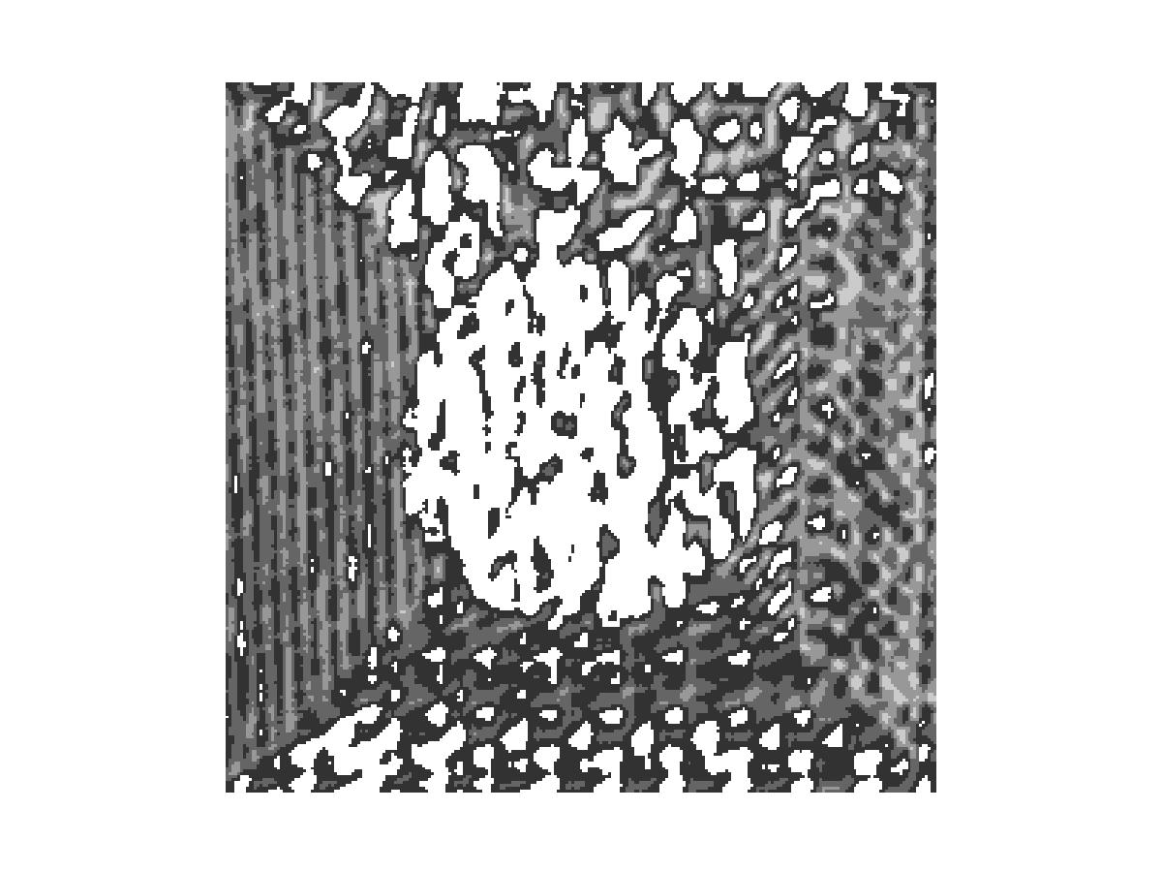

The above figure was segmented using 4 clusters but the result does not seem convincing.

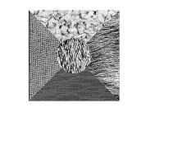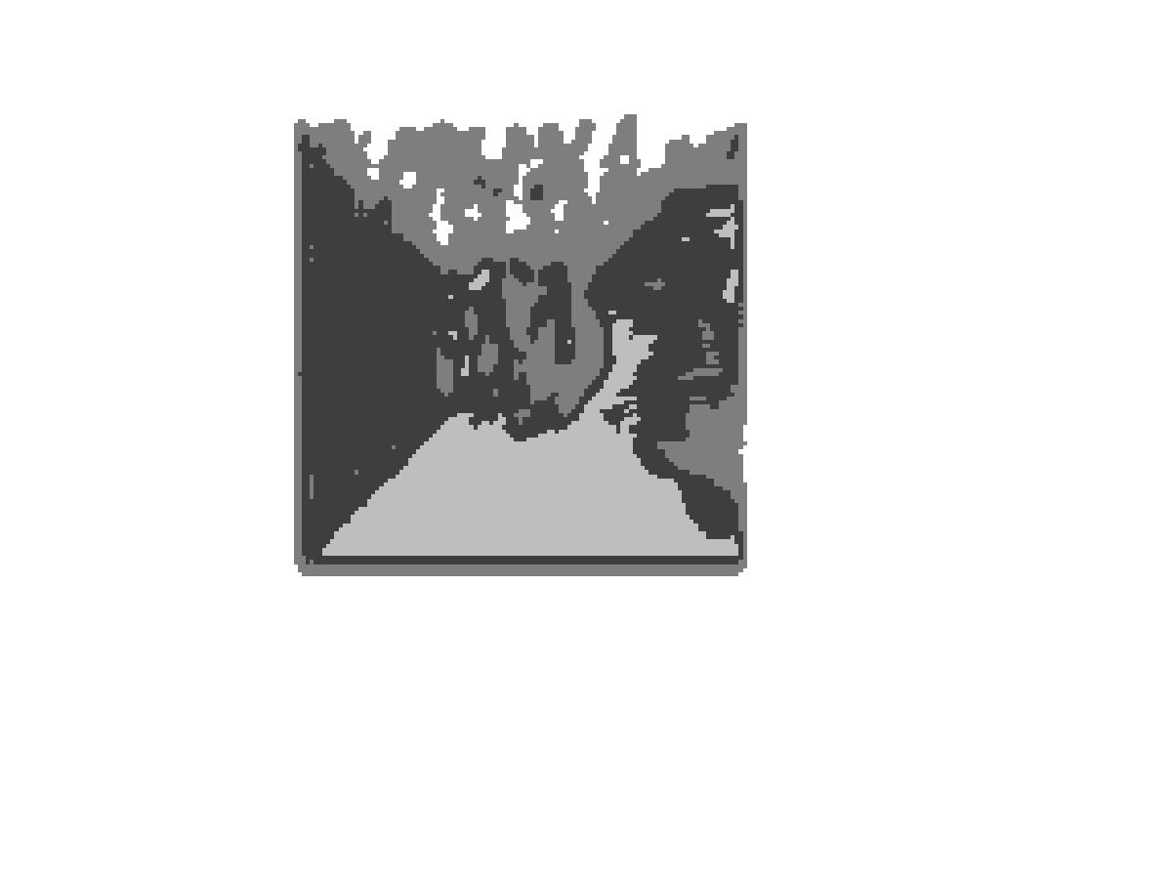
The results in the above figure though not perfect have been segmented appropriately.

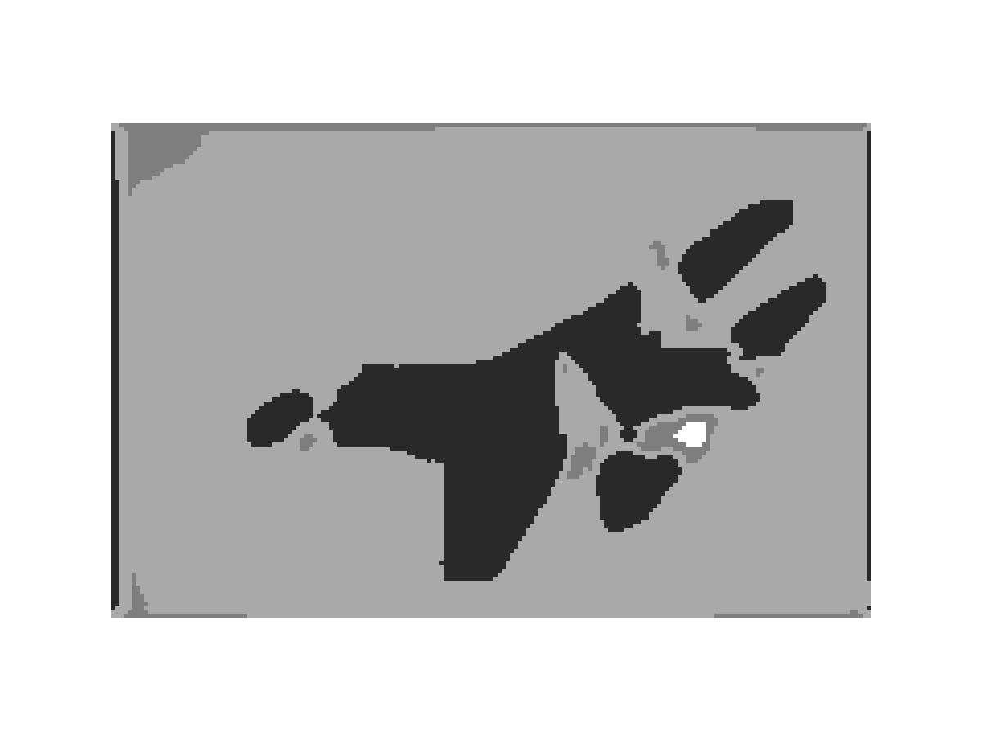

This segmented image has a block size of 5


This image has a block size of 10.

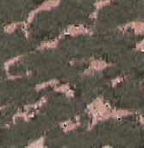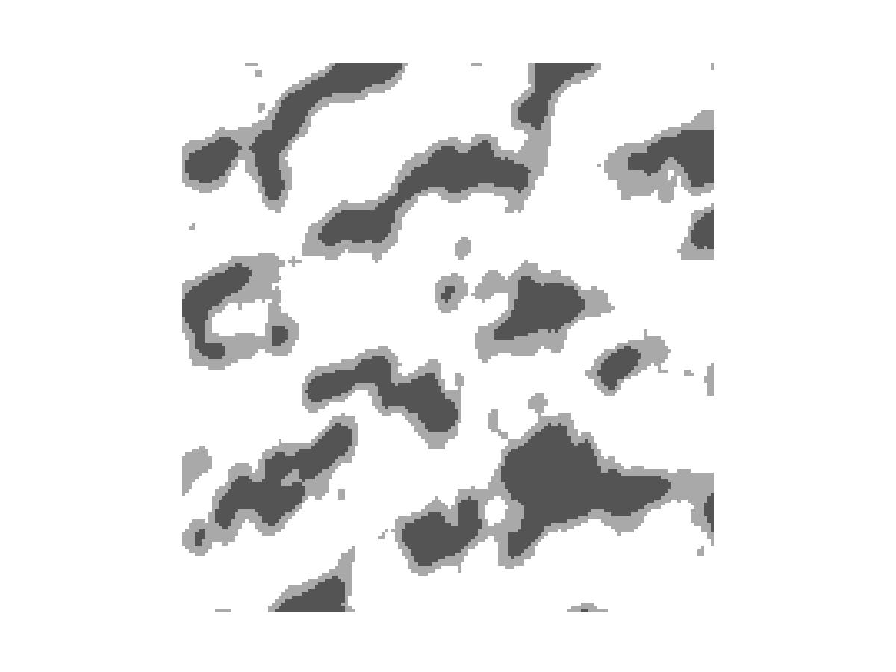
Segmented using 3 clusters


Segmented using 2 clusters.

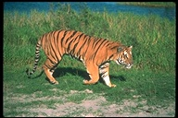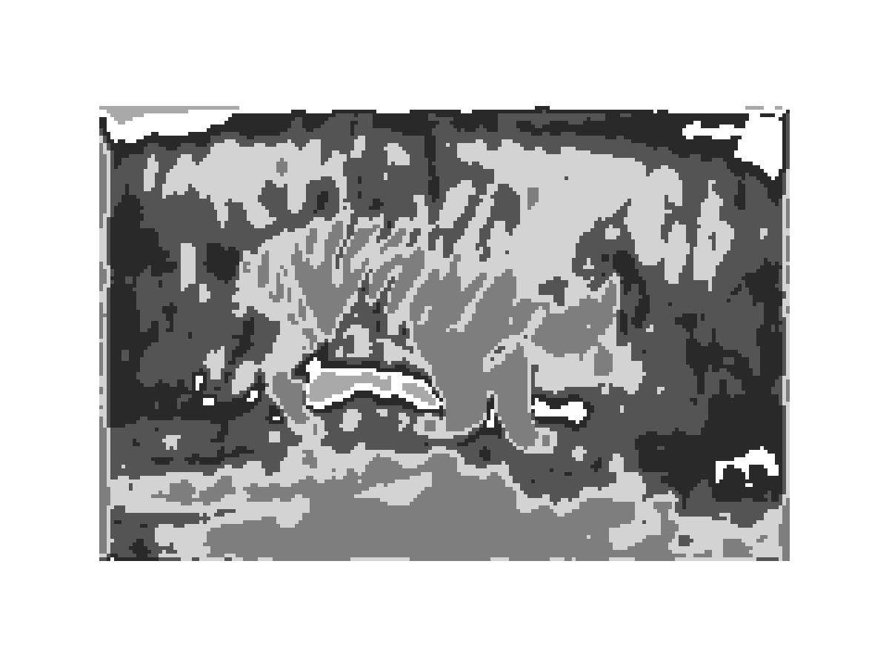
Segmented using 4 clusters.

The above image is very poorly segmented as the whole image only consists of very fine and similar textures.

This application has also been run on real time images. We have also applied our texture segmentation algorithm to some real world problems including
the analysis of ultrasound images of the blood flow in a heart.

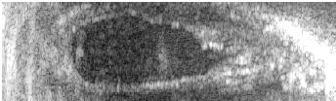


In the above image the portion segmented in white and gray represents blood.
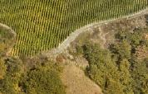
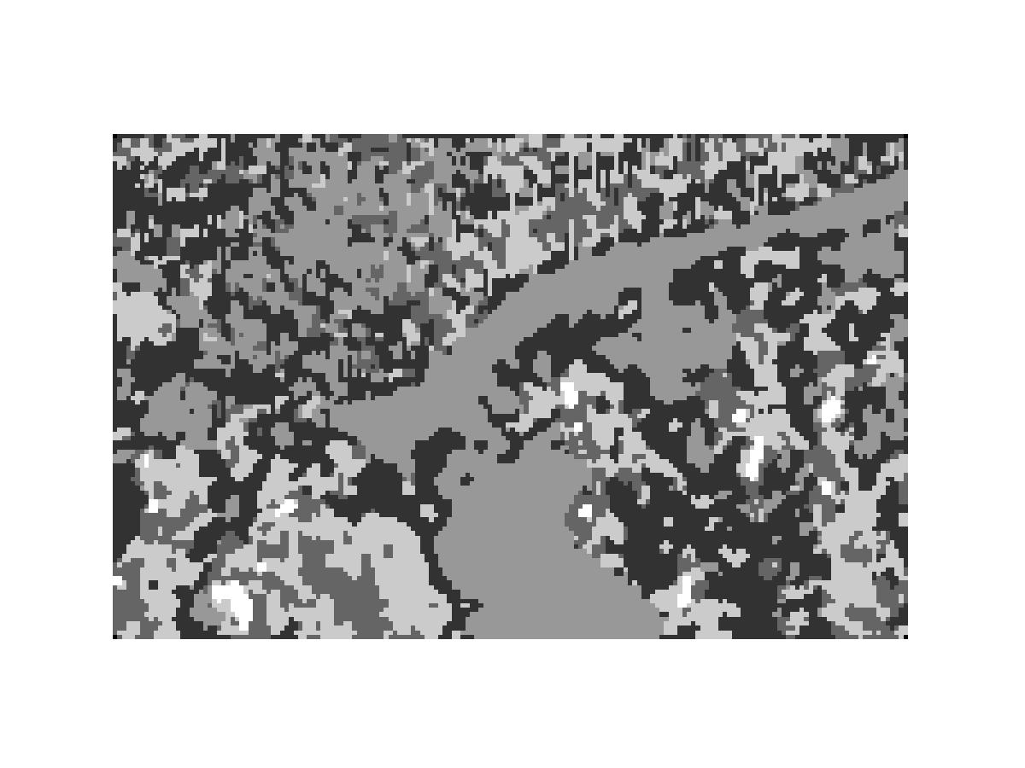
Segmentation result of run 1.

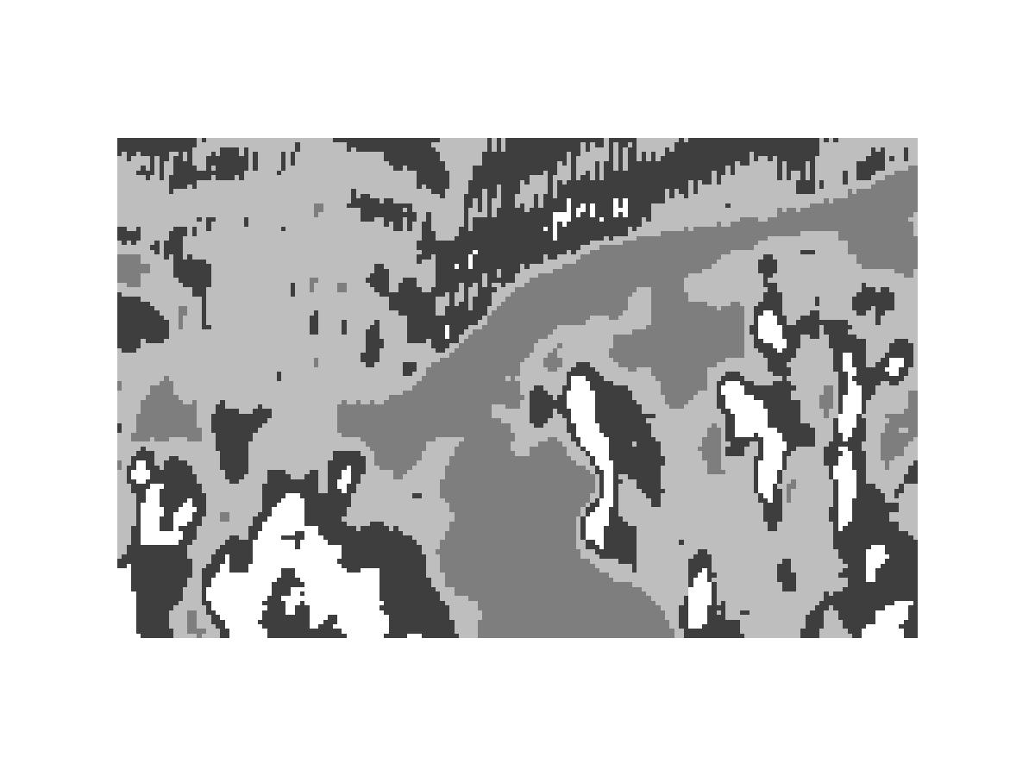
Segmentation result of run 2.

In the above image we observe that the kmeans algorithm is not very efficient. The images segmented above are the result of successive runs of the program for the same image. It is seen that the results are not the same. The first the segmentation was good where as the second one is segmented in a different way which is not very well segmented.


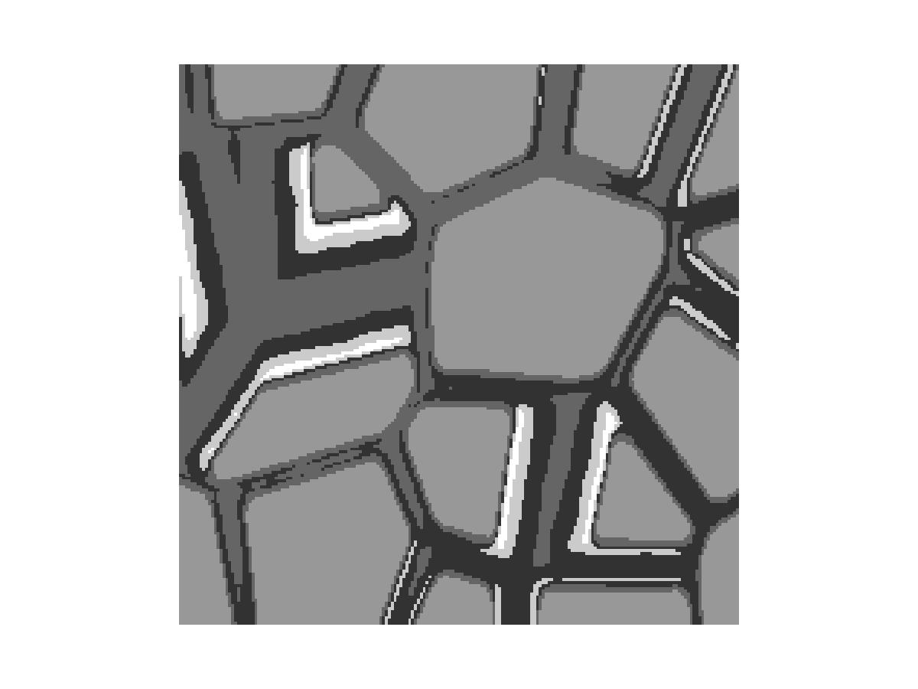
For some images the segmentation is almost perfect. The above image is one such example.

Conclusions:

In this paper we have developed a texture segmentation algorithm based on the moments of an image. The algorithm first computes moments within localized regions of the image around each pixel, then it computes a feature vector for each pixel based on these moments. Finally it segments these feature vectors (hence the texture regions) using the KMeans clustering algorithm.

The results of the segmentation algorithm show that the image moments computed over local regions provide a powerful set of features that reflect certain textural properties in images.

But certain aspects of this project have to be closely observed. From the results of this project three things could be observed

Firstly, the size of the initial block of image. The image initial block should be smaller for images with finer textures and bigger for images with coarse textures

Secondly, the number of moments to be considered. In this project seven moments were taken and the results were not very satisfactory for certain images with very fine texture. May be fewer moments like five or six i.e with a p value from 0, 1, 2 would give a better result.

Lastly, the output is dependent on the efficiency of the clustering algorithm and the numbers of clusters are to be mentioned manually in accordance with the image. In this project we observe that the Kmeans algorithm two different results in successive computations.

References:

- Segmentation
http://civs.stat.ucla.edu/Segmentation/Segment.htm
http://civs.stat.ucla.edu/Texture/Julesz/Julesz_ensemble.htm

- Clustering http://documents.wolfram.com/applications/digitalimage/UsersGuide/7.5.html
http://rkb.home.cern.ch/rkb/AN16pp/node131.html

- Kmeans:
www.csee.usf.edu/~hall/papers/fastclust.pdf
www.cs.umd.edu/~mount/Papers/pami02.pdf

- Moments:
http://www.cs.iupui.edu/~tuceryan/research/ComputerVision/moment- paper. PDF

- Digital Imageprocessing Using Matlab, Gonzales
www.imageprocessingbook.com

