Apply Independent Component Analysis on Images and Videos

Instructor: Dr. Longin Jan Latecki
Student: Bo Han

1 Introduction

In most cases, what we see and hear from the world is the mixture of several independent source signals. People are curious to explore the method of separating such sources automatically. Among all blind source separation (BSS) techniques, independent component analysis (ICA) is a powerful statistical and computational technique for revealing underlying signals.

ICA becomes more and more popular as its application area has been greatly enlarged. Typical examples are separating mixtures of simultaneous speech signals, brain waves recorded by multiple sensors, climate factors for global warming. In many cases, the data samples are given as a set of parallel signals or time series. In this study, we explore to apply ICA to separate independent components in images and videos.

From mathematical view, the ICA problem can be described as follows, each of h mixture signals x₁(k), x₂(k), …, x_{h}(k) is a linear combination of q independent source signals s₁(k), s₂(k), …, s_{q}(k), that is, X=AS where A is a mixing matrix. Now given X, we hope to compute A and S. Obviously, this is a difficult question since both A and S are unknown.

Based on some statistical assumptions, ICA successfully gains A and S. However, the independent sources in different application fields vary in different forms. For image and video, we would like to explore their mapping from independent components to some textures in image or some objects in video, which bring benefits for pattern recognition in images or motion detection in video.

In the following sections, I will describe our methods and experiments of applying ICA on images in details.

2 Methodologies

2.1 Assumptions
For solving the problem of computing A and S with given X, ICA make two assumptions:
- The source signals are mutual independent. 2) Each source signal has nongaussian distribution.
These two assumptions are keys to compute ICs (Independent Components). Here, I will explain them one by one.
The first one is a strong assumption about signals, even stronger than uncorrelated in PCA. It bring two advantages, we can compute the source signal in any order without considering the involvement of other sources; uncorrelated is just partly independent, so we can use PCA as a pre-processing to whiten data and reduce the dimensionality.
The following paragraph proves an important property of independent variables, that is E[h₁(y₁)h₂(y₂)]=E[h₁(y₁)]E[h₂(y₂)], where h1, h2 are two functions.
$\begin{aligned}E[h_{1}(y_{1})h_{2}(y_{2})]=\iint{h_{1}(y_{1})h_{2}(y_{2})p(y_{1},y_{2}){\text{dy}}_{1}{\text{dy}}_{2}} \\ \begin{matrix}\begin{matrix} & \end{matrix} & & & \begin{matrix} & \end{matrix}\iint{h_{1}(y_{1})h_{2}(y_{2})p(y_{1})p(y_{2}){\text{dy}}_{1}{\text{dy}}_{2}}\end{matrix} \\ \begin{matrix}\begin{matrix} & \end{matrix} & & & \begin{matrix} & \end{matrix}\int{h_{1}(y_{1})p(y_{1}){\text{dy}}_{1}}\int{h_{2}(y_{2})p(y_{2}){\text{dy}}_{2}}\end{matrix} \\ \begin{matrix}\begin{matrix} & \end{matrix} & & & \begin{matrix} & \end{matrix}E[h_{1}(y_{1})]E[h_{2}(y_{2})]\end{matrix}\end{aligned}$

From this property, we see that by uncorrelated, that is E[y₁y₂]=E[y₁]E[y₂], we can not infer to E[h₁(y₁)h₂(y₂)]=E[h₁(y₁)]E[h₂(y₂)]. But from E[h₁(y₁)h₂(y₂)]=E[h₁(y₁)]E[h₂(y₂)], let h₁(y₁)=y₁ and h₂(y₂)=y₂, we have E[y₁y₂]=E[y₁]E[y₂].
The second assumption is critical to separate signals. We see that gaussian signals look like following figure, a nearly symmetric shape from all angles. If source signals observe gaussian distributions, by center limit theory, their linear combination of source signals should more like gaussian, which becomes more difficult to separate. Hence, nongaussian is a necessary condition to extract sources by detecting non-symmetric in mixtures..
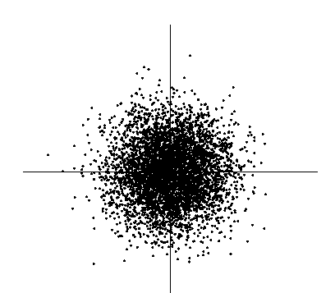

2.2 ICA Algorithm
Based on the first assumption, we clearly see that independent signals are uncorrelated, so we can first use either PCA or ANN to remove correlation among mixture signals and reduce the dimensionality, which bring much benefit in application of speech, text and video detection.
With second assumption, we have the following solution to solve BSS problems:
By X=AS, we have S=A⁻¹X=WX (where W=A⁻¹). Hence, our task is to select an appropriate W which applied on X to maximize the nongaussianity of source signals. This can be done in an iteration procedure.
Different ICA algorithms measure nongaussianity by different methods. Some use
Kurtosis function: Kurt(y)=E[y⁴]-3(E[y²])², which approaches 0 for a Gaussian random var; some use negentropy: negentropy(y)=H(y_{gauss})-H(y) (H is entropy); some use approximations of negentropy, J(y)=E[y³]²/12 + Kurt(y)²/48.
The most popular ICA algorithm, FAST ICA, uses non-quadratic function, such that g(y)=tanh(a_{1*}y), g(y)=y*exp(-y²/2), to compute nongaussianity. The following lists its algorithm steps,
Step1: choose an initial weight vector w
Step2: Let w⁺=E[xg(w^{T}x)]-E[g’(w^{T}x)]w (g: a non-quadratic function)
Step3: Let w=w⁺/||w⁺||
Step4: if not converged, go back to Step2.

2.3 Apply ICA on images and videos
To apply ICA on images, we must do some pre-process and post-process. Given some images (or a clip of videos),
1) For each image, change its corresponding matrix to a vector;
2) Centering each vector and resulting a variable with 0-mean value;
3) Applying PCA to whiten the data: remove any correlations in the data and make variance equal unity. At the same time, the dimensionality is reduced;
4) Applying ICA on matrix which is composed of new vectors;
5) Converting independent components to source images, which detect the independent texture changes in images or objects occurring in video clips.

3 Program Descriptions

Based on FASTICA package, I coded for this project. The following table gives a brief description about their function.

File Name | Function
ICAshow.m | Experiment1 main program: show the correctness of program
icaimage.m | Experiment2 main program: show ICA on images
image_ica: | Given a matrix, compute its independent components
image_ica_debug.m | Kennel of FastICA algorithm with debug function (pause at each iteration for computing the mixing matrix W)
fpica.m | Kennel of FastICA algorithm
demosig.m | simulate 4 source signals and their mixture
debugica.m | Debug main algorithm of fixed point ICA.
remmean.m | Centering: remove the mean from vectors
icaplot.m | plot signals in various ways
tanh.m | Compute tanh()
Pcamat | Calculate pca for data
whitenv.m | Whiten data
getSamples.m | Choose samples in computing

In each program, the detailed annotation is provided besides corresponding code pieces.

4 Experimental Results

To explore ICA on images, I did 3 experiments. The first experiment showed the correctness of my ICA program (I revised program based on FASTICA package). The following figure is 4 source signals for simulating.
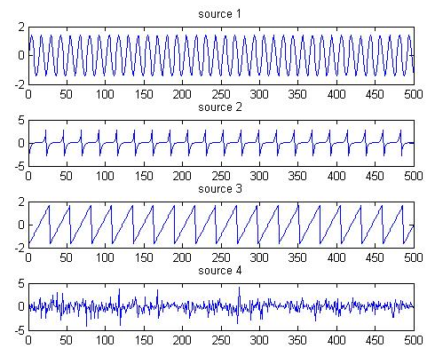

The following figure is 4 mixtures randomly combined by the above source signals.
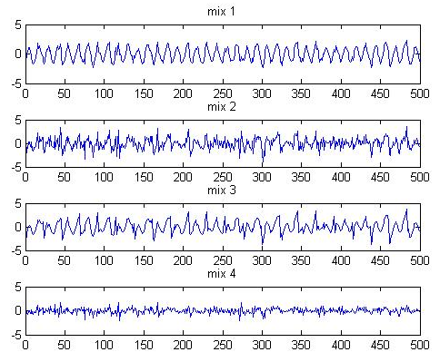

The following figure shows how w updates and how the 3rd source signal been detected in 4 iterations. From the signal histogram, we see that it change from gaussian to nongaussian.

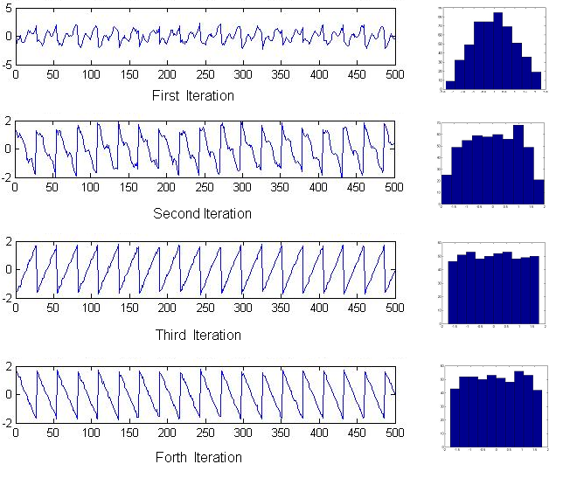

The final detected independent signals list as follows,
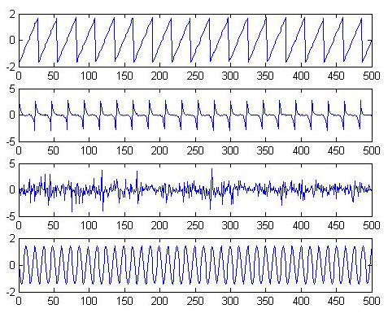

We can find that they are almost the same as the original source signals except they are listed in different order and some signal direction is reversed.
The second experiment showed how ICA applied on images.
The four source images are listed as follows,
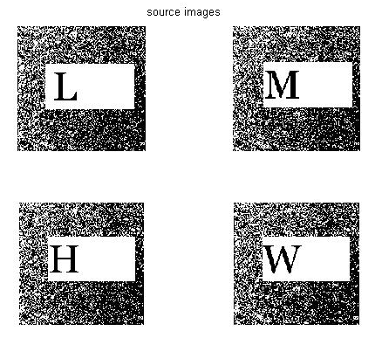
The detected independent components are listed as follows,
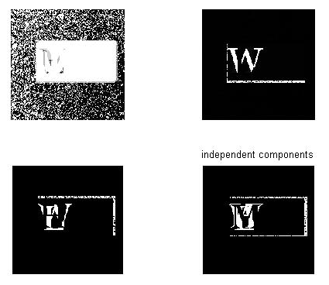
We can see that the background and letters are separated into different source signals, which are what we expect.

The last experiment showed how ICA performs on video clips.

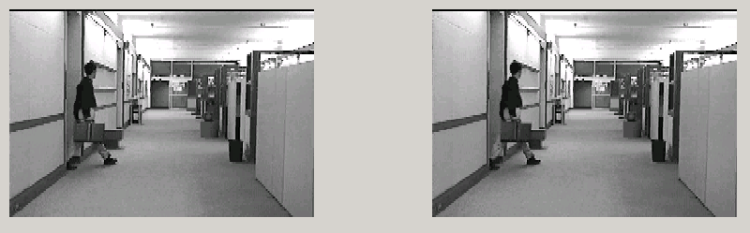
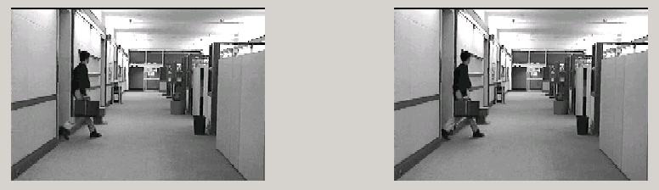

By the above four sequential frames, we have the following independent signals, which shows one object in these series images,
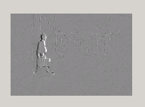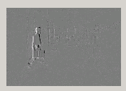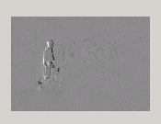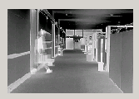
By another four sequential frames listed below,

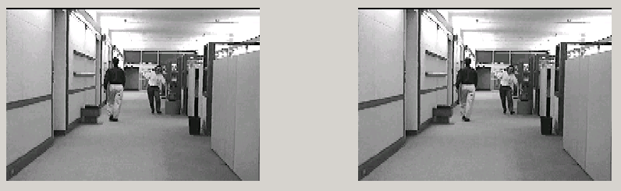
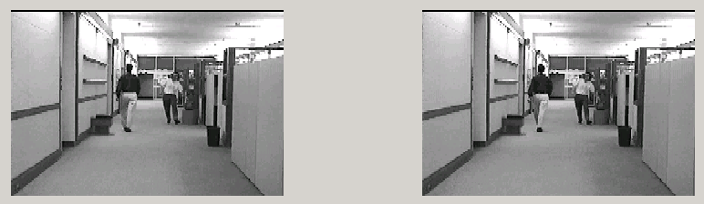
We have the following independent signals,

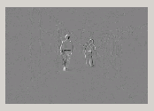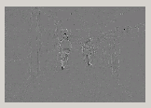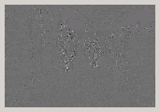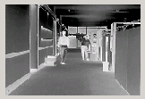

We see that by sharping or edge detection on independent sources, we easily detect 2 objects in these 4 frames. Hence, by ICA, we potentially have the method to do motion detection or outlier intrusion.

5 Conclusions

Our practice of applying ICA on images showed that ICA can really used to detect independent changing/moving parts in images and videos. But it is very sensitive to the position change and alignment is needed. Hence, in the video field with similar neighborhood frames, ICA showed its potential to be a good motion detection method. Integrating ICA and image processing methods (such as edge detection, similarity measure), my future work might be proposing an efficient and effective motion detecting/outlier intrusion approach for videos.

6 References

1) A. Hyvärinen and E. Oja. Independent Component Analysis: Algorithms and Applications. Neural Networks, 13(4-5):411-430, 2000.
2) D. Pokrajac and L. J. Latecki: Spatiotemporal Blocks-Based Moving Objects Identification and Tracking, IEEE Visual Surveillance and Performance Evaluation of Tracking and Surveillance (VS-PETS), October 2003.
3) L. J. Latecki and D. Pokrajac. Entropy-Based Approach for Detecting Feature Reliability. Invited Paper, 48th Annual Conf. FOR ELECTRONICS, TELECOMMUNICATIONS, COMPUTERS, AUTOMATION, AND NUCLEAR ENGINEERING (ETRAN). Cacak, Serbia, 2004.
4) P.O. Hoyer and A. Hyvärinen. Independent Component Analysis Applied to Feature Extraction from Colour and Stereo Images. Network: Computation in Neural Systems, 11(3):191-210, 2000.
5) Longin Jan Latecki, Roland Miezianko, Dragoljub Pokrajac. Motion Detection Based on Local Variation of Spatiotemporal Texture
6) Longin Jan Latecki, Dragoljub Pokrajac , Roland Miezianko. Instantaneous Reliability Assessment of Motion Features in Surveillance Videos

