- ICA Problems Specification
  - 2 people talking simultaneously(s1(t) s2(t))
  - 2 microphones in different locations(gives us two time signals x1(t) x2(t))
x1 = a12 * s1+ a12 * s2
x2 = a21 * s1 + a22 * s2
  - aij are values depending on distance of mic from speakers.
  - Want to estimate s1 and s2 using only x1 and x2

- q source signals s1(k), s2(k), …, sq(k)
  - with 0 means
  - k is the discrete time index or pixels in images
  - scalar valued
  - mutually independent for each value of k

- h measured mixture signals x1(k), x2(k), …, xh(k)

- Statistical independence for source signals
  - p[s1(k), s2(k), …, sq(k)] = П p[si(k)]

- The measured signals will be given by
  - xj(k) = Σsi(k)aij + nj(k)

- For j = 1, 2, …, h, the elements aij are unknown.

- Define vectors x(k) and s(k), and matrix A
  - Observed: x(k) = [x1(k), x2(k), …, xh(k)]
  - Source: s(k) = [s1(k), s2(k), …, sq(k)]
  - Mixing matrix: A = [a1, a2, …, aq]

- The equation above can be stated in vector-matrix form
    - x(k) = As(k) + n(k) = Σsi(k)ai + n(k)

summary: solving x=As
  - A is mixing matrix, s is source vector, x is mixtures
  - Generative model: describes how observed data are generated by a process of mixing components of s.
Two major assumptions
  - Components si are statistically independent
  - Independent component must have nongaussian distributions
(Part of Larger Problem Blind Source Separation (BSS))

2. Comparision of PCA and ICA
- PCA: finds directions of maximal variance in gaussian data
- ICA: finds directions of maximal independence in nongaussian data
Maximizes joint entropy and minimizes mutual information between signal channels
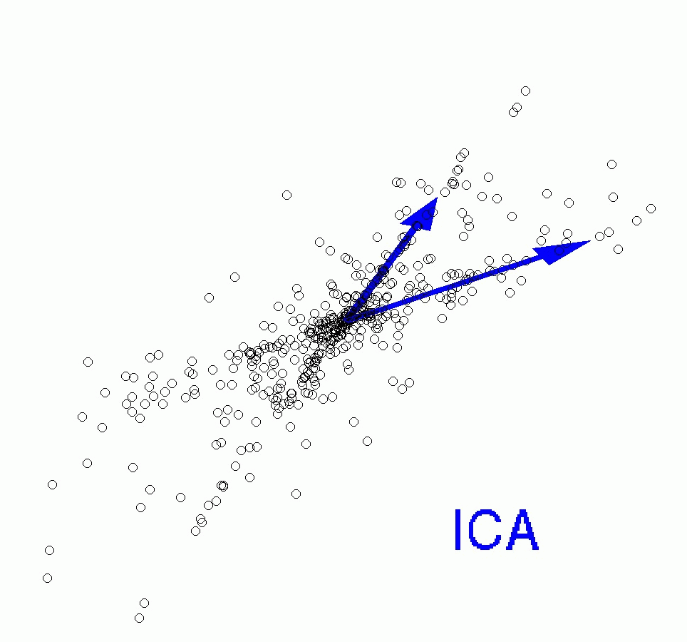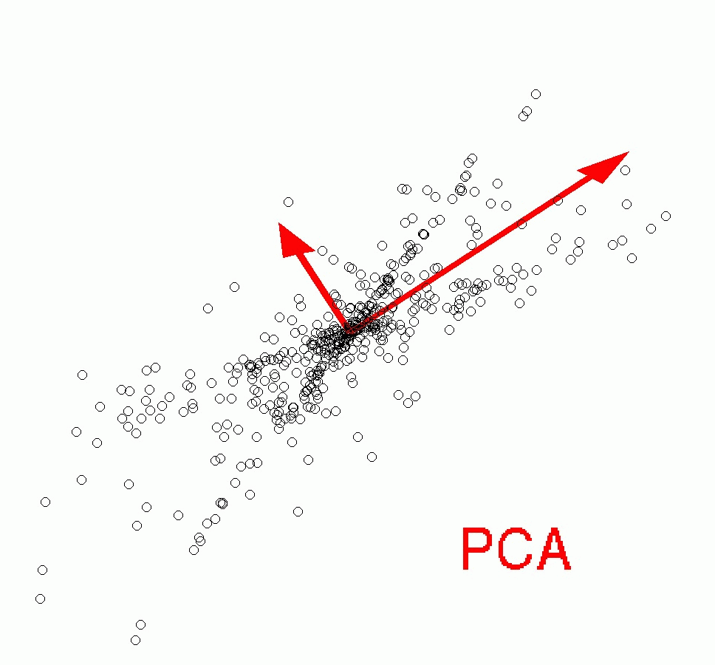

- ICA steps:
1) Whiten (sphere) the data
This means that we remove any correlations in the data, i.e. the signals are forced to be uncorrelated. Again putting the words in mathematical terms, we seek a linear transformation V such that when y = Vx we now have E{yy'} = I. This is easily accomplished by setting V = C^{-1/2}, where C = E{xx'} is the correlation matrix of the data, since then we have E{yy'} = E{Vxx'V'} = C^{-1/2}CC^{-1/2} = I.

2) The separated signals can be found by an orthogonal transformation of the whitened signals y. The appropriate rotation is sought by maximizing the non-normality of the marginal densities (shown on the edges of the density plot). This is because of the fact that a linear mixture of independent random variables is necessarily more Gaussian than the original variables. (This is the same phenomenon as is stated by the central limit theorem.) This implies that in ICA we must restrict ourselves to at most one Gaussian source signal
a. Measures of nongaussianity
Kurtosis: Kurt(y)=E{y⁴}-e(E{y²})² (approach 0 for a Gaussian random var)
Negentropy: Neg(y)=H(y_{gauss})-H(y) (H: entropy; 0 if and only if y has a Gaussian distribution)
Approximations of negentropy:

b. FastICA:
Step1: choose an initial weight vector w
Step2: Let w⁺=E{xg(w^{T}x)}-E{g’(w^{T}x)}w (g: any non-quadratic function)
Step3: Let w=w⁺/||W⁺||
Step4: if not converged, go back to Step2
The figure below shows the signals y and the joint density p(y) after such an operation.
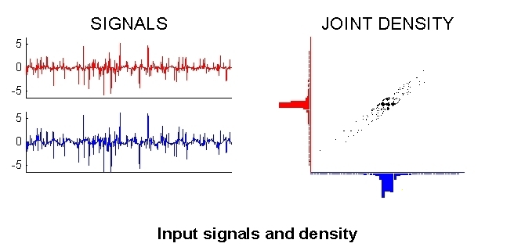

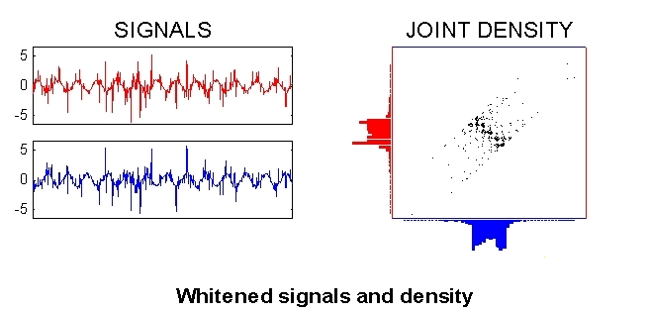
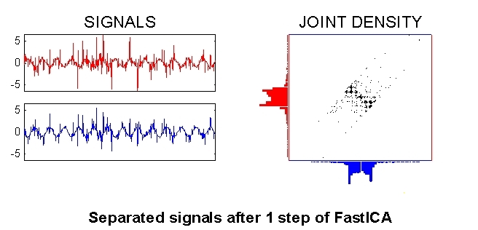
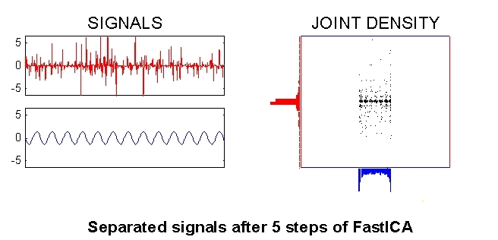
4. Ambiguities with ICA
- Amplitudes of separated signals cannot be determined.

- There is a sign ambiguity associated with separated signals.

- The order of separated signals cannot be determined.

5. Applications of ICA
- Typically used in Blind Source Separation problems.
- ICA is also used in feature extraction.

