Project Report for CIS 601, Fall 2004
Student: Archana Gupta

Range image processing

Aim: reconstructing an accurate three-dimensional model by using the data obtained from the Swiss Ranger for a particular scene

Abstract: With the advancement of technology it is now possible to capture depth images as well as gray-scale images by sampling the amount of modulated light reflected by objects in the scene. The Swiss Center for Electronics and Micro technology (CSEM) has developed one such sensor called Swiss Ranger, which is capable of producing dense three dimensional data in real time. My project aims at reconstructing an accurate three-dimensional model by using the data obtained from the Swiss Ranger for a particular scene.

Basic algorithm

1. Convert mesh coordinates to real world coordinates.

2. Use patch command to draw the mesh.

3. Convert the mesh ‘data.m’ file to ‘data.smf’ file to prepare it for the QSlim software. This is done as below copy the mesh data to world file precede each vertex row by the letter ‘v’ and each face row by the letter ‘f’. Also just in the beginning of the data file type the lines below which basically specify how many faces and vertices the mesh data consists of.

#$SMF 1.0
#$vertices 17632
#$faces 34730

4. Finally save the file with a ‘.smf’ extension and use it in the QSlim software. The various user options that can be specified are stated in the Running QSlim instructions in this report.

5. Get simplified data from QSlim and use it to display the mesh in matlab.

6. Finally smooth the mesh using triangle normals to align the simplified mesh triangles and get a better output.

Running the program

1. To create 3d cloud and 3d mesh at command line type ‘visual’. It takes about a minute to give the filtered image, the 3d cloud points and the mesh.

2. Thereafter covert the mesh data to ‘.smf’ file as explained in the steps above describing the algorithm.

3. Then use the Qslim software to simplify the mesh to the number of triangle faces required by using the command:

qslim –t <no of faces> -o <output file> -M <output format> input filename

The location of qslim on my lucas account is:

cd qslim-2.1/tools/qslim

4. To draw the simplified mesh load the data for the faces and vertices and then at command line type ‘simpmesh (vertices, faces)’

e.g. f = load ('f1_500.txt');
v = load ('v1_500.txt');
simpmesh (v, f)

5. Finally at command line type ‘iter(v, f, iterno)’. ‘v’ contains the simplified mesh vertices, f contains the faces using and iterno defines how many iterations you want to run to get the smoothed mesh using Mean filter for averaging face normals algorithm.

RUNNING QSLIM

The standard QSlim executable is a non-interactive program called 'qslim' which you invoke using a command of the form:

qslim <options> <filename>

This will input the initial model from the specified file and simplify it. When simplification is complete, it will output the resulting model and report to you how long the process took.

The command line options recognized by QSlim are:

A. Controlling output:

-t <n> Specify the desired number of faces in the simplified model. You are not guaranteed to get exactly the number you ask for, but it should generally be within 1-2 faces of the target.

-o <file> Output resulting model to the named file. By default, the simplified model is sent to standard output.

-M <format> Select the format for the output model. The supported formats are:

smf -- This is the default format
iv -- Inventor format (preliminary support only)
vrml -- VRML 1.0 format (preliminary support only)

B. Customizing simplification:

-O <n> Specify the policy for selecting the target position for edge contractions. The following levels of optimization are available:

3 -- Pick point which minimizes error [default].
2 -- Pick best point along edge.
1 -- Pick best of endpoints or midpoint.
0 -- Pick best of the two endpoints.

-B <weight> Specifies the weight assigned to boundary constraint planes. The default value is currently 1000. Specify a weight of 0 to disable boundary constraints entirely.

-W <n> Select the quadric weighting policy. Available policies are:

0 -- Weight all quadrics uniformly
1 -- Weight by area of contributing triangle [default]
2 -- Weight by angle around vertex

C. Miscellaneous features:

-r Enable history recording. This is not terribly useful in the command-line version. However, in the interactive version (see below) this will enable you to simplify a model and then back up to a previous level of detail. NOTE: This will cause the program to use more memory.

-j Only perform contractions that do not remove any faces. You can use this feature in conjunction with custom edge sets (see below) to effect a form of stitching. This is not terribly reliable, it's just an experimental feature.

-F This will cause the simplification algorithm to use iterative face contraction rather than iterative edge contraction. Generally speaking, this has the following effects:

- Simplification is faster
- Less memory is consumed
- Geometric quality of the results is reduced

Calculation details

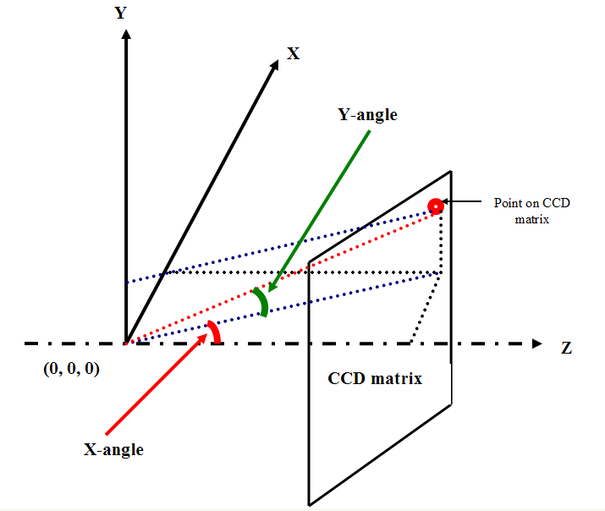

Finding angles

$\begin{aligned}\text{tan}\text{21}\text{°=}\text{61}\text{.}5/{F_{x}} \\ \text{Xangle}=\text{arctan}({\text{newx}}/{F_{x}}) \\ \\ \text{tan}\text{23}\text{°=}\text{79}\text{.}5/{F_{y}} \\ \text{Yangle}=\text{arctan}({\text{newy}}/{F_{y}}) \\ \\ \end{aligned}$

$\begin{aligned}L_{\text{yz}}=\text{cos}(\text{Xangle})×z \\ X=\text{sin}(\text{Xang})×z \\ Y=\text{sin}(\text{Yang})×L_{\text{yz}} \\ Z=\text{cos}(\text{Yang})×L_{\text{yz}}\end{aligned}$Finding real world coordinates

The link below has the details of the Qslim algorithm used to simplify the mesh and the link to the software

http://graphics.cs.uiuc.edu/~garland/papers/quadric2.pdf

http://graphics.cs.uiuc.edu/~garland/software.html

The link below has the Mean filter for averaging face normals algorithm used to smooth the simplified mesh

http://www.u-aizu.ac.jp/labs/sw-sm/Yagou/gmp02yob.pdf

Conclusions
The mesh produced after converting image coordinates to real world coordinates is quite impressive.
The Qslim software works very well in simplifying the mesh to the number of triangle faces required by the user.
Finally the Mean filter for averaging face normals algorithm seems to do a good job at defining the ball but distorts the wall edges.

