CIS 601, Tom Gradel, Homework#7

Background:

Two different samples were taken from 6 different textures, arranged as follows:

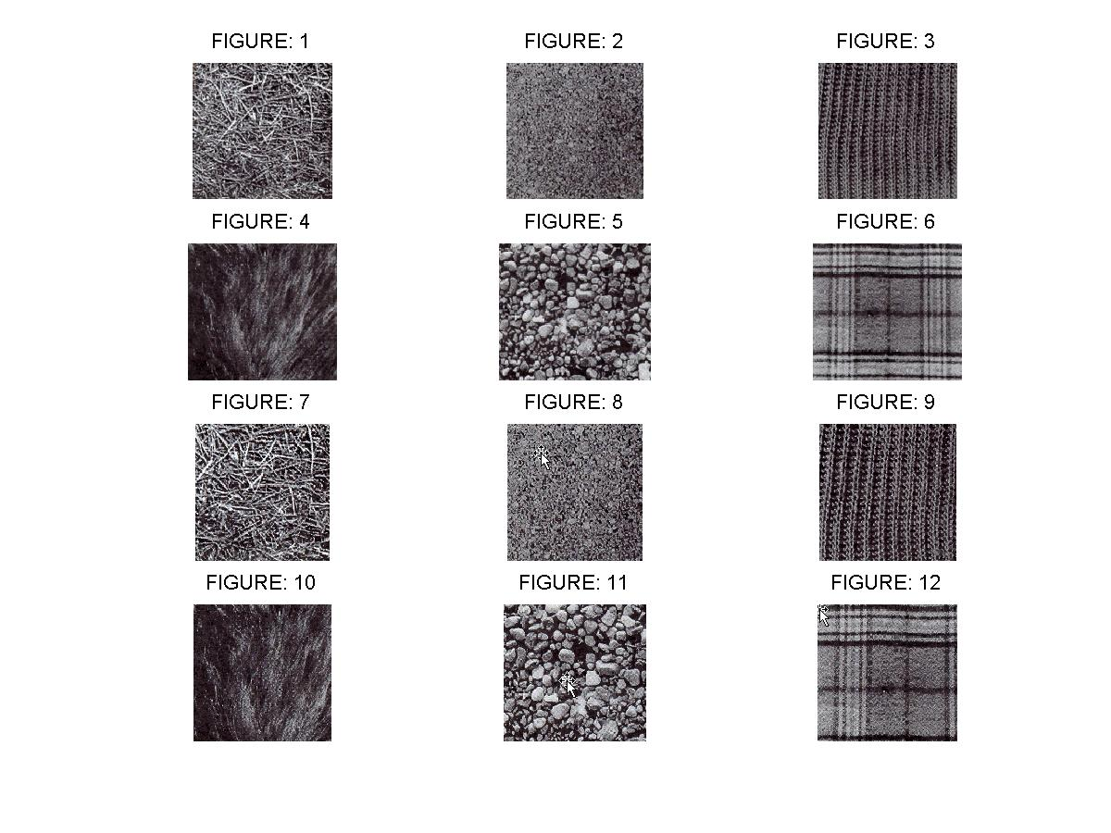

After converting to grayscale and extracting a image 135x135 pixels in size, they images were concatenated, and PCA was performed on the composite matrix.
Results

The resulting matrix of the first 12 PCA components was then displayed as follows:

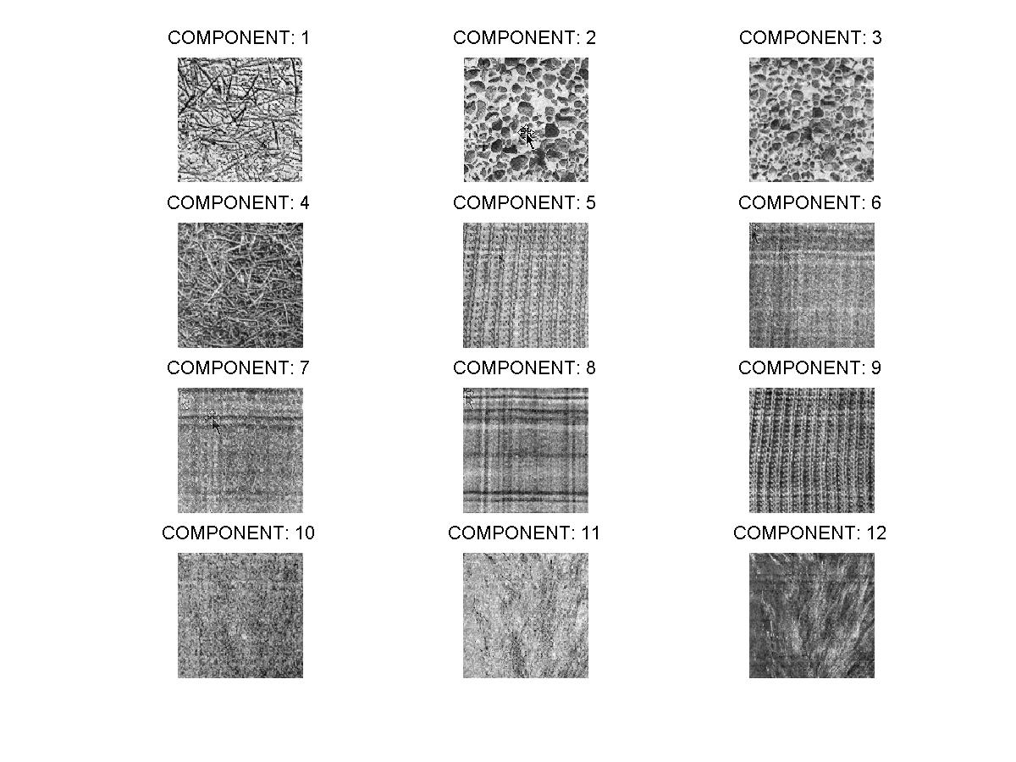

The grass-like texture was the first principal component, indicating that it is the most important for distinguishing these figures from each other. The next two were the stones, followed by more grass-like texture. The remaining components were those necessary to identify plaid, knit, etc. The least useful were two components that resembled hair.

Program Description:

I followed the outline in our text. Surprisingly, I couldn't specify more than the number of images for the second parameter to princomp function, probably because it is using the 'matrix trick' internally to computer the principal components.

