ARCHANA GUPTA
HW#6
IMAGE PROCESSING

Table 1: RESULTS FOR ACTUAL IMAGES

Φ1 Φ2 Φ3 Φ4 Φ5 Φ6 Φ7
FUR1 5.9708 18.1635 21.8814 23.0747 45.6789 32.3602 46.4094
HAY1 6.4773 19.1619 26.1689 25.7093 52.1340 36.1056 51.9543
LIN 6.3988 17.4552 27.2982 26.5825 54.3684 35.6429 53.6479
SAND 6.3994 20.8485 25.7530 24.6987 51.6939 37.2783 50.0412
STONE 6.4263 17.6270 25.4807 26.4202 52.5745 35.2343 52.9179
SWEATER 6.0809 19.3681 26.2426 26.9597 53.6191 36.7919 54.6646

Table 2: RESULTS FOR SECTIONS OF THE IMAGES

Φ1 Φ2 Φ3 Φ4 Φ5 Φ6 Φ7
FUR1 5.8187 16.5529 23.9000 21.9087 44.8435 33.3239 46.3337
FUR2 6.0746 17.4013 23.3064 24.1321 47.9890 36.0639 48.6651
HAY1 6.4531 19.3183 25.2912 26.3740 56.2334 36.0453 52.2068
HAY2 6.5455 19.8714 29.7302 26.2380 54.3280 37.0858 56.0733
LIN1 6.3964 18.6537 25.3496 24.6429 49.8013 34.2830 50.3790
LIN2 6.3528 18.6917 25.3814 24.8229 50.1188 34.5702 50.8018
SAND1 6.5264 20.5309 26.9941 26.7877 53.9172 38.1797 54.4529
SAND2 6.3388 18.8309 25.3025 25.0188 52.1634 35.9369 50.2871
STONE1 6.4712 18.5421 27.7787 27.1682 54.6437 36.6021 57.4034
STONE1 6.4269 19.4205 24.9187 25.9228 51.8582 36.2950 51.5646
SWEATER1 6.1030 19.3885 25.9692 26.0009 52.4047 35.7527 52.3639
SWEATER2 6.0754 18.2036 26.2157 27.9173 56.3603 37.1974 55.1130

Table 3: AVERAGE OF VALUES FOR IMAGE SECTIONS

Φ1 Φ2 Φ3 Φ4 Φ5 Φ6 Φ7
FUR1 5.9467 16.9771 23.6032 23.0204 46.4163 34.6939 47.4994
HAY1 6.4993 19.5949 27.5107 26.3060 55.2807 36.5656 54.1400
LIN 6.3746 18.6727 25.3655 24.7329 49.9601 34.4266 50.5904
SAND 6.4326 19.6809 26.1483 25.9032 53.0403 37.0583 52.3700
STONE 6.4490 18.9813 26.3487 26.5455 53.2510 36.4486 54.4840
SWEATER 6.0892 18.7961 26.0925 26.9591 54.3825 36.4751 53.7384

PLOTS OF THE AVERAGES WITH THE ORIGINAL FIGURE

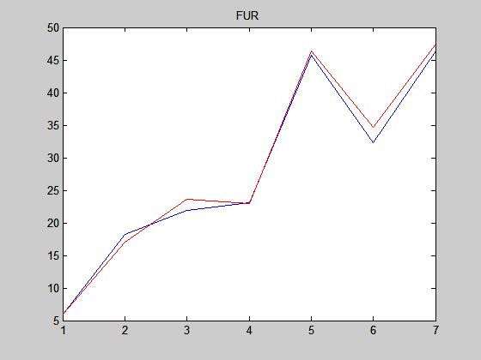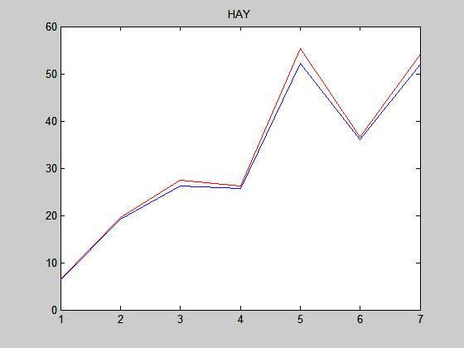

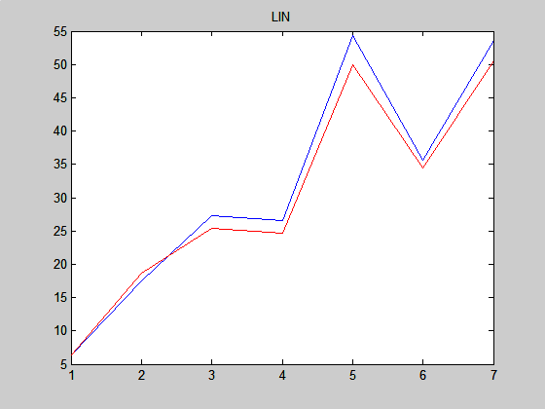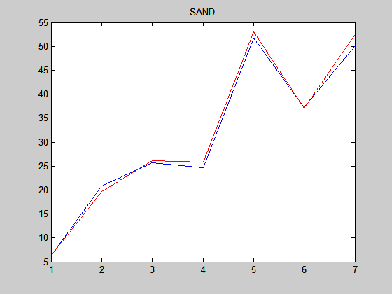

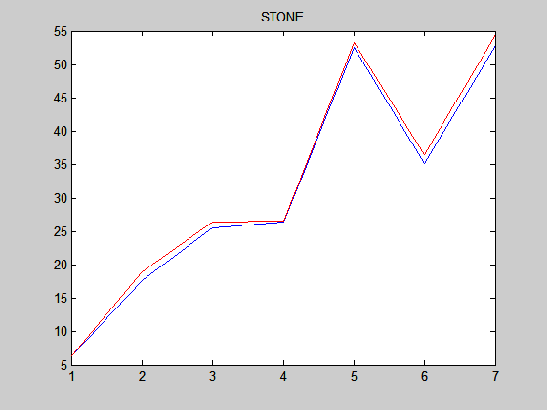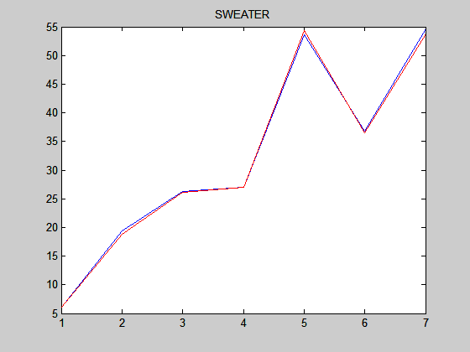

CONCLUSIONS

When extracting different sections of the same image the various moments have similar values. Once these values are averaged we get values closer to that of the actual image. This is also better illustrated by the plots between the averages and the actual image values.

Further more moment calculations are certainly helpful in finding an exact copy of the image. However they would not be very helpful in finding similar images because a different image might have similar moment patterns.

Also Φ1 moment seems to have a great influence on issues of similarity. It seems to contribute a high ratio in determining similarity of images. This is confirmed by the results in table 2. Φ1 of sections of same image seem to be very similar and separates to a great extent the other textures.

