HW6: How do the 7 moment classify the six textures?

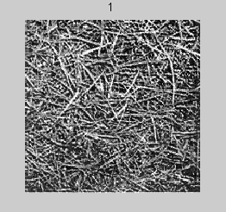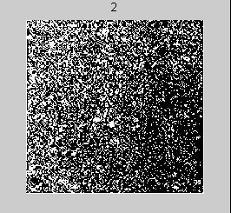
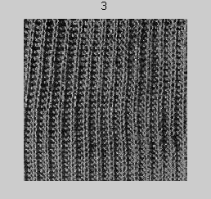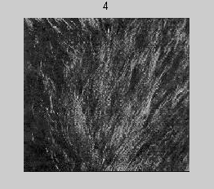
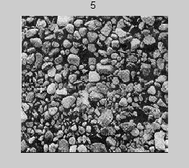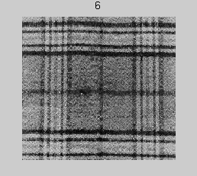

Solution: Given the above 6 pictures, I first compute the absolute value of the log(moment invariant) values for each image by the following function:
abs(log(invmoments(img)))

The results are listed as follows,
Image1: 6.4742 21.1178 26.1091 25.9546 52.9065 36.7147 52.0927
Image2: 6.2139 18.2667 22.6742 22.3567 45.8338 31.7310 45.0817
Image3: 6.1454 20.7410 26.4425 27.3955 54.6453 38.0216 54.6773
Image4: 6.0291 18.2633 22.4268 23.6047 46.6396 32.7504 48.3637
Image5: 6.4338 17.7314 25.8712 26.7080 53.2434 35.5738 53.4706
Image6: 6.4140 17.8186 27.5859 27.2279 55.3499 36.4978 54.8033

We see that for different moments, they have different ranges, which result in bias in computing Euclidean distance. Hence, I standardize each moments by z-score= $\frac{M−\text{mean}(M)}{\text{std}(M)}$ , the results are showed as following,
Image1: 1.0424 1.3970 0.4348 0.1984 0.3556 0.6112 0.1736
Image2: -0.3923 -0.4747 -1.1814 -1.5284 -1.3554 -1.4196 -1.6220
Image3: -0.7698 1.1497 0.5917 0.8899 0.7763 1.1437 0.8355
Image4: -1.4106 -0.4769 -1.2978 -0.9294 -1.1604 -1.0042 -0.7814
Image5: 0.8198 -0.8261 0.3229 0.5600 0.4371 0.1463 0.5265
Image6: 0.7106 -0.7689 1.1298 0.8095 0.9467 0.5228 0.8678

In the next step, I used two different measure : Euclidean distance and Cosine distance to compute the image difference.

The following matrix show the difference with Eulidean distance,
 | Image1 | Image2 | Image3 | Image4 | Image5 | Image6
Image1 | 0 | 4.6294 | 2.1787 | 4.4298 | 2.3415 | 2.5489
Image2 | 4.6294 | 0 | 5.3784 | 1.5252 | 4.3009 | 5.2328
Image3 | 2.1787 | 5.3784 | 0 | 4.5734 | 2.7959 | 2.5659
Image4 | 4.4298 | 1.5252 | 4.5734 | 0 | 3.9406 | 4.7952
Image5 | 2.3415 | 4.3009 | 2.7959 | 3.9406 | 0 | 1.1164
Image6 | 2.5489 | 5.2328 | 2.5659 | 4.7952 | 1.1164 | 0

The following matrix show the difference with Cosine distance,
 | Image1 | Image2 | Image3 | Image4 | Image5 | Image6
Image1 | 0 | 1.5551 | 0.49167 | 1.7471 | 0.90167 | 0.74044
Image2 | 1.5551 | 0 | 1.8176 | 0.11609 | 1.5762 | 1.8173
Image3 | 0.49167 | 1.8176 | 0 | 1.5681 | 0.98463 | 0.61936
Image4 | 1.7471 | 0.11609 | 1.5681 | 0 | 1.6618 | 1.8334
Image5 | 0.90167 | 1.5762 | 0.98463 | 1.6618 | 0 | 0.10857
Image6 | 0.74044 | 1.8173 | 0.61936 | 1.8334 | 0.10857 | 0

From these, we clearly see that picture 2 and picture 4 are in one category. And picture 1, 3, 5, 6 are in another category, in which picture 5 and 6 have very small distance and may be grouped into a subcategory.

