YOUR NAME:

CIS 601, Final Exam, December 15, 2003

Choose 10 out of 14 tasks. You may receive up to 10 points for each solution and total 100 points for 10 correct solutions.

1. Compute the histogram with 3 equally spaced bins for the following image, i.e., define the bins and tell how many pixels contribute to each bin.

1 | 2 | 1 | 5 | 1
1 | 1 | 1 | 5 | 1
1 | 2 | 1 | 5 | 9
3 | 4 | 5 | 6 | 7

2. Provide a definition of a 4 (8)-connected set in a digital image.
Is set A 4-connected?: Yes or No Is set A 8-connected?: Yes or No
Is set B 4-connected?: Yes or No Is set B 8-connected?: Yes or No

A B

3. Describe the connected-component labeling algorithm for 4-connectedness.

4. Give an example of a 3x3 mask for image smoothing. Outline an algorithm for image smoothing that uses this mask.

5. Provide a set of 3x3 operators for edge detection that yield not only edge magnitude but also determine the edge direction.

6. In a binary image (objects represented by 1s and the background represented by 0s), there is noise in form of small blobs that contain at most three ones.
Which filter(s) can we apply to eliminate these blobs, i.e., change their values from 1 to 0? Describe an algorithm that uses this filter(s).

7. Design an algorithm to find the letter “L” given by the following template in a gray value image of size 100x100 with 256 gray values (0 is black, 255 is white).

0 | 255 | 0
0 | 255 | 0
0 | 255 | 0
0 | 255 | 255

8. Describe an image segmentation algorithm. Illustrate its application to the following image A.

1 | 1 | 1 | 5
1 | 9 | 9 | 9
3 | 1 | 9 | 5
3 | 1 | 9 | 5
3 | 3 | 9 | 3
Image A

9. Which image similarity measure could be used for shot detection in videos (hard cuts). Define this measure and outline the algorithm for shot detection that is based on this measure.

10. This question has three parts.
10.1 Please insert the values in the schemes below for
a) Blurring Filter b) Edge Filter (e.g. Laplacian) c) A Filter that does NOTHING (identity)

a | b | c

10.2 The following pictures show typical results of filtering with Blurring, Sobel, Laplacian. Please assign the filter-name to each picture.

 | 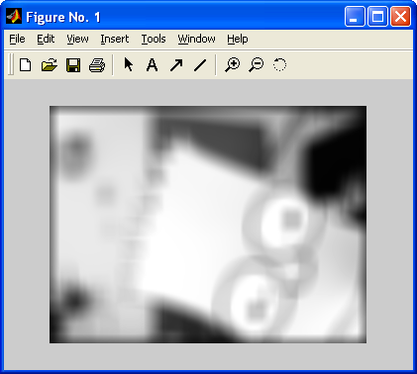 | 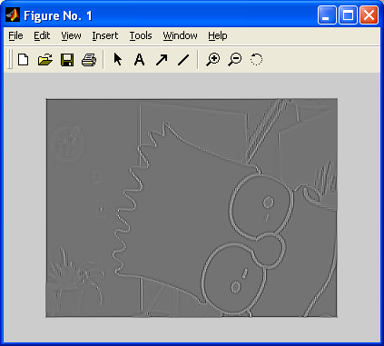
a | b | c

10.3 What would the following filters do ?
0 | 0 | 0
0 | 0 | 0
0 | 0 | 0

0 | 1 | 0
0 | 0 | 0
0 | 0 | 0

0 | 0 | 0
0 | 1 | 0
0 | 0 | 0

11. ‘Salt and Pepper Noise’ are black and white (max. values!) spots on the image. Is it a good idea to use a blurring filter to reduce this kind of noise?
Which filter could be more effective and why?

12. Please compute the results for median and average filtering for the gray-shaded pixels in the following picture, using the 3x3-neighborhood. Give a definition for both fileters.

1 | 4 | 3 | 7
4 | 2 | 7 | 5
6 | 8 | 9 | 6

Median:

Average:

13. Define morphological closing. Sketch a constellation of 4 pixels, where the morphological closing using the structural elements A and B shows a different result:

A | B
  1 | 1 | 1
  1 | 1 | 1
  1 | 1 | 1
   | 1
  1 | 1 | 1
   | 1

14. Describe the split and merge clustering algorithm. Construct the quadtree representation obtained by this algorithm for the following image B.

1 | 1 | 1 | 5
1 | 1 | 9 | 9
1 | 1 | 9 | 9
1 | 1 | 9 | 5
Image B

