Cis 350, 2003 FINAL EXAM
NAME:

Question 1 (1 point)
Which of the following functions transforms an image f to the max. range of gray-values (0..255) , if max,min denote the max.,min. grayvalues ?

- T(f) = (f-min)/max
- T(f) = f/max * 255
- T(f) = (f-min)/ (max-min)* 255
- T(f) = f/max

Question 2a (6 points)
Write a MATLAB-like program that subsamples a picture by factor 2 in x and y direction by averaging the values of 4 pixels:

_____________________________________________________________
Question 2b (2 points)
What is the result of the algorithm of question 2a for the following picture ?
4 | 2 | 0 | 0 | 1 | 2
3 | 1 | 0 | 0 | 0 | 1
0 | 0 | 4 | 4 | 16 | 16
0 | 8 | 4 | 4 | 4 | 8

_____________________________________________________________

Question 3 (2 + 2 points)
Let a color picture C be given as a matrix 240x320x3, containing only the colors red (255,0,0) and white (255,255,255). A clever programmer wants to create a graylevel version of this picture by extracting the red-layer only.
What will he get ?

How can in general a graylevel image be obtained from an RGB picture ?

Question 4 (2 + 2 points)
A CCD-Camera (e.g. web-camera) typically has an array of 1024x768 pixels, each pixel represented by 3 bytes. A picture taken with such a camera, saved as JPEG image, has a typical size of 100kB. How high is the compression ratio ?

How high is the data redundancy relative to the data obtained directly from the chip ?

Question 5 (2 points)
What is achieved by the following image transformations ?

- f = f * 5

- f = f / 5

- f = f ^ 2

- if f>127 f=255 else f=0

Question 6 (3 points)
What is the effect of histogram equalization to an image, and how does the equalized histogram look like ?

Question 7 (2 + 3 points)
Using grayvalue statistics, the average contrast of a picture can be described by the standard deviation. Having multiple versions of the same picture in different levels of contrast, how can the sharpest image be obtained ?

Can you think of another method for getting the sharpest image (e.g. in another space) ?

Question 8 (2 + 6 points)
A movie taken by a surveillance camera shows an empty street, with sometimes a single car passing by. Since it's raining, the movie is pretty noisy. How can a single picture ('the background picture') be obtained showing the street, without car and with noise reduced ?

How can the frames be detected showing the car (the car is seen as a rel. big object) ? Note that since the movie is noisy, the simple technique of taking difference-pictures would lead to unpredictable results, since the raindrops presumably would show up as many small objects. One could think about a morphological filtering step in order to eliminate these small objects, that reduces without really effecting the big objects, i.e. the car. Which technique am i talking about ?

The technique:

The algorithm to detect the frame showing the car:

Question 9 (3 points)
Please insert the values in the schemes below for
a) Blurring Filter b) Edge Filter (e.g. Laplacian)
c) A Filter that does NOTHING (identity)

a | b | c

Question 10 (2 points)
The following pictures show typical results of filtering with Blurring, Sobel, Laplacian.
Please assign the filter-name to each picture.

 | 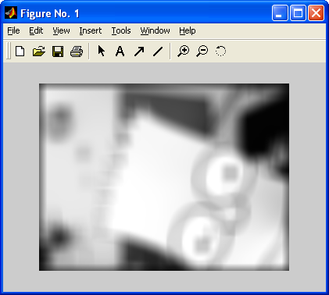 | 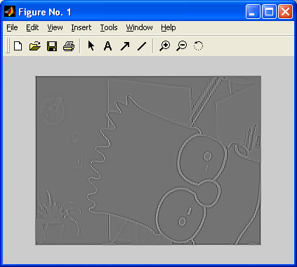

Question 11 (3 points)
What will the following filters do ?
0 | 0 | 0
0 | 0 | 0
0 | 0 | 0

0 | 1 | 0
0 | 0 | 0
0 | 0 | 0

0 | 0 | 0
0 | 1 | 0
0 | 0 | 0

Question 12 (1 + 1 point)
‘Salt and Pepper Noise’ are black and white (max. values!) spots on the image. Is it a good idea to use a blurring filter to reduce this kind of noise ?

Which filter could be more effective ?

Question 13 (4 points)
Please compute the results for median and average filtering for the gray-shaded pixels in the following picture, using the 8-neighborhood.

1 | 4 | 3 | 7
4 | 2 | 7 | 5
6 | 8 | 9 | 6

Median:

Average:

Question 14 (4 points)
Sketch a constellation of 4 pixels, where the morphological closing using the structural elements A and B given below shows a different result:

A | B
  1 | 1 | 1
  1 | 1 | 1
  1 | 1 | 1
   | 1
  1 | 1 | 1
   | 1

Question 15 (3 + 6 + 2 points)
A company producing toothed wheels mandates you to design a software for automatic inspection of their product line. They have wheels different in diameter and number of teeth. They offer you (besides an enormous salary) to set up a camera in a way that the input to your software will be binary pictures, with the wheels being solid white objects, one wheel at a time. Your software should tell them the number of teeth and the diameter.
Not telling them that you did something very similar already as an undergraduate seminar assignment, you accept, thinking about the CDF - algorithm.

a) How do you solve the problem in principle, i.e. how can the CDF give a solution ?

b) Which basic moduls have to be programmed, which steps have to be done, how do you get from the binary image to the output, a 2dim vector, showing diameter and number of teeth ?

c) Unfortunately the programmer you employed (flattered by the high salary, you thought you didn't want to code the program by yourself but drive your new Ferrari) coded the module in a way that you just have access to the Fourier Coefficients, not to any results of preprocessing steps. Is it still possible do distinguish between different diameters ? Give a reason for your answer !

Question 16 (1 point)
Given a 1 dimensional function F: [0.. 2π] → ℜ, which of the following statements is true for construction of F with Fourier Synthesis ?
- F can never be constructed by the Fourier Synthesis, since only sine functions can be synthesized
- F can be constructed, but it must be periodical in [0.. 2π], i.e. it must ‘repeat at least twice’
- F can always be constructed (there are minor restructions, but they don't count here)

Question 17 (1 point)
Two sine curves s₁ and s₂ are defined in a way that they differ only in their ‘phase’. This means:
- their max. value is different
- their number of oscillations is different
- s₁ can be achieved from s₂ by shifting s₂ left or right (a certain amount)
- their average value (defined over neg. to pos. infinity) is different

Question 18 (3 points)
Let a one dimensional function g: ℜ→ ℜ be given, let a second function h be defined by: h(x)= a* g(x + s) + b, with a,s,b ∈ ℜ. Let F_{g} and F_{h} be the set of amplitudes of the fourier-coefficients (=the ‘fourier spectrum’) for g and h. Which of the following statements are true ? (multiple correct answers might be possible)

- The fourier spectra are always identical
- If b=0 the fourier spectra differ by a constant factor k (F_{g}^{i} = k * F_{h}^{i} )
- if a=1 and b=0 the spectra are identical
- if a = 1 and b <>0, the spectra differ only in the dc - coefficient
- The fourier spectra are never identical, since f and g are different

Question 19 (3 points)
The base functions of the 2D fourier transform are defined by
a*cos(ux + vy) + b*sin(ux + vy), where u,v are integer constants defining the frequency.
Assign the following combinations of a,b,u,v to the pictures:
- a=1, b=0, u=1, v=0
- a=1, b=0, u=2, v=4
- a=0, b=1, u=0, v=1
- a=0, b=1, u=1, v=2

 | 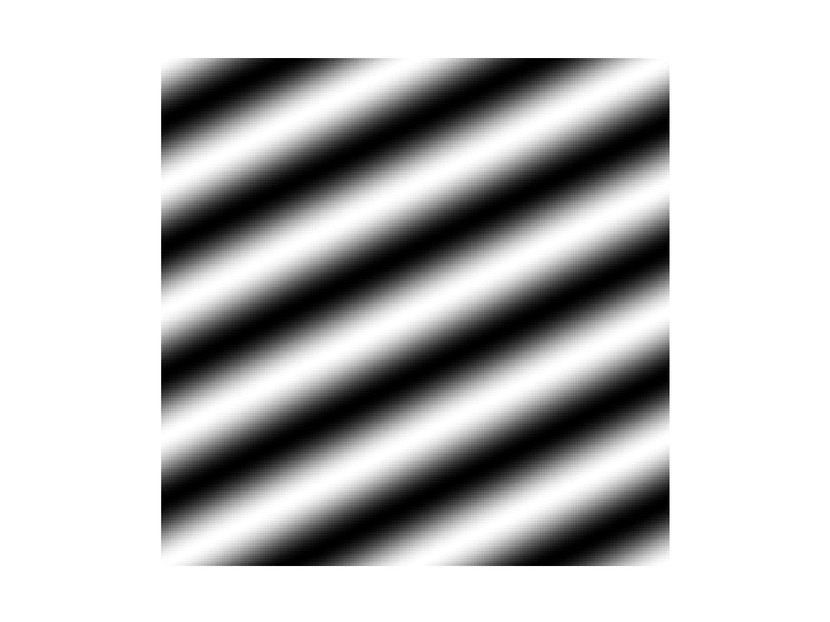
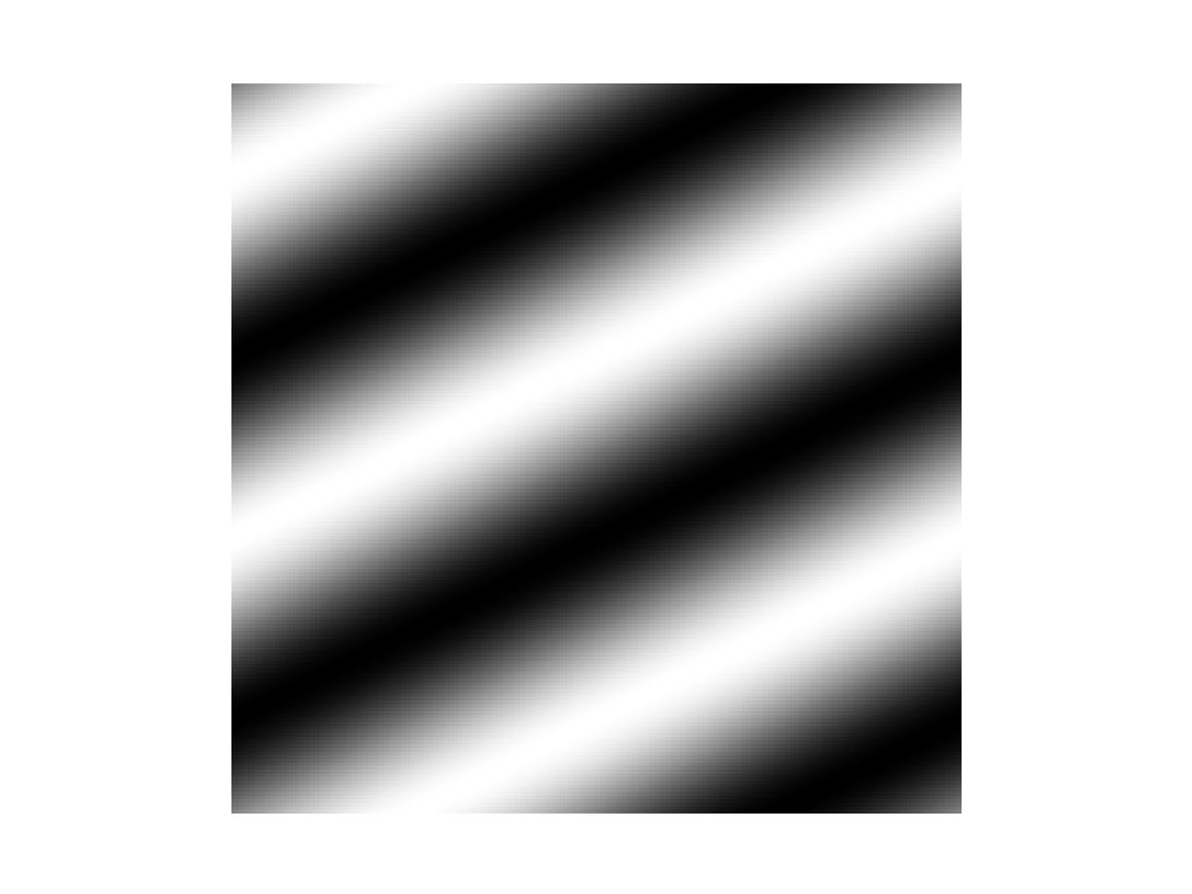 | 

Question 20 (3 points)
The discrete fourier coefficients of the 1D fourier transform of a discrete function f(x) are defined by
F(u)=1/M * Σ f(x) * (cos(2πux/M) - i*sin(2πux/M))

What’s the meaning of the different variables u, M, f, x ,F?
__ is defined by the number of samples in the function to be analysed
__ is the index of the frequency component
__ is an imaginary number, the fourier coefficients for each frequency component
__ is the function to be analyzed
__ is the ‘running’ variable for the summation

Question 21 (2 points)
How do you get a blurred version of an image, using a filter in the fourier space ?

Question 22 (3 points)
What is the difference between coding / interpixel and psychovisual redundancy reduction ?

Question 23 (2 points)
In the basing coding scheme, there is a psychovisual red. encoding step, but no decoding step. Why ?

Question 24 (2 points)
How can you objectively measure the distance between two pictures (e.g. the second one obtained by psychovisual red. reduction of the first) ?

Question 25 (4 points)
Given a shape as a polygonal curve, the DCE can be seen as a psychovisual redundancy reduction algorithm. How does it work (sketch the algorithm, not going into detail of the information value function), and why does it compress the data ?

Question 26 (7 points)
Below a dataset using 5 different symbols is given. Please write down the Huffman encoded version. Worksteps: compute the Huffman code for the symbols, then encode the datastream.

the dataset: DABABBCDEB

Question 27 (2 points)
Does it make sense to Huffman-encode a histogram equalized image ? Give a reason !

Question 28 (10 + 2 points)
In a JPEG-like compression format, a 4x4 block (JPEG uses 8x8, but it's easier to use 4x4 for this question) is runlength encoded using the zig-zag-like scheme shown below. Write a MATLAB - like program to encode the 4x4 block by that scheme (hint: it is not forbidden in software design to use lookup-tables, e.g. for complicated indexing schemes !)

The scheme:
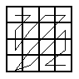

What is the encoded result result for the following data-block ?
1 | 1 | 0 | 0
1 | 1 | 0 | 0
0 | 0 | 1 | 0
0 | 0 | 0 | 0

