Image Segmentation in Color Space
Presented by: Anisa Chaudhary
AIM:

This project aims at segmenting few images using various Segmentation techniques. A comparison is then made between all the algorithms and conclusion is drawn. I have implemented all the algorithms using GUI in Matlab

TECHNIQUES:
I have implemented four different algorithms on different images. The algorithms that I have used for segmentation are

Clustering algorithm,
Region growing algorithm

Thresholding with the Pixel Value Average

I have changed my thresholding algorithm that now calculates the Threshold value with Pixel Value Average rather than simple histogram thresholding.

Watershed Algorithm.

The Six images are:

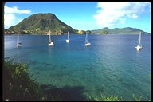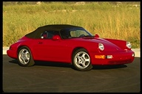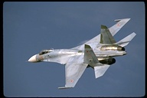

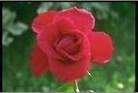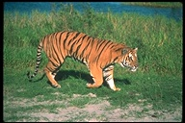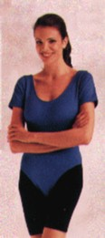

CONCLUSIONS:

The conclusion has been drawn on the different segmentation algorithm using the above images based on the time taken by each segmentation algorithm and
how well the images are segmented.

