Elementary Row Matrix (and Column) Operations
There are three types of row operations on a matrix A of dimension m-by-n that can be produced by multiplying it from left with an elementary matrix E of dimension m-by-m, E⋅A:
- row switching, that is interchanging two rows of a matrix.
- row addition, that is adding a row to another.
- row multiplication, that is multiplying all entries of a row by a non-zero constant.
In mathematics, an elementary matrix is a matrix which differs from the identity matrix by one single elementary row operation. Repeated multiplication of the identity matrix by the elementary matrices can generate any invertible matrix (definition of the inverse matrix will come later). Left multiplication (pre-multiplication) by an elementary matrix represents elementary row operations, while right multiplication (post-multiplication) represents elementary column operations. Elementary row operations are the basis of the very important method of Gaussian elimination (will be explained below).

Row-switching transformations
The first type of row operation on a matrix A switches all matrix elements on row i with their counterparts on row j. The corresponding elementary matrix is obtained by swapping row i and row j of the identity matrix.
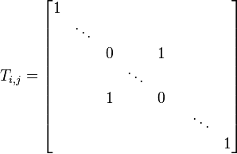
So T_{ij}⋅A is the matrix produced by exchanging row i and row j of A.

Row-multiplying transformations
The next type of row operation on a matrix A multiplies all elements on row i by m where m is a non-zero scalar (usually a real number). The corresponding elementary matrix is a diagonal matrix, with diagonal entries 1 everywhere except in the ith position, where it is m.
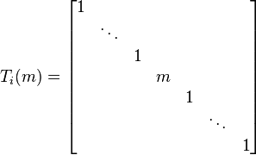
So T_{i}(m)⋅A is the matrix produced from A by multiplying row i by m.

Row-addition transformations
The final type of row operation on a matrix A adds row j multiplied by a scalar m to row i. The corresponding elementary matrix is the identity matrix but with an m in the (i,j) position.
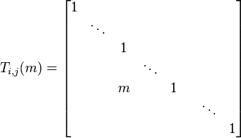
So T_{i,j}(m)⋅A is the matrix produced from A by adding m times row j to row i.

Examples:
M*A adds 2 times row 1 to row 3:

M*A adds 4 times row 2 to row 1:

